**“VEGETATION On the way”**

**A**

**Project Report**

**Submitted in Partial Fulfillment for the Award of**

**Bachelor of Engineering in**

**Computer Science & Engineering**

**Submitted To**

**RAJIV GANDHI PROUDYOGIKI VISHWAVIDYALAYA**

**BHOPAL (M.P.)**



Submitted By

**PIYUSH GANGLE 0882CS161019**

**BILAL KHAN 0882CS161006**

**PRIYANK MALVIYA 0882CS161023**

**Under the Supervision of**

**Dr. Chetan Nagar**



**Department of Computer Science & Engineering**

**SHREEJEE INSTITUTE OF TECHNOLOGY AND MANAGEMENT KHARGONE 451001**

**2016-2020**

**SHREEJEE INSTITUTE OF TECHNOLOGY AND MANAGEMENT, KHARGONE**



**CERTIFICATE**

This is to certify that PIYUSH GANGLE , BILAL KHAN , PRIYANK MALVIYA students of final year (Computer Science & Engineering) Session 2016-2020 have completed their project work on “VEGETATION ON THE WAY ” and have submitted their project report in partial fulfillment of the requirements of Rajiv Gandhi Proudyogiki Vishwavidyalaya, Bhopal for award of the degree of bachelor of engineering (CSE) It is a bonafide presentation of the work by them under our guidance and supervision.

Internal Examiner External Examiner

Date Date

**SHREEJEE INSTITUTE OF TECHNOLOGY AND MANAGEMENT, KHARGONE**



**PROJECT APPROVAL SHEET**

The major project entitled “VEGETATION ON THE WAY” Submitted by PIYUSH GANGLE , BILAL KHAN , PRIYANK MALVIYA is approved as partial fulfillment for the award of the Bachelor of Engineering (Computer Science & Engineering ) Degree By Rajiv Gandhi Prodyogiki Vishwavidyalaya, Bhopal.

**Project Incharge Project Guide**

**SHREEJEE INSTITUTE OF TECHNOLOGY AND MANAGEMENT, KHARGONE**



**RECOMMENDATION**

This major project Work on “VEGETATION ON THE WAY” done PIYUSH GANGLE , BILAL KHAN , PRIYANK MALVIYA of final year Computer Science & Engineering is satisfactory and this project and this report is recommended for submission to Rajiv Gandhi Proudyogiki Vishwavidyalaya Bhopal(M.P.) towards the partial fulfillment for the award of the Bachelor of Engineering degree in Computer Science & Engineering .

Dr. Chetan Nagar Dr. Chetan Nagar

**HOD GUIDE**

Dr. Chetan Nagar

**Principal**

**Shreejee Institute of Technology and Management, Khargone**

**ACKNOWLEDGEMENT**

It gives me immense pleasure to express my deepest sense of gratitude and sincere thanks to my highly respected and supervisor Dr. Chetan Nagar, Head of Department of Computer Science and Engineering, Shreejee Institute of Technology and Management for their valuable guidance, encouragement and help for completing this work. Their useful suggestions for this whole work and co-operative behavior are sincerely acknowledged.

I also wish to express my gratitude to Dr. Chetan Nagar Assistant Professor and HOD (Computer Science & Engineering) for this kind hearted support. At the end I also wish to express my indebtedness to my parents as well as family members whose blessings and support always helped me to face challenges ahead

Submitted By

Piyush Gangle [0882CS161019]

Bilal Khan [0882CS161006]

Priyank Malviya[0882CS161023]

**TABLE OF CONTENTS**

|  |  |
| --- | --- |
| **TITLE** | **PAGE NO**. |
| **ABSTRACT** | 1 |
| **CHAPTER 1. INTRODUCTION** |  |
| 1.1 Problem Statement | 2 |
| 1.2 Solution to the problem | 2 |
| 1.3Need & Future Scope | 3 |
| 1.4 Glossary | 4 |
| **CHAPTER 2. REQUIREMENT GATHERING AND ANALYSIS** |  |
| 2.1 Questionnaires with answers | 5 |
| 2.2 Data Dictionary | 9 |
| 2.3 Feasibility Analysis | 9 |
| 2.4 Requirement Analysis | 10 |
| 2.5 Risk Analysis | 12 |
| **CHAPTER 3.DESIGN** |  |
| 3.1 Design Model | 13 |
| 3.2 Use Case Diagram | 15 |
| 3.3 Sequence Diagram | 16 |
| 3.4 Activity Diagram | 17 |
| 3.5 Class Diagram  3.6 State Diagram | 18  19 |
| 3.7 E-R Diagram | 20 |
| 3.8 Data Flow Diagram  3.8.1 Level 0  3.8.2 Level 1 | 21  21 |
| **CHAPTER 4. IMPLEMENTATION**  4.1 Description of technology and platform  4.2 Description of Backend  4.3 Testing  4.4 Types of testing  4.5 Used testing in project  4.6 output snapshot | 22  24  273  274  275  276 |
| **CHAPTER 5. LIMITATIONS AND FUTURE ENHANCEMENT**  **CHAPTER 6. CONCLUSION** | 279  281 |
| **REFERENCES** | 282 |

**ABSTRACT**

In today’s day to day life purchasing of products by visiting stores has become a tough job. As a standing in a queue for making the payment of the product has become difficult for customer. To overcome these difficulties, we are coming up with “Vegetation On The Way”.

“Vegetation On The Way” is an online Plants & Flower buying and renting website. That provides an online platform that a user can use to choose their favorite Plants & Flowers to buy or rent it.

The purpose of Online Plant Store is to automate the existing manual system by the help of computerized equipment and full-fledged computer software, fulfilling their requirements, so that their valuable data/information can be stored for a longer period with easy accessing and manipulation of the same.

**1. Introduction**

The “Online Vegetation Store (Online Plant Store)” has been developed to override the problems prevailing in the practicing manual system. This software is supported to eliminate and, in some cases, reduce the hardships faced by this existing system. Moreover, this system is designed for the particular need of company to carry out operations in smooth and effective manner.

Every organization, whether big or small, has challenges to overcome and managing the information of Stocks, Plants & Flowers, Customer, Bill, and Payment. Every Online Store has different needs, this store provides all the types of Plants as your need.

This website is reduced as much as possible to avoid errors while entering the data. It also provides error message while entering invalid data. No formal knowledge is needed for the user to use this system. Thus, by this all it proves it is user-friendly. Online Vegetation Store can lead to error free, secure, reliable and fast management system. It can assist the user to concentrate on their other activities rather to concentrate on their record keeping.

* 1. **Problem Statements:**

Today, purchasing online is accepted by many, but if you look across categories of purchase, there are some sectors where there is still reluctance to buy online, so online retailers still need to work on their tactics to encourage online conversion and multichannel tactics to encourage offline purchase in store.

* 1. **Solution to the Problem:**
* Customer can browser through the product catalogue and add the items to shopping cart.
* He can proceed to checkout as long as his shopping cart is not empty.
* Customer will require to login to the system when he proceed to checkout, or he can create an account if he not yet have one.
* Customer need to provides full name, email address, phone number and billing address details when creating an account.
* Customer can login to the system to maintain his account information, such as changing phone number, address and check the status of his orders.
* Once the order has been placed , then pass the order to courier company and deliver them to customer and payment mode is pay on delivery.
* the items customer ordered is out of stock, then the order will mark as on hold.
* Once the items arrived, the order will pass to courier company for delivery.
* Courier company will pack the item with standard packaging, but if the order is marked as gift, then the items will pack as gift.
* the items arrived with damage, customer can return it by register in the online shop.
* Courier company will collect the item from customer and sales staff will refund the money for that item.& marketing staff responsible to maintain the product catalogue.
* He can also setup the promotion item list and send promotion email to customer.
  1. **Need and Future Scope:**

**Need:**

* To make a responsive, easy to operate, fast and efficient retrieval of communication as per the client requirements.
* To provide good Interface for user attraction.
* To make a database that is consistent, reliable and more secure.

**Future Scope:** Purchasing and selling products and services over the internet without the need of going physically to the market is what online shopping all about. Online shopping is just like a retail store shopping that we do by going to the market, but it is done through the internet. Online shopping has made shopping painless and added more fun. Online stores offer product description, pictures, comparisons, price and much more. Few examples of these are Amazon.com, ebay.com, framt.com and the benefits of online shopping is that by having direct access to consumer ,the online stores can offer products that cater to the needs of consumer ,cookies can be used for tracking the customer selection over the internet or what is of their interest when they visit the site again . Online shopping makes use of digital technology for managing the flow of information, products, and payment between consumer, site owners and suppliers. Online shopping can be either B2B (business to business) or B2C (business to consumer)

Shopping cart is one of the important facility provided in online shopping, this lets customer to browse different goods and services and once they select an item to purchase they can place the item in shopping cart, and continue browsing till the final selection. Customers can even remove the items from shopping cart that were selected earlier before they place the final order. It reminds us of shopping basket that we carry in departmental store

* 1. **Glossary**

1 **Vegetation:** plants considered collectively, especially those found in a particular area or habitate.

1. **Shrubs:** a woody plant which is smaller than a tree and has several main stems arising at or near the ground.
2. **Planters:** a decorative container in which plants are grown**.**
3. **Perennial:** (of a plant) living for several years.
4. **Botanical Garden:** an establishment where plants are grown for scientific study and display to the public.
5. **Landscaping:** the process of making a garden or other piece of land more attractive by altering the existing design, adding ornamental features, and planting trees and shrubs.
6. **Green Walls:** Vertical Gardens or wall Gardens.

**2. Requirement Gathering and Analysis**

**2.1 Questionnaires with answers**

**Q.1) What kind of business do you have?**

**Ans:-** We have a nursery through which we provide selling and renting facility of plants.

**Q.2) What is your organization’s name?**

**Ans:-** The name of our organization is “Vriksham”.

**Q.3) What kind of application or platform do you need (App / Website)?**

**Ans:-** We want a website.

**Q.4) What kind of plants you sell or rent?**

**Ans:-** We have all types of plants. Fruiting plants, Vegetable plants, Flowering plants and Trees.

**Q.5) What kind of payment methods do you need in website?**

**Ans:-** We want to use only cash on delivery method for payment.

**Q.6) What name you suggest for website?**

**Ans:-** I want the name of my website is “vegetation on the way”.

**Q.7) What is maximum amount of customers that can be handled by website at same time?**

**Ans:-** Minimum 200 customers should be able to access website at same time.

**Q.8) What is the maximum quantity of renting plants at one time?**

**Ans:-** The customer can rent 10 quantities of plants at one time.

**Q.9) What is the maximum quantity of purchasing plants at one time?**

**Ans:-** The customer can purchase 10 quantities of plants at one time.

**Q.10) Do you want separate web pages for rent and purchase?**

**Ans:-** Yes, the process of renting and purchasing must be separated from each other.

**Q.11) Do you want to generate invoice by website?**

**Ans:-** No, we provide a hand made purchase receipt with the plant.

**Q.12) Do you want to provide order cancellation facility?**

**Ans:-** Yes, but only till the dispatching of the plant from the nursery.

**Q.13) What is the range of service coverage area?**

**Ans:-** We cover every area of the khargone city.

**Q.14) Pricing for renting and purchasing is static or dynamic?**

**Ans:-** We want a dynamic system for pricing. A website administrator should be able to modify website contents.

**Q.15) Do you sell Plant caring stuff also?**

**Ans:-** No, we sell only Plants.

**Q.16) What is your current way of managing data of nursery?**

**Ans:-** We use pen paper based system to manage data. Orders are written in hand-written diaries.

**Q.17) What information do you need to store about a customer?**

**Ans:-** We want some basic information about the customer just like:- Name, Email, password , Address and Mobile Number.

**Q.18) What kind of new features do you need in this project?**

**Ans:-**

1. Computer Based database management.
2. Login and Registration Facility.
3. Visitor’s Count.
4. Separate Buy and Rent facility.
5. Administrator window to provide highly privileged powers to update price and order confirmation.
6. Order cancel facility.
7. Vegetation search facility and buy/rent cart insert update and remove facility

**Q.19) Do you want desktop support or mobile support website or both?**

**Ans:-** Right now we want only desktop support website.

**Q.20) In how many weeks do you want your website ready?**

**Ans:-** We will shift our nursery to a new place in 6 weeks so we want the website complete before shifting.

**Q.21) Is there any delivery charges apply with plant’s price?**

**Ans:-** No, we provide free home delivery on every plant.

**Q.22) Do you want to get any feedback from customers?**

**Ans:-** No, right now we do not want this feature in our website, but you may include this feature in future upgrades.

**Q.23) Do you want to share location of your nursery on the website?**

**Ans:-** Yes, we want a map based location on the website page.

**Q.24) Do you want to share your organization’s social page links on website?**

**Ans:-** Yes, our organization has pages on various social sites like Facebook, Instagram, Twitter , WhatsApp and Google+. They help us to promote our business on digital platform.

**Q.25) Does your requirements can change in future?**

**Ans:-** Yes, we update our stock when we get any new species of plants so our requirements get change at any time.

**Q.26) What kind of features that you want to add in future?**

**Ans:-** In future, we want to provide online payment method, invoice generation, we also want a mobile support website in future and a feedback section for customers.

**Q.27) What information you want to show about your organization on website?**

**Ans:-** The contact number and email of our managers.

**Q.28) Do you want newsfeed on website to show the latest info about your organization?**

**Ans:-** Yes, as we update our stock we want to show the new plants on the newsfeed and other new information also.

**Q.29) Do you have any customer care department?**

**Ans:-** No, right now we do not have any department for handling the customer’s complaint. Customer can reach us through various means like email and official contact numbers.

**Q.30) Do you have your own delivery system or you use courier services for delivery?**

**Ans:-** We delivered the plants with our own transportation facility, because the plants need some extra care.

**Q.31) Can a customer can put request for a plant that is not present in website?**

**Ans:-**No, because currently we do not have sufficient number of employees to handle nursery and manage the new desired stock.

**Q.32) Is there is any replacement policy for plants?**

**Ans:-**No, once product is purchased it cannot be replaced or returned.

**Q.33) Is there is penalty for delayed rent product return?**

**Ans:-**Yes, it will be charged as per our organization’s officials.

**Q.34) Will you require a IT professional to handle website?**

**Ans:-**No, some training will be sufficient to handle administrative functionality, like adding ,updating ,removing plants and their attributes.

**Q.35) Do you want GUI to administrator’s page?**

**Ans:-** No ,it should be simple enough to perform regular operations with ease.

**2.2 Data Dictionary**

|  |  |  |
| --- | --- | --- |
| **S.NO.** | N**AME** | **DESCRIPTION** |
| 1 | Client | Client work under the control of Server. |
| 2 | Server | A program that can provide services to the other program called server. |
| 3 | Network | A set of autonomous interconnection System |
| 4 | Data | Meaning full Information. |
| 5 | Protocol | A set of rules, which are used in network transaction. |
| 6 | Connection Request | A message sent to establish a connection. |
| 7 | Database | A Database in out application stores the information both client and server |
| 8 | Message | Data & Product which send from source to destination. |
| 9 | Password | It provides security by the unauthorized user |

**2.3 Feasibility Analysis**

Feasibility is the determination of whether or not a project is worth doing. The process followed in making this determination is called a feasibility study. This type of study determines if a project can and should be taken. Once it has been determined that a project is feasible, the analyst can go ahead and prepare the project specification which finalizes project requirement

**Different Type of Feasibility Study:-**

In the conduct of the feasibility study, the analyst will usually consider seven distinct, but inter- related types of feasibility. They are some feasibility types

Technical Feasibility, Operational Feasibility, Economic Feasibility

**2.4 Requirement Analysis**

**2.4.1 Functional Requirements**

**1. Administrator**

* **Database Management:** Control the database and keep track of all records of customers and employee details.
* **Contact and Giving Permission to Vendors:** Contact with the vendors and give permission to sell their product under the site after testing the product’s quality.
* **View all details:** View the details of all employees and control the whole site.
* **Advertising the Site:** Responsible for making advertisements for the site.

**2. Customer**

* **Login:** Customers must have a valid login id to enter into the site.
* **Registration:** New users can sign up by creating new ID.
* **View and edit Own Details:** Can view/edit his personal details, payment details, anddetails about services provided.
* **Choosing and comparing products:** Can view all available products and can compare them and make a choice for purchasing products.
* **Purchasing:** Can purchase any product through valid credit card.
* **Giving Feedback to Customer Care:** Can give feedback to the 24X7 Customer Care Service center about their impression for the site and services.
* **Logout:** Customer must logoutof the site after purchasing products.

**3. Visitors**

* **Visiting the Site:** Can only visit the site without registration.
* **Register**

**4. Shop Owner**

* **Taking Permission from Administrator:** Vendors must take permission from the Administrator for selling their products under the site. Administrator will test product’s quality according to its market price to permit vendor for selling purpose.
* **Consulting with Administrator:** Can consult with the Administrator regarding product’s quality and advertisements.
* **Advertising Vendor’s Own Products:** Responsible for making advertisements of his products, but the site will not be responsible for any kind of advertisements about products.

**5. Sales Manager**

* **View customer details:** View the personal details of the customer.
* **Managing Sales to Customers:** Responsible for properly allocating the selected product according to the customer’s choice and delivering product to the customer.
* **View Product Stocks:** Keep track of each product item’s stocks for selling purpose.
* **Contacting with Administrator:** Responsible for informing administrator when any product item’s stock goes under the minimum level.

**6. Purchase Manager**

* **Consulting with Administrator:** Taking permission from the Administrator for the product to be purchased from vendor.
* **Product Stock Management:** Responsible for managing stocks of each product items.

**7. Account Manager**

* **Regulating Payments:** Keep track of all the payment transactions made by the customers and update the payment information.
* **Consulting with Banks:** Responsible for contacting the banks for the validation of the a/c number provided by the customer while purchasing and make the transaction from the given a/c.
* **Consulting with Administrator:** Consult with the Administrator about the payment details of the customers for the updating of the database.

**8. Customer Care**

* **Getting Feedback from the Customers:** Responsible for receiving complaints, queries and feedback from the customers.
* **Providing Solutions to Customers:** Provide feasible solutions to the customers on their complaints and queries.

**2.4.2 Non-functional Requirements**

* **Performance Requirements**  
  • The system shall accommodate high number of items and users without any fault.  
  • Responses to view information shall take no longer than 5 seconds to appear on the screen.
* **Safety Requirements**  
  • System use shall not cause any harm to human users.
* **Security Requirements**  
  • System will use secured database.  
  • Normal users can just read information but they cannot edit or modify anything except their personal and some other information.  
  • System will have different types of users and every user has access constraints.
* **Error handling**

OFS shall handle expected and non expected errors in ways that prevent loss in information and long downtime period.

**2.5 Risk Analysis**

* **Password:** The first rule of any online shopping platform process is to use secure passwords.
* **Pricing:** Take care when choosing which sites and which sellers you buy from. Keep an eye on pricing. If a price on an unfamiliar website seems too good to be true, it probably is
* **Protection:** If you do find something on a site you’ve never used before, you need to make sure that the checkout is secure. Whenever you’re inputting personal information, but especially if you’re entering financial info, make sure the URL starts ‘https’ rather than ‘http’.

That mean the site is using secure server.

* **Payment method:** our payment method is only cash on delivery method.
* **Privacy:** Privacy is important to everyone, but many people give it away all too freely online. Most online forms have minimum requirements for information sharing, it’s important that you don’t share more than you have to.

**3.DESIGN**

**3.1 design model**

We have used spiral model for our major project development. Spiral model is one of the most important Software Development Life Cycle models, which provides support for Risk Handling. In its diagrammatic representation, it looks like a spiral with many loops. The exact number of loops of the spiral is unknown and can vary from project to project. Each loop of the spiral iscalled a Phase of the software development process**.** The exact number of phases needed to develop the product can be varied by the project manager depending upon the project risks. As the project manager dynamically determines the number of phases, so the project manager has an important role to develop a product using spiral model. The Radius of the spiral at any point represents the expenses(cost) of the project so far, and the angular dimension represents the progress made so far in the current phase.

Below diagram 3.1.1 shows the different phases of the Spiral Model:

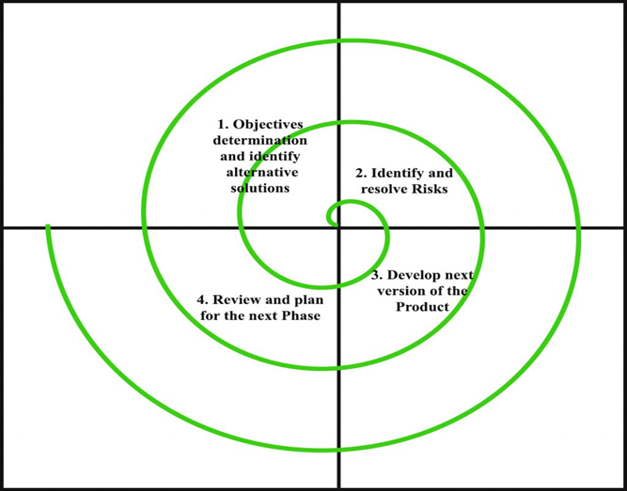

**Fig 3.1.1**

**Each phase of Spiral Model is divided into four quadrants as shown in the above figure. The functions of these four quadrants are discussed below-**

1. **Objectives determination and identify alternative solutions:** Requirements are gathered from the customers and the objectives are identified, elaborated and analyzed at the start of every phase. Then alternative solutions possible for the phase are proposed in this quadrant.
2. **Identify and resolve Risks:** During the second quadrant all the possible solutions are evaluated to select the best possible solution. Then the risks associated with that solution is identified and the risks are resolved using the best possible strategy. At the end of this quadrant, Prototype is built for the best possible solution.
3. **Develop next version of the Product:** During the third quadrant, the identified features are developed and verified through testing. At the end of the third quadrant, the next version of the software is available.
4. **Review and plan for the next Phase:** In the fourth quadrant, the Customers evaluate the so far developed version of the software. In the end, planning for the next phase is started.

* **Reason behind using spiral model are as follows:**
* There was a budget constraint and risk evaluation was important.
* Project had medium risks.
* Long-term project commitment because of potential changes to economic priorities as the requirements change with time.
* Customer was not sure of their requirements which is usually the case.
* Requirements were complex and need evaluation to get clarity.
* New product line which should be released in phases to get enough customer feedback.
* Significant changes were expected in the product during the development cycle.

**3.2 Use Case Diagram**

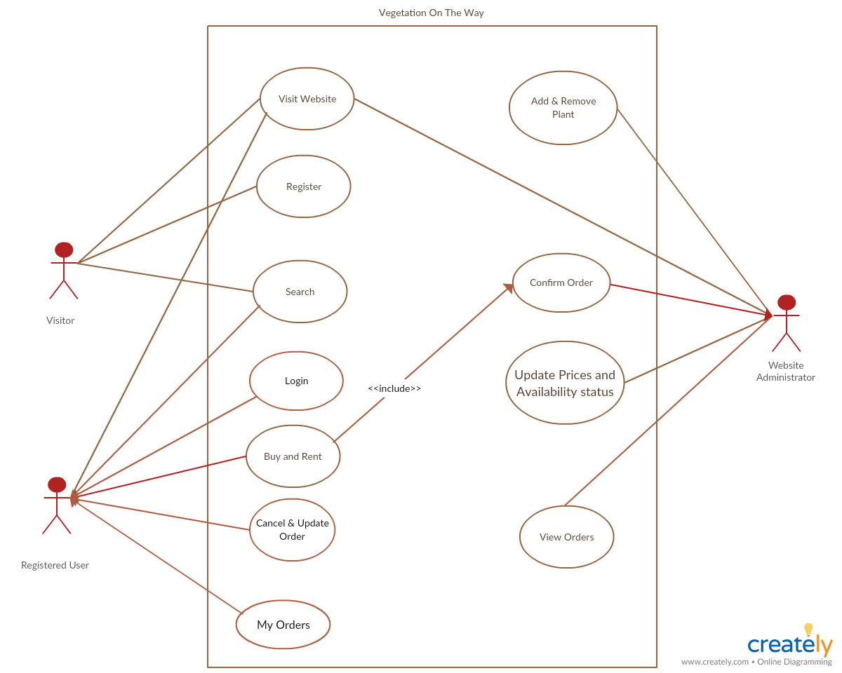

**Fig 3.1.2**

**3.3 Sequence Diagram**

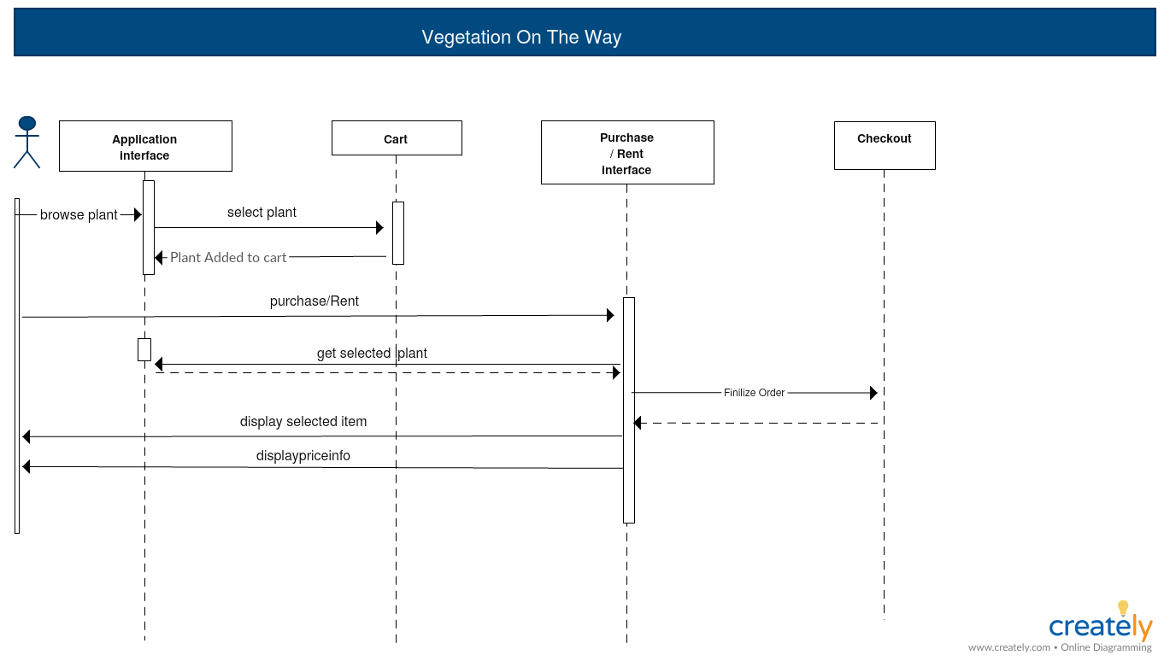

**Fig 3.1.3**

**3.4 Activity Diagram**

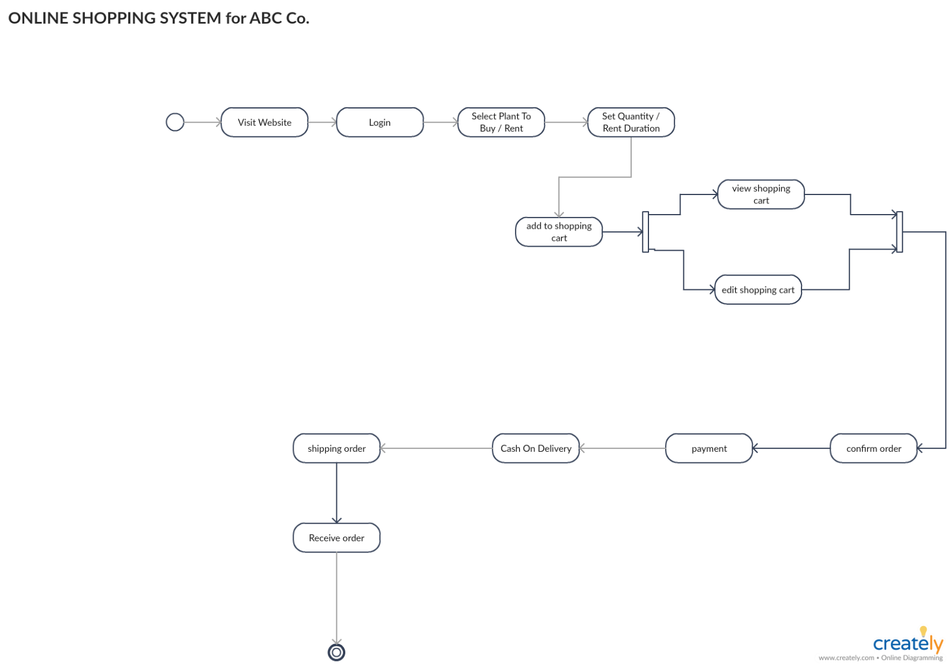

**Fig 3.1.4**

**3.5 Class Diagram**

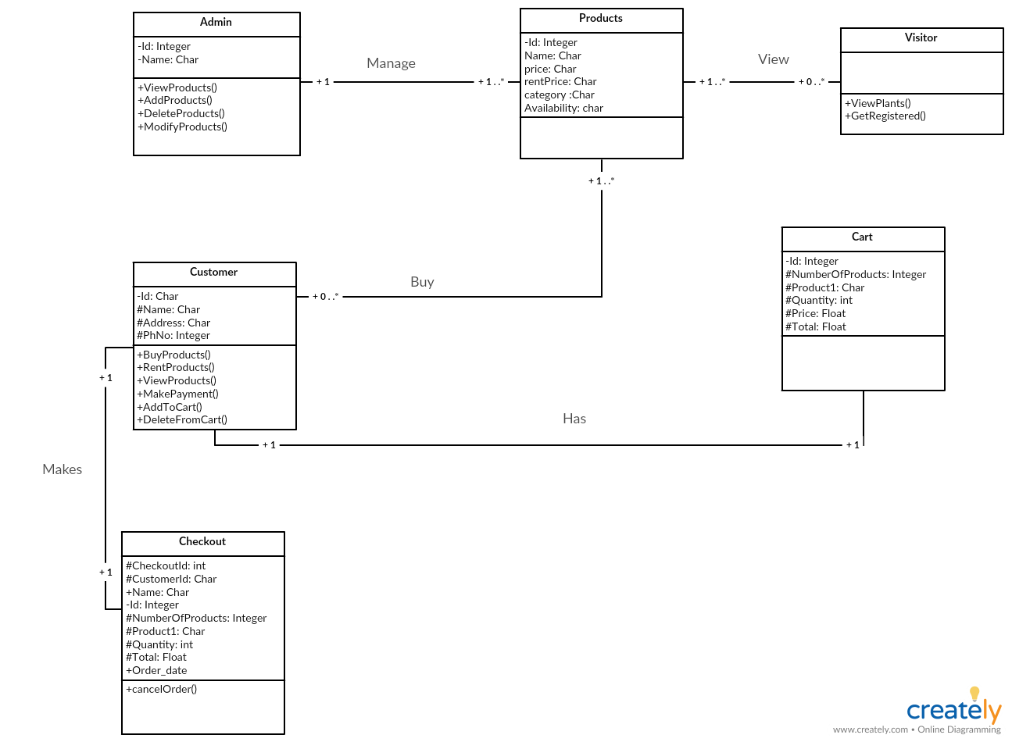

**Fig 3.1.5**

**3.6 State Diagram**

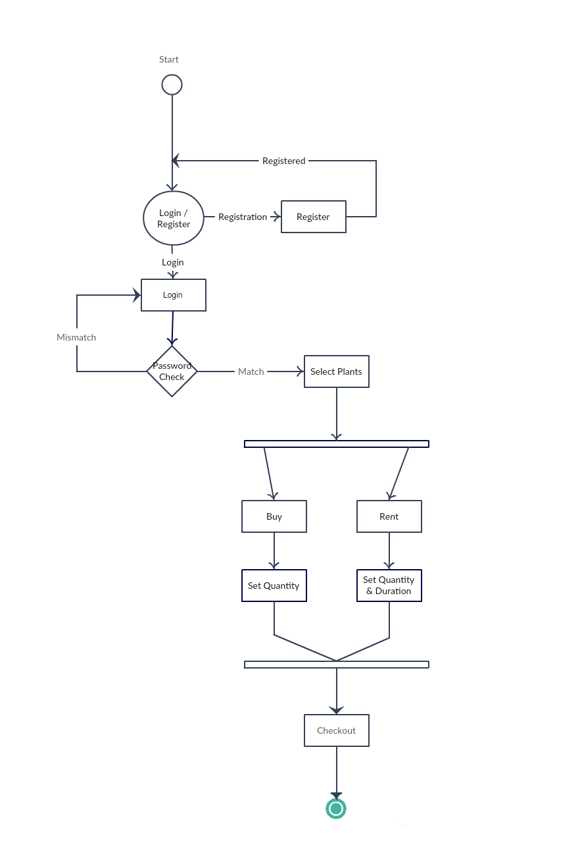

**Fig 3.1.6**

**3.7 E-R Diagram**

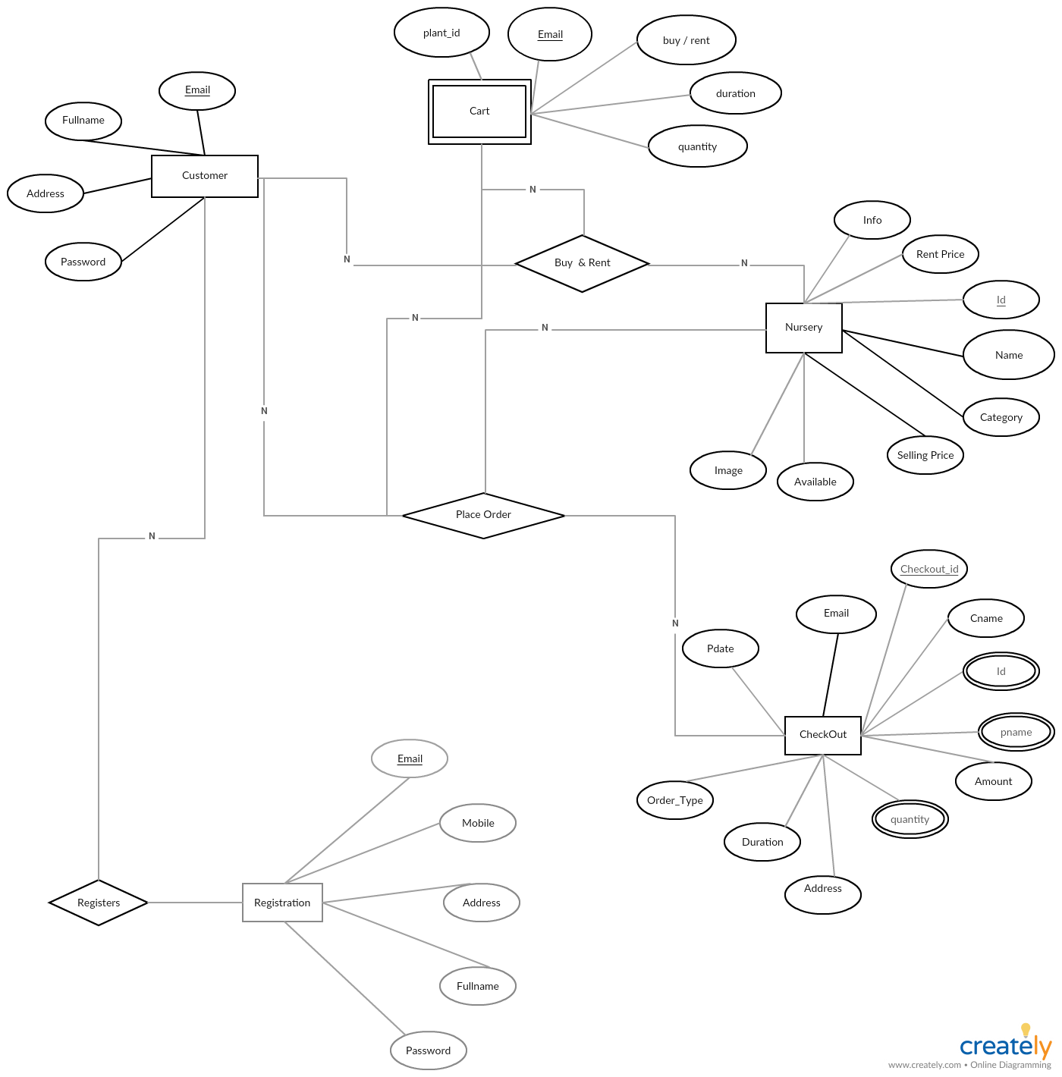

**Fig 3.1.7**

**3.8 Data Flow Diagram**

* **3.8.1 Level 0**

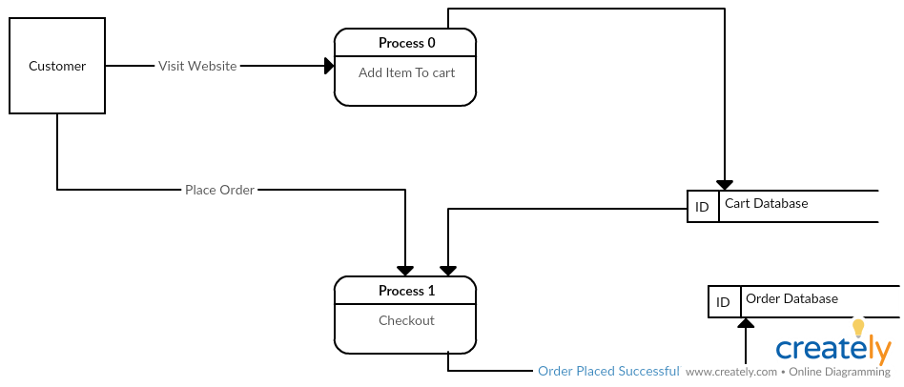

**Fig 3.1.8**

* **3.8.2 Level 1**

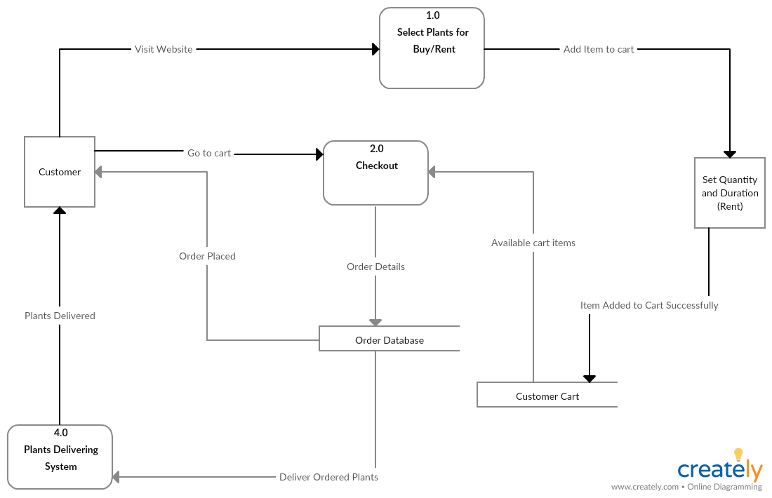

**Fig 3.1.9**

**4. Implementation**

**4.1 Description of technology and platform**

“Vegetation On The Way” is a online plant selling and renting platform which is mainly developed using JAVA. We have incorporated various technologies that are mentioned below

1. **Oracle Database 11g Express Edition:** Oracle Database 11g Express Edition (Oracle Database XE) is an entry-level, small-footprint database based on the Oracle Database 11g Release 2 code base. It's free to develop, deploy, and distribute; fast to download; and simple to administer.
2. **HTML:** Hypertext Markup Language (HTML is the standard markup language for creating web pages and web applications. With Cascading Style Sheets (CSS) and JavaScript, it forms a triad of cornerstone technologies for the World Wide Web.
3. **CSS:** Cascading Style Sheets is a style sheet language used for describing the presentation of a document written in a markup language like HTML. CSS is a cornerstone technology of the World Wide Web, alongside HTML and JavaScript.
4. **JavaScript:** JavaScript, often abbreviated as JS, is a high-level, interpreted programming language that conforms to the ECMAScript specification. It is a programming language that is characterized as dynamic, weakly typed, prototype-based and multi-paradigm.
5. **AJAX:** Ajax is a set of web development techniques using many web technologies on the client side to create asynchronous web applications. With Ajax, web applications can send and retrieve data from a server asynchronously without interfering with the display and behavior of the existing page.
6. **JSTL:** The Java Server Pages Standard Tag Library is a component of the Java EE Web application development platform. It extends the JSP specification by adding a tag library of JSP tags for common tasks, such as XML data processing, conditional execution, database access, loops and internationalization.
7. **JSP:** Java Server Pages (JSP) is a technology that helps software developers create dynamically generated web pages based on HTML, XML, or other document types. Released in 1999 by Sun Microsystems, JSP is similar to PHP and ASP, but it uses the Java programming language.

**4.1.1 Hardware & software requirement :-**

* **Hardware requirements are as follows:**

Min 4GB RAM

Pointing device (mouse)

CGA(Color Graphics Adapter)

* **Software requirements are as follows:**

Operating System Windows XP or above

JDK 5 and above

Glassfish 4.4+

NetBeans (8.0.2 & above) installed (IDE)

Oracle Database 11g express Edition

**4.2 Description of Backend**

The back end of the web application is basically the brains behind the front end. It comprises three components: server, application and database. It is a link between the server and the user. Most of the coding for the web application can be found in the back end and the quality of this code will determine how the website functions. Knowledge of required programming languages and database, as well as of the server side architecture is essential to prevent sluggish performance, continuous crashes or errors.

**Java:** Java Enterprise Edition is considered to still hold its ground for large web applications that require reliability, scalability and stability. Knowledge of Java is required for websites that are high-security (such as for those used in banking and insurance) or generate high traffic. Our project follows MVC (Model View Control) approach. Various servlets are implemented for safe and secure data exchange between client and server.

**SQL:** Structured Query Language (SQL) is the standard language for relational database management systems. It is used to interact with the database that is a part of the back end. Statements written in SQL are employed to accomplish tasks related to updating or retrieval of data. We have used Oracle Database 11g Express Edition (Oracle Database XE) which is an entry-level, small-footprint database based on the Oracle Database 11g Release 2 code base. It's free to develop, deploy, and distribute; fast to download; and simple to administer.

**JavaScript:** JavaScript is a dynamic computer programming language. It is lightweight and most commonly used as a part of web pages, whose implementations allow client-side script to interact with the user and make dynamic pages. It is an interpreted programming language with object-oriented capabilities.

* JavaScript is a lightweight, interpreted programming language.
* Designed for creating network-centric applications.
* Complementary to and integrated with Java.
* Complementary to and integrated with HTML.
* Open and cross-platform

**Source Code**

* **Web.xml :**

<?xml version="1.0" encoding="UTF-8"?>

<web-app version="3.1" xmlns="http://xmlns.jcp.org/xml/ns/javaee" xmlns:xsi="http://www.w3.org/2001/XMLSchema-instance" xsi:schemaLocation="http://xmlns.jcp.org/xml/ns/javaee http://xmlns.jcp.org/xml/ns/javaee/web-app_3_1.xsd">

<welcome-file-list>

<welcome-file>home.jsp</welcome-file>

</welcome-file-list>

<servlet>

<servlet-name>AddDataServlet</servlet-name>

<servlet-class>admin.AddDataServlet</servlet-class>

</servlet>

<servlet>

<servlet-name>DisplayDataServlet</servlet-name>

<servlet-class>admin.DisplayDataServlet</servlet-class>

</servlet>

<servlet>

<servlet-name>ListDataServlet</servlet-name>

<servlet-class>admin.ListDataServlet</servlet-class>

</servlet>

<servlet>

<servlet-name>DeleteServlet</servlet-name>

<servlet-class>admin.DeleteServlet</servlet-class>

</servlet>

<servlet>

<servlet-name>UpdateServlet1</servlet-name>

<servlet-class>admin.UpdateServlet1</servlet-class>

</servlet>

<servlet>

<servlet-name>UpdateImageServlet1</servlet-name>

<servlet-class>admin.UpdateImageServlet1</servlet-class>

</servlet>

<servlet>

<servlet-name>UpdateServlet</servlet-name>

<servlet-class>admin.UpdateServlet</servlet-class>

</servlet>

<servlet>

<servlet-name>UpdateServlet2</servlet-name>

<servlet-class>admin.UpdateServlet2</servlet-class>

</servlet>

<servlet>

<servlet-name>login</servlet-name>

<servlet-class>admin.login</servlet-class>

</servlet>

<servlet>

<servlet-name>register</servlet-name>

<servlet-class>admin.register</servlet-class>

</servlet>

<servlet>

<servlet-name>logout</servlet-name>

<servlet-class>admin.logout</servlet-class>

</servlet>

<servlet>

<servlet-name>removecartServlet</servlet-name>

<servlet-class>admin.removecartServlet</servlet-class>

</servlet>

<servlet>

<servlet-name>Search</servlet-name>

<servlet-class>admin.Search</servlet-class>

</servlet>

<servlet-mapping>

<servlet-name>AddDataServlet</servlet-name>

<url-pattern>/AddDataServlet</url-pattern>

</servlet-mapping>

<servlet-mapping>

<servlet-name>DisplayDataServlet</servlet-name>

<url-pattern>/DisplayDataServlet</url-pattern>

</servlet-mapping>

<servlet-mapping>

<servlet-name>ListDataServlet</servlet-name>

<url-pattern>/ListDataServlet</url-pattern>

</servlet-mapping>

<servlet-mapping>

<servlet-name>DeleteServlet</servlet-name>

<url-pattern>/DeleteServlet</url-pattern>

</servlet-mapping>

<servlet-mapping>

<servlet-name>UpdateServlet1</servlet-name>

<url-pattern>/UpdateServlet1</url-pattern>

</servlet-mapping>

<servlet-mapping>

<servlet-name>UpdateImageServlet1</servlet-name>

<url-pattern>/UpdateImageServlet1</url-pattern>

</servlet-mapping>

<servlet-mapping>

<servlet-name>UpdateServlet</servlet-name>

<url-pattern>/UpdateServlet</url-pattern>

</servlet-mapping>

<servlet-mapping>

<servlet-name>UpdateServlet2</servlet-name>

<url-pattern>/UpdateServlet2</url-pattern>

</servlet-mapping>

<servlet-mapping>

<servlet-name>login</servlet-name>

<url-pattern>/login</url-pattern>

</servlet-mapping>

<servlet-mapping>

<servlet-name>register</servlet-name>

<url-pattern>/register</url-pattern>

</servlet-mapping>

<servlet-mapping>

<servlet-name>logout</servlet-name>

<url-pattern>/logout</url-pattern>

</servlet-mapping>

<servlet-mapping>

<servlet-name>removecartServlet</servlet-name>

<url-pattern>/removecartServlet</url-pattern>

</servlet-mapping>

<servlet-mapping>

<servlet-name>Search</servlet-name>

<url-pattern>/Search</url-pattern>

</servlet-mapping>

<session-config>

<session-timeout>

30

</session-timeout>

</session-config>

</web-app>

* **myCSS.css**

input[type=text], input[type=password]{

color:seagreen;

width: 89%;

background-color: burlywood;

border-radius: 10px;

font-size: 18px;

font-family: 'Galada';

}

body{

margin: 0px;

background-image: url(../images/backgrouns.png);

background-repeat: no-repeat;

background-size: cover;

}

.outerdiv{

height: 1000px;

width: 80%;

border: 1px black solid;

background-color:floralwhite;

margin: auto;

border-radius: 10px;

}

.headerdiv{

font-family: 'Amita';font-size: 22px;

height: 100px;

width: 100%;

background-color:olivedrab;

border-top-left-radius: 10px;

border-top-right-radius: 10px;

float: left -20px;

}

.logodiv{

background-repeat: no-repeat;

border-radius: 50px;

height: 100px;

width: 100px;

overflow: hidden;

margin-left: 30px;

float: left;

}

.logodiv a:hover img{

transform: rotate(360deg);

transition-duration: 2s;

}

.projecttitlediv{

float:right;

line-height:4;

margin-right: 550px;

color: cornsilk;

font-size: 35px;

}

.marqueediv{

border: 1px darkseagreen solid;

height: 20px;

width: 80%;

line-height: -65px;

font-size: 20;

position: absolute;

color: darkgoldenrod;

font-family: 'Galada';font-size: 15px;

}

.menubardiv{

float: left;

height: 40px;

width: 100%;

background-color:darkgoldenrod ;

position: relative;

margin-top: -18px;

}

.menubardiv ul{

height: 40px;

width: 140px;

float: left;

text-align: center;

//border: 1px aqua solid;

margin: 0px;

padding: 0px;

text-align: center;

display: inline-block;

font-size: 21px;

font-family: 'Galada';

}

.menubardiv ul li{

display: inline-block;

margin: 0px;

}

.menubardiv ul li a{

text-decoration: none;

width: 140px;

color: khaki;

display: inline-block;

line-height: 50px;

}

.menubardiv ul li:hover a{

display: block;

background-color: yellow;

height: 40px;

width: 140px;

color: brown;

border-radius: 10px;

}

.menubardiv ul li ul li{

display: none;

}

.menubardiv ul li:hover ul li {

display: block;

color:gold;

}

.menubardiv ul li a:hover{

color:limegreen;

}

.counterdiv{

font-family: Amita;

font-size: x-large;

color: aliceblue;

float: left;

margin-top: 5.3%;

height: 100px;

width: 80%;

margin-left: 0px;

background-color:olivedrab;

position: absolute;

border-radius: 10px;

}

.counterimage{

position: absolute;

float: right;

margin-left: 35%;

line-height: 110px;

}

.loginlinkdiv{

position: absolute;

margin-left: 67%;

line-height: 60px;

}

.loginlinkdiv a{

position: absolute;

margin-left: 50%;

line-height: 60px;

cursor: pointer;

color: azure;

}

.logindiv{

font-family: Tillana;

height: 150px;

width: 300px;

background-color:activecaption;

border: chocolate dotted;

border-radius: 10px;

position: fixed;

top: 33%;

left: 33%;

opacity: 90%;

z-index: 135654;

cursor: pointer;

color: azure;

}

.imageslidediv{

margin-top: -8%;

}

.imageslidediv img{

height: 250px;

width: 450px;

border-collapse: collapse;

margin-top: 4.9%;

}

#overlay {

position: fixed;

display: none;

width: 100%;

height: 100%;

top: 0;

left: 0;

right: 0;

bottom: 0;

background-color: rgba(0,0,0,0.75);

z-index: 2;

cursor: pointer;

}

.registrationdiv{

font-family: Tillana;

height: 290px;

width: 340px;

background-color:activecaption;

border: chocolate dotted;

border-radius: 10px;

position: fixed;

top: 33%;

left: 33%;

opacity: 90%;

z-index: 135654;

cursor: pointer;

}

.plantsdiv{

margin-top: 0.5%;

width: 80%;

height: 50%;

//position: absolute;

overflow: scroll;

margin-left: 120px;

font-family: Tillana;

overflow-x: hidden;

display: block;

}

.decorationdiv{

margin-top: 0.5%;

width: 80%;

height: 50%;

//position: absolute;

overflow: scroll;

margin-left: 120px;

font-family: Tillana;

overflow-x: hidden;

display: none;

}

.fruitdiv{

margin-top: 0.5%;

width: 80%;

height: 50%;

//position: absolute;

overflow: scroll;

margin-left: 120px;

font-family: Tillana;

overflow-x: hidden;

display: none;

}

.vegetablediv{

margin-top: 0.5%;

width: 80%;

height: 50%;

//position: absolute;

overflow: scroll;

margin-left: 120px;

font-family: Tillana;

overflow-x: hidden;

display: none;

}

.treediv{

margin-top: 0.5%;

width: 80%;

height: 50%;

//position: absolute;

overflow: scroll;

margin-left: 120px;

font-family: Tillana;

overflow-x: hidden;

display: none;

}

.medicinaldiv{

margin-top: 0.5%;

width: 80%;

height: 50%;

//position: absolute;

overflow: scroll;

overflow-x: hidden;

margin-left: 120px;

font-family: Tillana;

display: none;

}

.spanname{

color: azure;

font-size: 19px;

margin-left: -10px;

}

.quantity{

font-family: Tillana;

height: 100px;

width: 100px;

background-color:activecaption;

border: chocolate dotted;

border-radius: 10px;

position: fixed;

top: 33%;

left: 33%;

opacity: 90%;

z-index: 135654;

cursor: pointer;

color: azure;

display: none;

}

.headerdiv .searchdiv{

float: left;

position: absolute;

margin-left: 50%;

height: 100px;

width: 400px;

line-height: 150px;

}

ul{

list-style-type: none;

}

.socialdiv {

position: fixed;

margin-top: 16%;

margin-left: 87.2%;

font-family: "Tillana";

}

.socialdiv .Facebook a:hover img{

transform:translate(70px,0px);

transition-duration: 0.5s;

}

.socialdiv .Facebook a img{

position: fixed;

transition-duration: 0.5s;

}

.socialdiv .Facebook p{

position: fixed;

visibility: hidden;

color:maroon;

font-weight: bolder;

}

.socialdiv .Facebook a:hover p{

margin-top: 0.62%;

position: fixed;

visibility: visible;

}

.socialdiv .Whatsapp a:hover img{

transform:translate(70px,0px);

transition-duration: 0.5s;

}

.socialdiv .Whatsapp a img{

margin-top: 40px;

position: fixed;

transition-duration: 0.5s;

}

.socialdiv .Whatsapp p{

margin-top: 120%;

position: fixed;

visibility: hidden;

color:maroon;

font-weight: bolder;

}

.socialdiv .Whatsapp a:hover p{

position: absolute;

visibility: visible;

}

.socialdiv .Skype a:hover img{

transform:translate(70px,0px);

transition-duration: 0.5s;

}

.socialdiv .Skype a img{

margin-top: 80px;

position: fixed;

transition-duration: 0.5s;

}

.socialdiv .Skype p{

margin-top: 220%;

position: fixed;

visibility: hidden;

color:maroon;

font-weight: bolder;

}

.socialdiv .Skype a:hover p{

position: absolute;

visibility: visible;

}

.socialdiv .Google a:hover img{

transform:translate(70px,0px);

transition-duration: 0.5s;

}

.socialdiv .Google a img{

margin-top: 120px;

position: fixed;

transition-duration: 0.5s;

}

.socialdiv .Google p{

margin-top: 320%;

position: fixed;

visibility: hidden;

color:maroon;

font-weight: bolder;

}

.socialdiv .Google a:hover p{

position: absolute;

visibility: visible;

}

.socialdiv .Instagram a:hover img{

transform:translate(70px,0px);

transition-duration: 0.5s;

}

.socialdiv .Instagram a img{

margin-top: 160px;

position: fixed;

transition-duration: 0.5s;

}

.socialdiv .Instagram p{

margin-top: 420%;

position: fixed;

visibility: hidden;

color:maroon;

font-weight: bolder;

}

.socialdiv .Instagram a:hover p{

position: absolute;

visibility: visible;

}

* **ViewJsp.jsp**

<%@page import="java.sql.ResultSet"%>

<%@page import="java.sql.DriverManager"%>

<%@page import="java.sql.PreparedStatement"%>

<%@page import="java.sql.Connection"%>

<%@page import="java.io.*"%>

<%@page contentType="text/html" pageEncoding="UTF-8"%>

<!DOCTYPE html>

<html style="background-color:cornsilk ;font-family:Tillana;">

<head>

<meta http-equiv="Content-Type" content="text/html; charset=UTF-8">

<title>JSP Page</title>

<link href='https://fonts.googleapis.com/css?family=Amita' rel='stylesheet'>

<link href='https://fonts.googleapis.com/css?family=Galada' rel='stylesheet'>

<link href='https://fonts.googleapis.com/css?family=Tillana' rel='stylesheet'>

<link rel="icon" href="images/minor3.ico">

</head>

<body>

</style >

<%

response.setContentType("text/html;charset=UTF-8");

Class.forName("oracle.jdbc.driver.OracleDriver");

Connection con = DriverManager.getConnection("jdbc:oracle:thin:@localhost:1521:xe", "admin", "admin");

PreparedStatement ps = con.prepareStatement("select id,name,category,price,info,available,rprice from nursery order by name");

ResultSet rs = ps.executeQuery();

%>

<a href="add.html"><h3>Add Plant</h3></a>

<a href="transaction.jsp"><h3>View Orders </h3></a>

<center><table border='1' style='border-collapse: collapse;border-color: green; '>

<%

while (rs.next()) {

out.println("<tr style='background-color: khaki ;'><td style='text-align:center;padding: 25px;'>");

out.println("<img width='200' height='200' style='width:200px; height: 200px; border-radius: 90px;' src=DisplayDataServlet?name=" + rs.getString("name") + "></img> ");

out.println("<h3> NAME : " + rs.getString("name").toUpperCase() + "</h3>");

out.println("<h4> ID : " + rs.getString("id") + "</h4>");

out.println("<h4> CATEGORY : " + rs.getString("category").toUpperCase() + "</h4>");

out.println("<h4> PRICE: <img src='images/img1.png' width='11' height='11'/>" + rs.getString("price") + "</h4>");

out.println("<h4> RENT_PRICE: <img src='images/img1.png' width='11' height='11'/>" + rs.getString("rprice") + "</h4>");

out.println("<h4> DETAILS : " + rs.getString("info").toUpperCase() + "</h4>");

out.println("<h4> AVAILABLE : " + rs.getString("available").toUpperCase() + "</h4>");

out.println("<form action='DeleteServlet'>");

out.println("<input type='hidden' name='id' value=" + rs.getString("id") + " />");

out.println("<input type='submit' style='float : left;' value='delete' />");

out.println("</form>");

out.println("<form action='UpdateServlet'>");

out.println("<input type='hidden' name='id' value=" + rs.getString("id") + " />");

out.println("<input type='submit' style='margin-right: -150px;' value='update' />");

out.println("</form>");

out.println("<HR>");

out.println("<form action='UpdateImageServlet1' enctype='multipart/form-data' method='POST'>");

out.println("<input type='file' name='image'/>");

out.println("<input type='hidden' name='id1' value=" + rs.getString("id") + " />");

out.println("<input type='submit' value='update image' />");

out.println("</form>");

out.println("<HR>");

out.println("</td>");

if (rs.next()) {

out.println("<td style='text-align:center;padding: 20px;'>");

out.println("<img width='300' height='300' style='width:200px; height: 200px; border-radius: 90px;' src=DisplayDataServlet?name=" + rs.getString("name") + "></img> ");

out.println("<h3> NAME : " + rs.getString("name").toUpperCase() + "</h3>");

out.println("<h4> ID : " + rs.getString("id") + "</h4>");

out.println("<h4> CATEGORY : " + rs.getString("category").toUpperCase() + "</h4>");

out.println("<h4> PRICE: <img src='images/img1.png' width='11' height='11'/>" + rs.getString("price") + "</h4>");

out.println("<h4> RENT_PRICE: <img src='images/img1.png' width='11' height='11'/>" + rs.getString("rprice") + "</h4>");

out.println("<h4> DETAILS : " + rs.getString("info").toUpperCase() + "</h4>");

out.println("<h4> AVAILABLE : " + rs.getString("available").toUpperCase() + "</h4>");

out.println("<form action='DeleteServlet'>");

out.println("<input type='hidden' name='id' value=" + rs.getString("id") + " />");

out.println("<input type='submit' style='float : left;' value='delete' />");

out.println("</form>");

out.println("<form action='UpdateServlet'>");

out.println("<input type='hidden' name='id' value=" + rs.getString("id") + " />");

out.println("<input type='submit' style='margin-right: -150px;' value='update' />");

out.println("</form>");

out.println("<HR>");

out.println("<form action='UpdateImageServlet1' enctype='multipart/form-data' method='POST'>");

out.println("<input type='file' name='image'/>");

out.println("<input type='hidden' name='id1' value=" + rs.getString("id") + " />");

out.println("<input type='submit' value='update image' />");

out.println("</form>");

out.println("<HR>");

out.println("</td>");

} else {

break;

}

if (rs.next()) {

out.println("<td style='text-align:center;padding: 20px;'>");

out.println("<img width='300' height='300' style='width:200px; height: 200px; border-radius: 90px;' src=DisplayDataServlet?name=" + rs.getString("name") + "></img> ");

out.println("<h3> NAME : " + rs.getString("name").toUpperCase() + "</h3>");

out.println("<h4> ID : " + rs.getString("id") + "</h4>");

out.println("<h4> CATEGORY : " + rs.getString("category").toUpperCase() + "</h4>");

out.println("<h4> PRICE: <img src='images/img1.png' width='11' height='11'/>" + rs.getString("price") + "</h4>");

out.println("<h4> RENT_PRICE: <img src='images/img1.png' width='11' height='11'/>" + rs.getString("rprice") + "</h4>");

out.println("<h4> DETAILS : " + rs.getString("info").toUpperCase() + "</h4>");

out.println("<h4> AVAILABLE : " + rs.getString("available").toUpperCase() + "</h4>");

out.println("<form action='DeleteServlet'>");

out.println("<input type='hidden' name='id' value=" + rs.getString("id") + " />");

out.println("<input type='submit' style='float : left;' value='delete' />");

out.println("</form>");

out.println("<form action='UpdateServlet'>");

out.println("<input type='hidden' name='id' value=" + rs.getString("id") + " />");

out.println("<input type='submit' style='margin-right: -150px;' value='update' />");

out.println("</form>");

out.println("<HR>");

out.println("<form action='UpdateImageServlet1' enctype='multipart/form-data' method='POST'>");

out.println("<input type='file' name='image'/>");

out.println("<input type='hidden' name='id1' value=" + rs.getString("id") + " />");

out.println("<input type='submit' value='update image' />");

out.println("</form>");

out.println("<HR>");

out.println("</td>");

} else {

break;

}

}

out.println("</table></center>");

con.close();

%>

</table>

</body>

</html>

* **aboutus.jsp**

<%@page contentType="text/html" pageEncoding="UTF-8"%>

<!DOCTYPE html>

<html>

<head>

<meta http-equiv="Content-Type" content="text/html; charset=UTF-8">

<title>About Us</title>

<meta charset="UTF-8">

<meta name="viewport" content="width=device-width, initial-scale=1.0">

<link href="css/myCSS.css" rel="stylesheet"/>

<link href='https://fonts.googleapis.com/css?family=Amita' rel='stylesheet'>

<link href='https://fonts.googleapis.com/css?family=Galada' rel='stylesheet'>

<link href='https://fonts.googleapis.com/css?family=Tillana' rel='stylesheet'>

<link href="counter.jsp" type="text/css"/>

<link rel="icon" href="images/minor3.ico">

<script src="js/jquery.js" type="text/javascript"></script>

<script type="text/javascript">

document.oncontextmenu = new Function("alert('says:: This function is not allowed!!!');return false;");

$(document).ready(function () {

$('.logindiv').css("display", "none");

$('#login').click(function () {

$('.logindiv').css("display", "block");

on();

});

$('.logindiv #cancel').click(function () {

$(".logindiv").hide(2000);

off();

});

$('.registrationdiv').css("display", "none");

$('#registration').click(function () {

$('.registrationdiv').css("display", "block");

$(".logindiv").hide(2000);

});

$('.registrationdiv #rcancel').click(function () {

$(".registrationdiv").hide(2000);

off();

});

function on() {

document.getElementById("overlay").style.display = "block";

}

function off() {

document.getElementById("overlay").style.display = "none";

$(".logindiv").hide(2000);

$(".registrationdiv").hide(2000);

}

$('#plants').click(function () {

$('.medicinaldiv').css("display", "none");

$('.treediv').css("display", "none");

$('.vegetablediv').css("display", "none");

$('.fruitdiv').css("display", "none");

$('.decorationdiv').css("display", "none");

$('.plantsdiv').css("display", "block");

});

$('#decoration').click(function () {

$('.plantsdiv').css("display", "none");

$('.medicinaldiv').css("display", "none");

$('.treediv').css("display", "none");

$('.vegetablediv').css("display", "none");

$('.fruitdiv').css("display", "none");

$('.decorationdiv').css("display", "block");

});

$('#fruit').click(function () {

$('.plantsdiv').css("display", "none");

$('.decorationdiv').css("display", "none");

$('.medicinaldiv').css("display", "none");

$('.treediv').css("display", "none");

$('.vegetablediv').css("display", "none");

$('.fruitdiv').css("display", "block");

});

$('#vegetable').click(function () {

$('.plantsdiv').css("display", "none");

$('.decorationdiv').css("display", "none");

$('.fruitdiv').css("display", "none");

$('.medicinaldiv').css("display", "none");

$('.treediv').css("display", "none");

$('.vegetablediv').css("display", "block");

});

$('#tree').click(function () {

$('.plantsdiv').css("display", "none");

$('.decorationdiv').css("display", "none");

$('.fruitdiv').css("display", "none");

$('.vegetablediv').css("display", "none");

$('.medicinaldiv').css("display", "none");

$('.treediv').css("display", "block");

});

$('#medicinal').click(function () {

$('.plantsdiv').css("display", "none");

$('.decorationdiv').css("display", "none");

$('.fruitdiv').css("display", "none");

$('.vegetablediv').css("display", "none");

$('.treediv').css("display", "none");

$('.medicinaldiv').css("display", "block");

});

$('#rregister').click(function () {

$.ajax({

url: "register",

data: {

email: $('#email').val(),

fullname: $('#fullname').val(),

address: $('#address').val(),

mobile: $('#mobile').val(),

password: $('#rpassword').val()

},

success: function (responseText) {

var str = responseText;

if (parseInt(str) == 1) {

$('#succ_msg').text("Registration Was Successfull");

} else {

$('#succ_msg').text("Registration Was Failed");

}

}

});

});

$('.searchdiv #search').click(function () {

$('.plantsdiv').css("display", "block");

$('.decorationdiv').css("display", "none");

$('.fruitdiv').css("display", "none");

$('.vegetablediv').css("display", "none");

$('.treediv').css("display", "none");

$('.medicinaldiv').css("display", "none");

});

$('#searchdiv #search').click(function () {

$.ajax({

url: "Search",

data: {

psearch: $('#psearch').val()

},

success: function (responseText) {

$('.plantsdiv').html(responseText);

$('.plantsdiv').css("display", "block");

}

});

});

});

</script>

</head>

<body>

<div class="socialdiv">

<ul class="social">

<li class="Facebook"><a title="Facebook" href="http://www.facebook.com" target="_blank"><img src="images/facebook.png" width="35" height="35" alt="facebook"/><p>Facebook</p></a></li>

<li class="Whatsapp"> <a href="http://www.whatsapp.com" target="_blank"><img src="images/Whatsapp.png" width="35" height="35" alt="whatsapp"/><p>Whatsapp</p></a></li>

<li class="Skype"><a href="http://www.skype.com" target="_blank"><img src="images/Skype.png" width="35" height="35" alt="skype"/><p>Skype</p></a></li>

<li class="Google"><a href="https://plus.google.com/discover" target="_blank"><img src="images/Google.png" width="35" height="35" alt="google+"/><p>Google</p></a></li>

<li class="Instagram"><a href="http://www.instagram.com" target="_blank"><img src="images/Instagram.png" width="35" height="35" alt="instagram"/><p>Instagram</p></a></li>

</ul>

</div>

<div class="outerdiv">

<div id="overlay" onclick="off()"></div>

<div class="headerdiv">

<div class="logodiv">

<a href="home.jsp"> <img src="images/icon2.jpg" width="100" height="100" alt="icon2"/></a>

</div> <!--logo division end-->

<div class="projecttitlediv" style="margin-top: -5%;">

<h6> Vegetation On-The-Way : : AboutUs</h5>

</div> <!--projecttitle division end-->

<div class="loginlinkdiv" onclick="on()">

<%

HttpSession hs = request.getSession();

if (hs.getAttribute("name") == null) {

%>

<a id="login">Login</a>

<%

} else {

%>

<span id="spanname" style=" color: aliceblue ; margin-left: -150px;"> <% out.println("Hi , " + hs.getAttribute("fullname")); %></span> &nbsp;&nbsp;&nbsp;&nbsp;

<a href="logout" id="logout" >Logout</a>

<%

}

%>

</div><!-- loginlinkdiv -->

<div class="searchdiv" id="searchdiv" style=" height: 7%; line-height: 50px; margin-top: 3%;">

<span style="color: aliceblue ; font-size: 15px; margin-left: 30px;"> Search For A Plant :</span> <input type="text" name="search" id="psearch" style="width: 160px;"/>

<input type="submit" value="search" id="search" style=" font-family: Tillana"/>

</div><!-- searchdiv end -->

</div><!--header division end-->

<div class="marqueediv" >

<marquee onmouseover="this.stop();" onmouseout="this.start();" >India's Largest Online Plants Selling And Renting Platform. Widest Range Of Vegetation And Decorating Plants.</marquee>

</div> <!--marquee vision end-->

<div class="menubardiv" style="margin-top: -2.5%;" >

<ul>

<li><a href="home.jsp">Home</a></li>

</ul>

<ul>

<li><a href="contactus.jsp">Contact Us</a></li>

</ul>

<ul>

<li><a href="aboutus.jsp">About Us</a></li>

</ul>

<ul>

<li><a >Cart</a>

<ul>

<li><a href="cart.jsp">My Cart</a></li>

<li><a href="rentcart.jsp">My Rent</a></li>

</ul>

</li>

</ul>

<ul>

<li><a >Order</a>

<ul>

<li><a href="order.jsp">My Order</a></li>

<li><a href="order1.jsp">My Rent</a></li>

</ul>

</li>

</ul>

</div> <!--menubar division end-->

<div class="logindiv" id="logindiv" >

<form action="login">

<table border="0">

<tr>

<td>USERNAME: </td>

<td><input type="text" name="name" id="name"/></td>

</tr>

<tr>

<td>PASSWORD: </td>

<td><input type="password" name="password" id="password"/></td>

</tr>

<tr>

<td><input type="button" value="cancel" id="cancel" style="background-color: chocolate;font-family: Amita;border-radius: 10px;"/></td>

<td><input type="submit" value="login" id="loginbutton" style="background-color: chocolate;font-family: Amita;border-radius: 10px; margin-left: 135px;"/></td>

</tr>

<tr>

<td>New User</td><td><a id="registration">Click here</a></td>

</tr>

</tbody>

</table>

</form>

</div><!-- logindiv end-->

<div class="registrationdiv">

<table border="0">

<tr>

<td>EMAIL: </td>

<td><input type="text" name="email" id="email"/></td>

</tr>

<tr>

<td>FULLNAME: </td>

<td><input type="text" name="fullname" id="fullname"/></td>

</tr>

<tr>

<td>ADDRESS: </td>

<td><input type="text" name="address" id="address"/></td>

</tr>

<tr>

<td>MOBILE: </td>

<td><input type="text" name="mobile" id="mobile"/></td>

</tr>

<tr>

<td>PASSWORD: </td>

<td><input type="password" name="password" id="rpassword"/></td>

</tr>

<tr>

<td><input type="button" value="cancel" id="rcancel" style="background-color: chocolate;font-family: Amita;border-radius: 10px;"/></td>

<td><input type="submit" value="register" id="rregister" style="background-color: chocolate;font-family: Amita;border-radius: 10px; margin-left: 135px;"/></td>

</tr>

<tr>

<span id="succ_msg" style=" position: absolute; line-height: 500px; margin-left: 75px;"></span>

</tr>

</table>

</div> <!--registration div-->

<div style="margin-top: 10%; margin-left:5%; font-family: Amita; color: darkgreen;">

<img src="images/tick.png" width="25" height="25" alt="tick"/>This Is A Major Project Made By Piyush Gangle ,Bilal Khan and Priyank Malviya.<BR>

<img src="images/tick.png" width="25" height="25" alt="tick"/> We are currently pursuing Bachelor Of Enginneing In Computer Science From Shreejee Instite Of Technoloy& Management.<BR>

<img src="images/tick.png" width="25" height="25" alt="tick"/>We have prepared this project in 36days.<BR>

<img src="images/tick.png" width="25" height="25" alt="tick"/> Technologies Used : &nbsp; Java , HTML , Ajax , JavaScript , JSON , XML.<BR>

<img src="images/tick.png" width="25" height="25" alt="tick"/>This is a dynamic website that can be customized as per customer requirement.

</div>

<div>

<img src="images/Developers.png" style="margin-left: 20%; margin-top: 7%;" width="700" height="450" alt="Developers"/>

</div>

<div class="counterdiv" style="margin-top: 6.6%;">

<div class="counterimage">

<%@include file="counter.jsp" %>

</div>

</div> <!-- counter division-->

</div> <!--outer division end-->

</body>

</html>

* **add.html**

<!DOCTYPE html>

<html>

<head>

<title>Administrator</title>

<meta charset="UTF-8">

<meta name="viewport" content="width=device-width, initial-scale=1.0">

</head>

<body>

<form id="adminform" enctype="multipart/form-data" action="AddDataServlet" method="POST">

<table border="0">

<tbody>

<tr>

<td>Name: </td>

<td> <input type="text" name="name" id="name" class="name" /></td>

</tr>

<tr>

<td>Category: </td>

<td> <select name="category" id="category" class="category" >

<option value="decoration">Decoration</option>

<option value="fruit">Fruit</option>

<option value="vegetable">Vegetable</option>

<option value="tree" >Tree</option>

<option value="medicinal" >Medicinal</option>

</select>

</td>

</tr>

<tr>

<td>Price: </td>

<td><input type="text" name="price" id="price" class="price" /></td>

</tr>

<tr>

<td>Rent_Price: </td>

<td><input type="text" name="rprice" id="rprice" class="rprice" /></td>

</tr>

<tr>

<td>Info: </td>

<td> <textarea name="info" rows="5" cols="35" id="info" class="info">

</textarea>

</td>

</tr>

<tr>

<td>Availability: </td>

<td><input type="text" name="available" id="available" class="available" /></td>

</tr>

<tr>

<td>Image: </td>

<td><input type="file" name="image" id="image" class="image"/></td>

</tr>

<tr>

<td><input type="reset" value="reset" style="margin-right: 10px;" id="reset"/></td> <td><input type="submit" value="submit" id="submit" /></td>

</tr>

</tbody>

</table>

</form><BR>

</body>

</html>

* **cancelorder.jsp**

<%@page import="java.sql.ResultSet"%>

<%@page import="java.sql.PreparedStatement"%>

<%@page import="java.sql.DriverManager"%>

<%@page import="java.sql.Connection"%>

<%@page contentType="text/html" pageEncoding="UTF-8"%>

<!DOCTYPE html>

<html>

<head>

<meta http-equiv="Content-Type" content="text/html; charset=UTF-8">

<title>Order Cancel</title>

</head>

<body>

<%

String checkoutid = request.getParameter("checkoutid");

Class.forName("oracle.jdbc.driver.OracleDriver");

Connection con = DriverManager.getConnection("jdbc:oracle:thin:@localhost:1521:xe", "admin", "admin");

PreparedStatement ps = con.prepareStatement("delete from checkout where checkoutid=?");

ps.setString(1, checkoutid);

ResultSet rs = ps.executeQuery();

out.println("Order was cancelled successfully");

con.close();

response.sendRedirect("order.jsp"); %> </body> </html>

* **cancelorder1.jsp**

<%@page contentType="text/html" pageEncoding="UTF-8"%>

<%@page import="java.sql.ResultSet"%>

<%@page import="java.sql.PreparedStatement"%>

<%@page import="java.sql.DriverManager"%>

<%@page import="java.sql.Connection"%>

<!DOCTYPE html>

<html>

<head>

<meta http-equiv="Content-Type" content="text/html; charset=UTF-8">

<title>Cancel Rent Order</title>

</head>

<body>

<%

String checkoutid = request.getParameter("checkoutid");

Class.forName("oracle.jdbc.driver.OracleDriver");

Connection con = DriverManager.getConnection("jdbc:oracle:thin:@localhost:1521:xe", "admin", "admin");

PreparedStatement ps = con.prepareStatement("delete from checkout where checkoutid=?");

ps.setString(1, checkoutid);

ResultSet rs = ps.executeQuery();

out.println("Rent Order was cancelled successfully");

con.close();

response.sendRedirect("order1.jsp"); %> </body> </html>

* **cart.jsp**

<%@page import="java.sql.ResultSet"%>

<%@page import="java.sql.DriverManager"%>

<%@page import="java.sql.PreparedStatement"%>

<%@page import="java.sql.Connection"%>

<%@page contentType="text/html" pageEncoding="UTF-8"%>

<!DOCTYPE html>

<html>

<head>

<meta http-equiv="Content-Type" content="text/html; charset=UTF-8">

<title>My Cart</title>

<meta charset="UTF-8">

<meta name="viewport" content="width=device-width, initial-scale=1.0">

<link href="css/myCSS.css" rel="stylesheet"/>

<link href='https://fonts.googleapis.com/css?family=Amita' rel='stylesheet'>

<link href='https://fonts.googleapis.com/css?family=Galada' rel='stylesheet'>

<link href='https://fonts.googleapis.com/css?family=Tillana' rel='stylesheet'>

<link rel="icon" href="images/minor3.ico">

<link href="counter.jsp" type="text/css"/>

<script src="js/jquery.js" type="text/javascript"></script>

<script type="text/javascript">

document.oncontextmenu = new Function("alert('says:: This function is not allowed!!!');return false;");

$(document).ready(function () {

$('.logindiv').css("display", "none");

$('#login').click(function () {

$('.logindiv').css("display", "block");

});

$('.logindiv #cancel').click(function () {

$(".logindiv").hide(2000);

off();

});

function on() {

document.getElementById("overlay").style.display = "block";

}

function off() {

document.getElementById("overlay").style.display = "none";

$(".logindiv").hide(2000);

$(".registrationdiv").hide(2000);

}

});

</script>

</head>

<body>

<div class="socialdiv">

<ul class="social">

<li class="Facebook"><a title="Facebook" href="http://www.facebook.com" target="_blank"><img src="images/facebook.png" width="35" height="35" alt="facebook"/><p>Facebook</p></a></li>

<li class="Whatsapp"> <a href="http://www.whatsapp.com" target="_blank"><img src="images/Whatsapp.png" width="35" height="35" alt="whatsapp"/><p>Whatsapp</p></a></li>

<li class="Skype"><a href="http://www.skype.com" target="_blank"><img src="images/Skype.png" width="35" height="35" alt="skype"/><p>Skype</p></a></li>

<li class="Google"><a href="https://plus.google.com/discover" target="_blank"><img src="images/Google.png" width="35" height="35" alt="google+"/><p>Google</p></a></li>

<li class="Instagram"><a href="http://www.instagram.com" target="_blank"><img src="images/Instagram.png" width="35" height="35" alt="instagram"/><p>Instagram</p></a></li>

</ul>

</div>

<div class="outerdiv">

<div id="overlay" onclick="off()"></div>

<div class="headerdiv">

<div class="logodiv">

<a href="home.jsp"> <img src="images/icon2.jpg" width="100" height="100" alt="icon2"/></a>

</div> <!--logo division end-->

<div class="projecttitlediv" style="font-size: x-large">

Vegetation On-The-Way : : My-Cart

</div> <!--projecttitle division end-->

<div class="loginlinkdiv" onclick="on()">

<%

HttpSession hs1 = request.getSession();

if (hs1.getAttribute("name") == null) {

%>

<a id="login">Login</a>

<%

} else {

%>

<span id="spanname" style=" color: aliceblue ; margin-left: -150px;"> <% out.println("Hi , " + hs1.getAttribute("fullname")); %></span> &nbsp;&nbsp;&nbsp;&nbsp;

<a href="logout" id="logout" >Logout</a>

<%

}

%>

</div><!-- loginlinkdiv -->

<div class="searchdiv" id="searchdiv" style=" height: 7%; line-height: 50px; margin-top: 3%;">

<span style="color: aliceblue ; font-size: 15px; margin-left: 30px;"> Search For A Plant :</span> <input type="text" name="search" id="psearch" style="width: 160px;"/>

<input type="submit" value="search" id="search" style=" font-family: Tillana"/>

</div><!-- searchdiv end -->

</div><!--header division end-->

<div class="marqueediv" style="margin-top: 0%;" >

<marquee onmouseover="this.stop();" onmouseout="this.start()

;" >India's Largest Online Plants Selling And Renting Platform. Widest Range Of Vegetation And Decorating Plants.</marquee>

</div> <!--marquee vision end-->

<div class="menubardiv" style="margin-top: 2%;">

<ul>

<li><a href="home.jsp">Home</a></li>

</ul>

<ul>

<li><a href="contactus.jsp">Contact Us</a></li>

</ul>

<ul>

<li><a href="aboutus.jsp">About Us</a></li>

</ul>

<ul>

<li><a >Cart</a>

<ul>

<li><a href="cart.jsp">My Cart</a></li>

<li><a href="rentcart.jsp">My Rent</a></li>

</ul>

</li>

</ul>

<ul>

<li><a >Order</a>

<ul>

<li><a href="order.jsp">My Order</a></li>

<li><a href="order1.jsp">My Rent</a></li>

</ul>

</li>

</ul>

</div> <!--menubar division end-->

<div class="logindiv" id="logindiv" >

<form action="login">

<table border="0">

<tr>

<td>USERNAME: </td>

<td><input type="text" name="name" id="name"/></td>

</tr>

<tr>

<td>PASSWORD: </td>

<td><input type="password" name="password" id="password"/></td>

</tr>

<tr>

<td><input type="button" value="cancel" id="cancel" style="background-color: chocolate;font-family: Amita;border-radius: 10px;"/></td>

<td><input type="submit" value="login" id="loginbutton" style="background-color: chocolate;font-family: Amita;border-radius: 10px; margin-left: 135px;"/></td>

</tr>

<tr>

<td>New User</td><td><a id="registration">Click here</a></td>

</tr>

</tbody>

</table>

</form>

</div><!-- logindiv end-->

<div class="datadiv" style="margin-top: 7% ;overflow: scroll; overflow-x: hidden;width: 80%; height: 75%; ">

<%

HttpSession hs = request.getSession();

if (hs.getAttribute("name") != null) {

int money = 0;

try {

String email = String.valueOf(hs.getAttribute("name"));

Class.forName("oracle.jdbc.driver.OracleDriver");

Connection con = DriverManager.getConnection("jdbc:oracle:thin:@localhost:1521:xe", "admin", "admin");

PreparedStatement ps = con.prepareStatement("select id,quantity from buy where email=?");

ps.setString(1, email);

ResultSet rs = ps.executeQuery();

while (rs.next()) {

int id = rs.getInt("id");

int quantity = rs.getInt("quantity");

PreparedStatement ps1 = con.prepareStatement("select * from nursery where id=?");

ps1.setInt(1, id);

ResultSet rs1 = ps1.executeQuery();

while (rs1.next()) {

out.println("<center><table border='1' style='border-collapse: collapse;border-color: green; '> ");

out.println("<td><img width='200' height='200' style='width:200px; height: 200px; border-radius: 90px;' src=DisplayDataServlet?name=" + rs1.getString("name") + "></img><td>");

out.println("<td>");

out.println("<h3> NAME : " + rs1.getString("name").toUpperCase() + "</h3>");

out.println("<h4> CATEGORY : " + rs1.getString("category").toUpperCase() + "</h4>");

out.println("<h4> PRICE: <img src='images/img1.png' width='11' height='11'/>" + rs1.getString("price") + "/UNIT" + "</h4>");

out.println("<h4>QUANTITY : " + quantity + "Units" + "</h4>");

money += Integer.parseInt(rs1.getString("price")) * quantity;

out.println("<a href='removecart.jsp?id=" + id + "'>Remove</a>");

out.println("<a href='updatecart.jsp?id=" + id + "'>Update Order</a>");

out.println("</td>");

out.println("</table></center>");

}

}

out.println("<center><div class='moneydiv' style='margin-top: 2%;'>");

out.println("Total Amount " + money);

HttpSession hs2 = request.getSession();

hs2.setAttribute("money", money);

out.println("<a href='checkout.jsp'><input type='submit' value='PlaceOrder' /></a>");

out.println("</center></div>");

con.close();

} catch (Exception ex) {

System.out.println("Piyush " + ex);

}

} else {

out.println("Please Login ");

}

%>

</div> <!-- datadiv close-->

<div class="counterdiv" style="margin-top: 0%; position: absolute; margin-left: 10%;">

<div class="counterimage">

<%@include file="counter.jsp" %>

</div>

</div><!-- counter division-->

</div> <!--outer division end-->

</body>

</html>

* **checkout.jsp**

<%@page import="java.util.Date"%>

<%@page import="java.text.SimpleDateFormat"%>

<%@page import="java.sql.ResultSet"%>

<%@page import="java.sql.PreparedStatement"%>

<%@page import="java.sql.PreparedStatement"%>

<%@page import="java.sql.DriverManager"%>

<%@page import="java.sql.Connection"%>

<%@page contentType="text/html" pageEncoding="UTF-8"%>

<!DOCTYPE html>

<html>

<head>

<meta http-equiv="Content-Type" content="text/html; charset=UTF-8">

<title>CheckOut</title>

</head>

<body>

<%

SimpleDateFormat formatter = new SimpleDateFormat("dd/MM/yyyy HH:mm:ss");

Date date = new Date();

String date_time = formatter.format(date);

response.setContentType("text/html;charset=UTF-8");

HttpSession hs = request.getSession();

String email = String.valueOf(hs.getAttribute("name"));

String money = String.valueOf(hs.getAttribute("money"));

String fullname = null;

String address = null;

String mobile = null;

String id = null;

String name = null;

String quantity = null;

Class.forName("oracle.jdbc.driver.OracleDriver");

Connection con = DriverManager.getConnection("jdbc:oracle:thin:@localhost:1521:xe", "admin", "admin");

PreparedStatement ps = con.prepareStatement("select fullname,address,mobile from registration where email=?");

ps.setString(1, email);

ResultSet rs = ps.executeQuery();

while (rs.next()) {

fullname = rs.getString("fullname");

address = rs.getString("address");

mobile = rs.getString("mobile");

}

PreparedStatement ps1 = con.prepareStatement("select buy.id,buy.quantity,name from buy,nursery where buy.id=nursery.id and email=? ");

ps1.setString(1, email);

ResultSet rs1 = ps1.executeQuery();

rs1.next();

id = rs1.getString("id");

name = rs1.getString("name");

quantity = rs1.getString("quantity");

while (rs1.next()) {

id = id + "," + rs1.getString("id");

name = name + "," + rs1.getString("name");

quantity = quantity + "," + rs1.getString("quantity");

}

PreparedStatement ps2 = con.prepareStatement("insert into checkout (email,cname,id,pname,quantity,amount,address,contact,pdate,type) values(?,?,?,?,?,?,?,?,?,?)");

ps2.setString(1, email);

ps2.setString(2, fullname);

ps2.setString(3, id);

ps2.setString(4, name);

ps2.setString(5, quantity);

ps2.setInt(6, Integer.parseInt(money));

ps2.setString(7, address);

ps2.setString(8, mobile);

Date date1 = new Date();

java.sql.Date sqlDate = new java.sql.Date(date1.getTime());

ps2.setDate(9, sqlDate);

ps2.setString(10, "BUY");

ResultSet rs2 = ps2.executeQuery();

out.println("Thank You For Purchase ");

//Code To Empty The Cart

PreparedStatement ps3 = con.prepareStatement("delete from buy where email=?");

ps3.setString(1, email);

ResultSet rs3 = ps3.executeQuery();

con.close();

response.sendRedirect("order.jsp");

%>

</body>

</html>

* **checkout1.jsp**

<%@page import="java.util.Date"%>

<%@page import="java.text.SimpleDateFormat"%>

<%@page import="java.sql.ResultSet"%>

<%@page import="java.sql.PreparedStatement"%>

<%@page import="java.sql.PreparedStatement"%>

<%@page import="java.sql.DriverManager"%>

<%@page import="java.sql.Connection"%>

<%@page contentType="text/html" pageEncoding="UTF-8"%>

<!DOCTYPE html>

<html>

<head>

<meta http-equiv="Content-Type" content="text/html; charset=UTF-8">

<title>Checkout 1</title>

</head>

<body>

<%

response.setContentType("text/html;charset=UTF-8");

HttpSession hs = request.getSession();

String email = String.valueOf(hs.getAttribute("name"));

String rent = String.valueOf(hs.getAttribute("rent"));

String fullname = null;

String address = null;

String mobile = null;

String id = null;

String name = null;

String quantity = null;

String duration = null;

Class.forName("oracle.jdbc.driver.OracleDriver");

Connection con = DriverManager.getConnection("jdbc:oracle:thin:@localhost:1521:xe", "admin", "admin");

PreparedStatement ps = con.prepareStatement("select fullname,address,mobile from registration where email=?");

ps.setString(1, email);

ResultSet rs = ps.executeQuery();

while (rs.next()) {

fullname = rs.getString("fullname");

address = rs.getString("address");

mobile = rs.getString("mobile");

}

PreparedStatement ps1 = con.prepareStatement("select rent.id,rent.quantity,rent.duration,name from rent,nursery where rent.id=nursery.id and email=? ");

ps1.setString(1, email);

ResultSet rs1 = ps1.executeQuery();

rs1.next();

id = rs1.getString("id");

name = rs1.getString("name");

quantity = rs1.getString("quantity");

duration = rs1.getString("duration");

while (rs1.next()) {

id = id + "," + rs1.getString("id");

name = name + "," + rs1.getString("name");

quantity = quantity + "," + rs1.getString("quantity");

duration = duration + "," + rs1.getString("duration");

}

PreparedStatement ps2 = con.prepareStatement("insert into checkout (email,cname,id,pname,quantity,amount,address,contact,pdate,type,duration) values(?,?,?,?,?,?,?,?,?,?,?)");

ps2.setString(1, email);

ps2.setString(2, fullname);

ps2.setString(3, id);

ps2.setString(4, name);

ps2.setString(5, quantity);

ps2.setString(6, rent);

ps2.setString(7, address);

ps2.setString(8, mobile);

Date date1 = new Date();

java.sql.Date sqlDate = new java.sql.Date(date1.getTime());

ps2.setDate(9, sqlDate);

ps2.setString(10, "RENT");

ps2.setString(11, duration);

ResultSet rs2 = ps2.executeQuery();

//Code To Empty The Cart

PreparedStatement ps3 = con.prepareStatement("delete from rent where email=?");

ps3.setString(1, email);

ResultSet rs3 = ps3.executeQuery();

con.close();

response.sendRedirect("order1.jsp");

%>

</body>

</html>

* **contactus.jsp**

<%@page contentType="text/html" pageEncoding="UTF-8"%>

<!DOCTYPE html>

<html>

<head>

<meta http-equiv="Content-Type" content="text/html; charset=UTF-8">

<title>Contact Us</title>

<meta charset="UTF-8">

<meta name="viewport" content="width=device-width, initial-scale=1.0">

<link href="css/myCSS.css" rel="stylesheet"/>

<link href='https://fonts.googleapis.com/css?family=Amita' rel='stylesheet'>

<link href='https://fonts.googleapis.com/css?family=Galada' rel='stylesheet'>

<link href='https://fonts.googleapis.com/css?family=Tillana' rel='stylesheet'>

<link href="counter.jsp" type="text/css"/>

<link rel="icon" href="images/minor3.ico">

<script src="js/jquery.js" type="text/javascript"></script>

<script type="text/javascript">

document.oncontextmenu = new Function("alert('says:: This function is not allowed!!!');return false;");

$(document).ready(function () {

$('.logindiv').css("display", "none");

$('#login').click(function () {

$('.logindiv').css("display", "block");

on();

});

$('.logindiv #cancel').click(function () {

$(".logindiv").hide(2000);

off();

});

$('.registrationdiv').css("display", "none");

$('#registration').click(function () {

$('.registrationdiv').css("display", "block");

$(".logindiv").hide(2000);

});

$('.registrationdiv #rcancel').click(function () {

$(".registrationdiv").hide(2000);

off();

});

function on() {

document.getElementById("overlay").style.display = "block";

}

function off() {

document.getElementById("overlay").style.display = "none";

$(".logindiv").hide(2000);

$(".registrationdiv").hide(2000);

}

$('#plants').click(function () {

$('.medicinaldiv').css("display", "none");

$('.treediv').css("display", "none");

$('.vegetablediv').css("display", "none");

$('.fruitdiv').css("display", "none");

$('.decorationdiv').css("display", "none");

$('.plantsdiv').css("display", "block");

});

$('#decoration').click(function () {

$('.plantsdiv').css("display", "none");

$('.medicinaldiv').css("display", "none");

$('.treediv').css("display", "none");

$('.vegetablediv').css("display", "none");

$('.fruitdiv').css("display", "none");

$('.decorationdiv').css("display", "block");

});

$('#fruit').click(function () {

$('.plantsdiv').css("display", "none");

$('.decorationdiv').css("display", "none");

$('.medicinaldiv').css("display", "none");

$('.treediv').css("display", "none");

$('.vegetablediv').css("display", "none");

$('.fruitdiv').css("display", "block");

});

$('#vegetable').click(function () {

$('.plantsdiv').css("display", "none");

$('.decorationdiv').css("display", "none");

$('.fruitdiv').css("display", "none");

$('.medicinaldiv').css("display", "none");

$('.treediv').css("display", "none");

$('.vegetablediv').css("display", "block");

});

$('#tree').click(function () {

$('.plantsdiv').css("display", "none");

$('.decorationdiv').css("display", "none");

$('.fruitdiv').css("display", "none");

$('.vegetablediv').css("display", "none");

$('.medicinaldiv').css("display", "none");

$('.treediv').css("display", "block");

});

$('#medicinal').click(function () {

$('.plantsdiv').css("display", "none");

$('.decorationdiv').css("display", "none");

$('.fruitdiv').css("display", "none");

$('.vegetablediv').css("display", "none");

$('.treediv').css("display", "none");

$('.medicinaldiv').css("display", "block");

});

$('#rregister').click(function () {

$.ajax({

url: "register",

data: {

email: $('#email').val(),

fullname: $('#fullname').val(),

address: $('#address').val(),

mobile: $('#mobile').val(),

password: $('#rpassword').val()

},

success: function (responseText) {

var str = responseText;

if (parseInt(str) == 1) {

$('#succ_msg').text("Registration Was Successfull");

} else {

$('#succ_msg').text("Registration Was Failed");

}

}

});

});

$('.searchdiv #search').click(function () {

$('.plantsdiv').css("display", "block");

$('.decorationdiv').css("display", "none");

$('.fruitdiv').css("display", "none");

$('.vegetablediv').css("display", "none");

$('.treediv').css("display", "none");

$('.medicinaldiv').css("display", "none");

});

$('#searchdiv #search').click(function () {

$.ajax({

url: "Search",

data: {

psearch: $('#psearch').val()

},

success: function (responseText) {

$('.plantsdiv').html(responseText);

$('.plantsdiv').css("display", "block");

}

});

});

});

</script>

</head>

<body>

<div class="socialdiv">

<ul class="social">

<li class="Facebook"><a title="Facebook" href="http://www.facebook.com" target="_blank"><img src="images/facebook.png" width="35" height="35" alt="facebook"/><p>Facebook</p></a></li>

<li class="Whatsapp"> <a href="http://www.whatsapp.com" target="_blank"><img src="images/Whatsapp.png" width="35" height="35" alt="whatsapp"/><p>Whatsapp</p></a></li>

<li class="Skype"><a href="http://www.skype.com" target="_blank"><img src="images/Skype.png" width="35" height="35" alt="skype"/><p>Skype</p></a></li>

<li class="Google"><a href="https://plus.google.com/discover" target="_blank"><img src="images/Google.png" width="35" height="35" alt="google+"/><p>Google</p></a></li>

<li class="Instagram"><a href="http://www.instagram.com" target="_blank"><img src="images/Instagram.png" width="35" height="35" alt="instagram"/><p>Instagram</p></a></li>

</ul>

</div>

<div class="outerdiv">

<div id="overlay" onclick="off()"></div>

<div class="headerdiv">

<div class="logodiv">

<a href="home.jsp"> <img src="images/icon2.jpg" width="100" height="100" alt="icon2"/></a>

</div> <!--logo division end-->

<div class="projecttitlediv" style="margin-top: -5%;">

<h6> Vegetation On-The-Way :: ContactUs</h6>

</div> <!--projecttitle division end-->

<div class="loginlinkdiv" onclick="on()">

<%

HttpSession hs = request.getSession();

if (hs.getAttribute("name") == null) {

%>

<a id="login">Login</a>

<%

} else {

%>

<span id="spanname" style=" color: aliceblue ; margin-left: -150px;"> <% out.println("Hi , " + hs.getAttribute("fullname")); %></span> &nbsp;&nbsp;&nbsp;&nbsp;

<a href="logout" id="logout" >Logout</a>

<%

}

%>

</div><!-- loginlinkdiv -->

<div class="searchdiv" id="searchdiv" style=" height: 7%; line-height: 50px; margin-top: 3%;">

<span style="color: aliceblue ; font-size: 15px; margin-left: 30px;"> Search For A Plant :</span> <input type="text" name="search" id="psearch" style="width: 160px;"/>

<input type="submit" value="search" id="search" style=" font-family: Tillana"/>

</div><!-- searchdiv end -->

</div><!--header division end-->

<div class="marqueediv" >

<marquee onmouseover="this.stop();" onmouseout="this.start();" >India's Largest Online Plants Selling And Renting Platform. Widest Range Of Vegetation And Decorating Plants.</marquee>

</div> <!--marquee vision end-->

<div class="menubardiv" style="margin-top: -2.5%;">

<ul>

<li><a href="home.jsp">Home</a></li>

</ul>

<ul>

<li><a href="contactus.jsp">Contact Us</a></li>

</ul>

<ul>

<li><a href="aboutus.jsp">About Us</a></li>

</ul>

<ul>

<li><a >Cart</a>

<ul>

<li><a href="cart.jsp">My Cart</a></li>

<li><a href="rentcart.jsp">My Rent</a></li>

</ul>

</li>

</ul>

<ul>

<li><a >Order</a>

<ul>

<li><a href="order.jsp">My Order</a></li>

<li><a href="order1.jsp">My Rent</a></li>

</ul>

</li>

</ul>

</div> <!--menubar division end-->

<div class="logindiv" id="logindiv" >

<form action="login">

<table border="0">

<tr>

<td>USERNAME: </td>

<td><input type="text" name="name" id="name"/></td>

</tr>

<tr>

<td>PASSWORD: </td>

<td><input type="password" name="password" id="password"/></td>

</tr>

<tr>

<td><input type="button" value="cancel" id="cancel" style="background-color: chocolate;font-family: Amita;border-radius: 10px;"/></td>

<td><input type="submit" value="login" id="loginbutton" style="background-color: chocolate;font-family: Amita;border-radius: 10px; margin-left: 135px;"/></td>

</tr>

<tr>

<td>New User</td><td><a id="registration">Click here</a></td>

</tr>

</tbody>

</table>

</form>

</div><!-- logindiv end-->

<div style="margin-top: 10%; font-family:Amita; color: brown ">

<b>Reach Us at : </b><BR>

7 KM, Beside Gayatri Mandir, Meharja,<BR>

Khargone-Khandwa Road<BR>

Khargone (M.P.) Pin-451001 <BR>

</div>

<div style="margin-top: -10%; margin-left: 80%; font-family:Amita; color: brown ">

<b> Contact Us On : </b><BR>

(+91-7282) 284584, 284641 <BR>

shreejeetech@gmail.com<BR>

www.shreejeetech.com<BR>

</div>

<style>

.google-maps {

}

.google-maps iframe {

margin-left: 10%;

margin-top: 6%;

width: 80%;

}

</style>

<div class="google-maps">

<iframe src="https://www.google.com/maps/embed?pb=!1m18!1m12!1m3!1d3704.0225175149867!2d75.67253191425952!3d21.818060865741348!2m3!1f0!2f0!3f0!3m2!1i1024!2i768!4f13.1!3m3!1m2!1s0x3bd887c975563691%3A0x1e53eb29113ec2ea!2sShreeJee+Institute+of+Technology+%26+Management!5e0!3m2!1sen!2sin!4v1553872973023!5m2!1sen!2sin" width="600" height="450" frameborder="0" style="border:0" ></iframe>

</div>

<div class="counterdiv" style="margin-top: 10%;">

<div class="counterimage">

<%@include file="counter.jsp" %>

</div>

</div> <!-- counter division-->

</div> <!--outer division end-->

</body>

</html>

* **counter.jsp**

<%@page contentType="text/html" pageEncoding="UTF-8"%>

<!DOCTYPE html>

<html>

<head>

<meta http-equiv="Content-Type" content="text/html; charset=UTF-8">

<title>Contact Us</title>

<meta charset="UTF-8">

<meta name="viewport" content="width=device-width, initial-scale=1.0">

<link href="css/myCSS.css" rel="stylesheet"/>

<link href='https://fonts.googleapis.com/css?family=Amita' rel='stylesheet'>

<link href='https://fonts.googleapis.com/css?family=Galada' rel='stylesheet'>

<link href='https://fonts.googleapis.com/css?family=Tillana' rel='stylesheet'>

<link href="counter.jsp" type="text/css"/>

<link rel="icon" href="images/minor3.ico">

<script src="js/jquery.js" type="text/javascript"></script>

<script type="text/javascript">

document.oncontextmenu = new Function("alert('says:: This function is not allowed!!!');return false;");

$(document).ready(function () {

$('.logindiv').css("display", "none");

$('#login').click(function () {

$('.logindiv').css("display", "block");

on();

});

$('.logindiv #cancel').click(function () {

$(".logindiv").hide(2000);

off();

});

$('.registrationdiv').css("display", "none");

$('#registration').click(function () {

$('.registrationdiv').css("display", "block");

$(".logindiv").hide(2000);

});

$('.registrationdiv #rcancel').click(function () {

$(".registrationdiv").hide(2000);

off();

});

function on() {

document.getElementById("overlay").style.display = "block";

}

function off() {

document.getElementById("overlay").style.display = "none";

$(".logindiv").hide(2000);

$(".registrationdiv").hide(2000);

}

$('#plants').click(function () {

$('.medicinaldiv').css("display", "none");

$('.treediv').css("display", "none");

$('.vegetablediv').css("display", "none");

$('.fruitdiv').css("display", "none");

$('.decorationdiv').css("display", "none");

$('.plantsdiv').css("display", "block");

});

$('#decoration').click(function () {

$('.plantsdiv').css("display", "none");

$('.medicinaldiv').css("display", "none");

$('.treediv').css("display", "none");

$('.vegetablediv').css("display", "none");

$('.fruitdiv').css("display", "none");

$('.decorationdiv').css("display", "block");

});

$('#fruit').click(function () {

$('.plantsdiv').css("display", "none");

$('.decorationdiv').css("display", "none");

$('.medicinaldiv').css("display", "none");

$('.treediv').css("display", "none");

$('.vegetablediv').css("display", "none");

$('.fruitdiv').css("display", "block");

});

$('#vegetable').click(function () {

$('.plantsdiv').css("display", "none");

$('.decorationdiv').css("display", "none");

$('.fruitdiv').css("display", "none");

$('.medicinaldiv').css("display", "none");

$('.treediv').css("display", "none");

$('.vegetablediv').css("display", "block");

});

$('#tree').click(function () {

$('.plantsdiv').css("display", "none");

$('.decorationdiv').css("display", "none");

$('.fruitdiv').css("display", "none");

$('.vegetablediv').css("display", "none");

$('.medicinaldiv').css("display", "none");

$('.treediv').css("display", "block");

});

$('#medicinal').click(function () {

$('.plantsdiv').css("display", "none");

$('.decorationdiv').css("display", "none");

$('.fruitdiv').css("display", "none");

$('.vegetablediv').css("display", "none");

$('.treediv').css("display", "none");

$('.medicinaldiv').css("display", "block");

});

$('#rregister').click(function () {

$.ajax({

url: "register",

data: {

email: $('#email').val(),

fullname: $('#fullname').val(),

address: $('#address').val(),

mobile: $('#mobile').val(),

password: $('#rpassword').val()

},

success: function (responseText) {

var str = responseText;

if (parseInt(str) == 1) {

$('#succ_msg').text("Registration Was Successfull");

} else {

$('#succ_msg').text("Registration Was Failed");

}

}

});

});

$('.searchdiv #search').click(function () {

$('.plantsdiv').css("display", "block");

$('.decorationdiv').css("display", "none");

$('.fruitdiv').css("display", "none");

$('.vegetablediv').css("display", "none");

$('.treediv').css("display", "none");

$('.medicinaldiv').css("display", "none");

});

$('#searchdiv #search').click(function () {

$.ajax({

url: "Search",

data: {

psearch: $('#psearch').val()

},

success: function (responseText) {

$('.plantsdiv').html(responseText);

$('.plantsdiv').css("display", "block");

}

});

});

});

</script>

</head>

<body>

<div class="socialdiv">

<ul class="social">

<li class="Facebook"><a title="Facebook" href="http://www.facebook.com" target="_blank"><img src="images/facebook.png" width="35" height="35" alt="facebook"/><p>Facebook</p></a></li>

<li class="Whatsapp"> <a href="http://www.whatsapp.com" target="_blank"><img src="images/Whatsapp.png" width="35" height="35" alt="whatsapp"/><p>Whatsapp</p></a></li>

<li class="Skype"><a href="http://www.skype.com" target="_blank"><img src="images/Skype.png" width="35" height="35" alt="skype"/><p>Skype</p></a></li>

<li class="Google"><a href="https://plus.google.com/discover" target="_blank"><img src="images/Google.png" width="35" height="35" alt="google+"/><p>Google</p></a></li>

<li class="Instagram"><a href="http://www.instagram.com" target="_blank"><img src="images/Instagram.png" width="35" height="35" alt="instagram"/><p>Instagram</p></a></li>

</ul>

</div>

<div class="outerdiv">

<div id="overlay" onclick="off()"></div>

<div class="headerdiv">

<div class="logodiv">

<a href="home.jsp"> <img src="images/icon2.jpg" width="100" height="100" alt="icon2"/></a>

</div> <!--logo division end-->

<div class="projecttitlediv" style="margin-top: -5%;">

<h6> Vegetation On-The-Way :: ContactUs</h6>

</div> <!--projecttitle division end-->

<div class="loginlinkdiv" onclick="on()">

<%

HttpSession hs = request.getSession();

if (hs.getAttribute("name") == null) {

%>

<a id="login">Login</a>

<%

} else {

%>

<span id="spanname" style=" color: aliceblue ; margin-left: -150px;"> <% out.println("Hi , " + hs.getAttribute("fullname")); %></span> &nbsp;&nbsp;&nbsp;&nbsp;

<a href="logout" id="logout" >Logout</a>

<%

}

%>

</div><!-- loginlinkdiv -->

<div class="searchdiv" id="searchdiv" style=" height: 7%; line-height: 50px; margin-top: 3%;">

<span style="color: aliceblue ; font-size: 15px; margin-left: 30px;"> Search For A Plant :</span> <input type="text" name="search" id="psearch" style="width: 160px;"/>

<input type="submit" value="search" id="search" style=" font-family: Tillana"/>

</div><!-- searchdiv end -->

</div><!--header division end-->

<div class="marqueediv" >

<marquee onmouseover="this.stop();" onmouseout="this.start();" >India's Largest Online Plants Selling And Renting Platform. Widest Range Of Vegetation And Decorating Plants.</marquee>

</div> <!--marquee vision end-->

<div class="menubardiv" style="margin-top: -2.5%;">

<ul>

<li><a href="home.jsp">Home</a></li>

</ul>

<ul>

<li><a href="contactus.jsp">Contact Us</a></li>

</ul>

<ul>

<li><a href="aboutus.jsp">About Us</a></li>

</ul>

<ul>

<li><a >Cart</a>

<ul>

<li><a href="cart.jsp">My Cart</a></li>

<li><a href="rentcart.jsp">My Rent</a></li>

</ul>

</li>

</ul>

<ul>

<li><a >Order</a>

<ul>

<li><a href="order.jsp">My Order</a></li>

<li><a href="order1.jsp">My Rent</a></li>

</ul>

</li>

</ul>

</div> <!--menubar division end-->

<div class="logindiv" id="logindiv" >

<form action="login">

<table border="0">

<tr>

<td>USERNAME: </td>

<td><input type="text" name="name" id="name"/></td>

</tr>

<tr>

<td>PASSWORD: </td>

<td><input type="password" name="password" id="password"/></td>

</tr>

<tr>

<td><input type="button" value="cancel" id="cancel" style="background-color: chocolate;font-family: Amita;border-radius: 10px;"/></td>

<td><input type="submit" value="login" id="loginbutton" style="background-color: chocolate;font-family: Amita;border-radius: 10px; margin-left: 135px;"/></td>

</tr>

<tr>

<td>New User</td><td><a id="registration">Click here</a></td>

</tr>

</tbody>

</table>

</form>

</div><!-- logindiv end-->

<div style="margin-top: 10%; font-family:Amita; color: brown ">

<b>Reach Us at : </b><BR>

7 KM, Beside Gayatri Mandir, Meharja,<BR>

Khargone-Khandwa Road<BR>

Khargone (M.P.) Pin-451001 <BR>

</div>

<div style="margin-top: -10%; margin-left: 80%; font-family:Amita; color: brown ">

<b> Contact Us On : </b><BR>

(+91-7282) 284584, 284641 <BR>

shreejeetech@gmail.com<BR>

www.shreejeetech.com<BR>

</div>

<style>

.google-maps {

}

.google-maps iframe {

margin-left: 10%;

margin-top: 6%;

width: 80%;

}

</style>

<div class="google-maps">

<iframe src="https://www.google.com/maps/embed?pb=!1m18!1m12!1m3!1d3704.0225175149867!2d75.67253191425952!3d21.818060865741348!2m3!1f0!2f0!3f0!3m2!1i1024!2i768!4f13.1!3m3!1m2!1s0x3bd887c975563691%3A0x1e53eb29113ec2ea!2sShreeJee+Institute+of+Technology+%26+Management!5e0!3m2!1sen!2sin!4v1553872973023!5m2!1sen!2sin" width="600" height="450" frameborder="0" style="border:0" ></iframe>

</div>

<div class="counterdiv" style="margin-top: 10%;">

<div class="counterimage">

<%@include file="counter.jsp" %>

</div>

</div> <!-- counter division-->

</div> <!--outer division end-->

</body>

</html>

* **delete.html**

<!DOCTYPE html>

<html>

<head>

<title>TODO supply a title</title>

<meta charset="UTF-8">

<meta name="viewport" content="width=device-width, initial-scale=1.0">

</head>

<body>

<form action="DeleteServlet">

Enter Id: <input type="text" name="id" id="id" />

<input type="submit" value="submit" />

</form>

</body>

</html>

* **home.jsp**

<%@page import="java.sql.ResultSet"%>

<%@page import="java.sql.PreparedStatement"%>

<%@page import="java.sql.DriverManager"%>

<%@page import="java.sql.Connection"%>

<%@page import="java.io.DataInputStream"%>

<%@page import="java.io.FileInputStream"%>

<%@page import="java.io.FileNotFoundException"%>

<%@page import="java.io.FileOutputStream"%>

<%@page import="java.io.OutputStream"%>

<%@page import="java.io.DataOutputStream"%>

<%@page import="java.io.File"%>

<%@page import="java.io.IOException"%>

<%@page contentType="text/html" pageEncoding="UTF-8"%>

<!DOCTYPE html>

<html>

<head>

<title>Home</title>

<meta charset="UTF-8">

<meta name="viewport" content="width=device-width, initial-scale=1.0">

<link href="css/myCSS.css" rel="stylesheet"/>

<link href='https://fonts.googleapis.com/css?family=Amita' rel='stylesheet'>

<link href='https://fonts.googleapis.com/css?family=Galada' rel='stylesheet'>

<link href='https://fonts.googleapis.com/css?family=Tillana' rel='stylesheet'>

<link href="counter.jsp" type="text/css"/>

<link rel="icon" href="images/minor3.ico">

<script src="js/jquery.js" type="text/javascript"></script>

<script type="text/javascript">

document.oncontextmenu = new Function("alert('says:: This function is not allowed!!!');return false;");

$(document).ready(function () {

$('.logindiv').css("display", "none");

$('#login').click(function () {

$('.logindiv').css("display", "block");

on();

});

$('.logindiv #cancel').click(function () {

$(".logindiv").hide(2000);

off();

});

$('.registrationdiv').css("display", "none");

$('#registration').click(function () {

$('.registrationdiv').css("display", "block");

$(".logindiv").hide(2000);

});

$('.registrationdiv #rcancel').click(function () {

$(".registrationdiv").hide(2000);

off();

});

function on() {

document.getElementById("overlay").style.display = "block";

}

function off() {

document.getElementById("overlay").style.display = "none";

$(".logindiv").hide(2000);

$(".registrationdiv").hide(2000);

}

$('#plants').click(function () {

$('.medicinaldiv').css("display", "none");

$('.treediv').css("display", "none");

$('.vegetablediv').css("display", "none");

$('.fruitdiv').css("display", "none");

$('.decorationdiv').css("display", "none");

$('.plantsdiv').css("display", "block");

});

$('#decoration').click(function () {

$('.plantsdiv').css("display", "none");

$('.medicinaldiv').css("display", "none");

$('.treediv').css("display", "none");

$('.vegetablediv').css("display", "none");

$('.fruitdiv').css("display", "none");

$('.decorationdiv').css("display", "block");

});

$('#fruit').click(function () {

$('.plantsdiv').css("display", "none");

$('.decorationdiv').css("display", "none");

$('.medicinaldiv').css("display", "none");

$('.treediv').css("display", "none");

$('.vegetablediv').css("display", "none");

$('.fruitdiv').css("display", "block");

});

$('#vegetable').click(function () {

$('.plantsdiv').css("display", "none");

$('.decorationdiv').css("display", "none");

$('.fruitdiv').css("display", "none");

$('.medicinaldiv').css("display", "none");

$('.treediv').css("display", "none");

$('.vegetablediv').css("display", "block");

});

$('#tree').click(function () {

$('.plantsdiv').css("display", "none");

$('.decorationdiv').css("display", "none");

$('.fruitdiv').css("display", "none");

$('.vegetablediv').css("display", "none");

$('.medicinaldiv').css("display", "none");

$('.treediv').css("display", "block");

});

$('#medicinal').click(function () {

$('.plantsdiv').css("display", "none");

$('.decorationdiv').css("display", "none");

$('.fruitdiv').css("display", "none");

$('.vegetablediv').css("display", "none");

$('.treediv').css("display", "none");

$('.medicinaldiv').css("display", "block");

});

$('#rregister').click(function () {

$.ajax({

url: "register",

data: {

email: $('#email').val(),

fullname: $('#fullname').val(),

address: $('#address').val(),

mobile: $('#mobile').val(),

password: $('#rpassword').val()

},

success: function (responseText) {

var str = responseText;

if (parseInt(str) == 1) {

$('#succ_msg').text("Registration Was Successfull");

} else {

$('#succ_msg').text("Registration Was Failed");

}

}

});

});

$('.searchdiv #search').click(function () {

$('.plantsdiv').css("display", "block");

$('.decorationdiv').css("display", "none");

$('.fruitdiv').css("display", "none");

$('.vegetablediv').css("display", "none");

$('.treediv').css("display", "none");

$('.medicinaldiv').css("display", "none");

});

$('#searchdiv #search').click(function () {

$.ajax({

url: "Search",

data: {

psearch: $('#psearch').val()

},

success: function (responseText) {

$('.plantsdiv').html(responseText);

$('.plantsdiv').css("display", "block");

}

});

});

});

</script>

</head>

<body>

<div class="socialdiv">

<ul class="social">

<li class="Facebook"><a title="Facebook" href="http://www.facebook.com" target="_blank"><img src="images/facebook.png" width="35" height="35" alt="facebook"/><p>Facebook</p></a></li>

<li class="Whatsapp"> <a href="http://www.whatsapp.com" target="_blank"><img src="images/Whatsapp.png" width="35" height="35" alt="whatsapp"/><p>Whatsapp</p></a></li>

<li class="Skype"><a href="http://www.skype.com" target="_blank"><img src="images/Skype.png" width="35" height="35" alt="skype"/><p>Skype</p></a></li>

<li class="Google"><a href="https://plus.google.com/discover" target="_blank"><img src="images/Google.png" width="35" height="35" alt="google+"/><p>Google</p></a></li>

<li class="Instagram"><a href="http://www.instagram.com" target="_blank"><img src="images/Instagram.png" width="35" height="35" alt="instagram"/><p>Instagram</p></a></li>

</ul>

</div>

<div class="outerdiv">

<div id="overlay" onclick="off()"></div>

<div class="headerdiv">

<div class="logodiv">

<a href="home.jsp"> <img src="images/icon2.jpg" width="100" height="100" alt="icon2"/></a>

</div> <!--logo division end-->

<div class="projecttitlediv">

Vegetation On-The-Way

</div> <!--projecttitle division end-->

<div class="loginlinkdiv" onclick="on()">

<%

HttpSession hs = request.getSession();

if (hs.getAttribute("name") == null) {

%>

<a id="login">Login</a>

<%

} else {

%>

<span id="spanname" style=" color: aliceblue ; margin-left: -150px;"> <% out.println("Hi , " + hs.getAttribute("fullname")); %></span> &nbsp;&nbsp;&nbsp;&nbsp;

<a href="logout" id="logout" >Logout</a>

<%

}

%>

</div><!-- loginlinkdiv -->

<div class="searchdiv" id="searchdiv" style=" height: 7%; line-height: 50px; margin-top: 3%;">

<span style="color: aliceblue ; font-size: 15px; margin-left: 30px;"> Search For A Plant :</span> <input type="text" name="search" id="psearch" style="width: 160px;"/>

<input type="submit" value="search" id="search" style=" font-family: Tillana"/>

</div><!-- searchdiv end -->

</div><!--header division end-->

<div class="marqueediv" >

<marquee onmouseover="this.stop();" onmouseout="this.start();" >India's Largest Online Plants Selling And Renting Platform. Widest Range Of Vegetation And Decorating Plants.</marquee>

</div> <!--marquee vision end-->

<div class="menubardiv" >

<ul>

<li><a href="home.jsp">Home</a></li>

</ul>

<ul>

<li><a id="plants">Plants</a>

<ul>

<li><a id="decoration">Decoration</a>

<li><a id="fruit">Fruit</a>

<li><a id="vegetable">Vegetable</a>

<li><a id="tree">Tree</a>

<li><a id="medicinal">Medicinal</a>

</ul>

</li>

</ul>

<ul>

<li><a href="contactus.jsp">Contact Us</a></li>

</ul>

<ul>

<li><a href="aboutus.jsp">About Us</a></li>

</ul>

<ul>

<li><a >Cart</a>

<ul>

<li><a href="cart.jsp">My Cart</a></li>

<li><a href="rentcart.jsp">My Rent</a></li>

</ul>

</li>

</ul>

<ul>

<li><a >Order</a>

<ul>

<li><a href="order.jsp">My Order</a></li>

<li><a href="order1.jsp">My Rent</a></li>

</ul>

</li>

</ul>

</div> <!--menubar division end-->

<div class="logindiv" id="logindiv" >

<form action="login">

<table border="0">

<tr>

<td>USERNAME: </td>

<td><input type="text" name="name" id="name"/></td>

</tr>

<tr>

<td>PASSWORD: </td>

<td><input type="password" name="password" id="password"/></td>

</tr>

<tr>

<td><input type="button" value="cancel" id="cancel" style="background-color: chocolate;font-family: Amita;border-radius: 10px;"/></td>

<td><input type="submit" value="login" id="loginbutton" style="background-color: chocolate;font-family: Amita;border-radius: 10px; margin-left: 135px;"/></td>

</tr>

<tr>

<td>New User</td><td><a id="registration">Click here</a></td>

</tr>

</tbody>

</table>

</form>

</div><!-- logindiv end-->

<div class="registrationdiv">

<table border="0">

<tr>

<td>EMAIL: </td>

<td><input type="text" name="email" id="email"/></td>

</tr>

<tr>

<td>FULLNAME: </td>

<td><input type="text" name="fullname" id="fullname"/></td>

</tr>

<tr>

<td>ADDRESS: </td>

<td><input type="text" name="address" id="address"/></td>

</tr>

<tr>

<td>MOBILE: </td>

<td><input type="text" name="mobile" id="mobile"/></td>

</tr>

<tr>

<td>PASSWORD: </td>

<td><input type="password" name="password" id="rpassword"/></td>

</tr>

<tr>

<td><input type="button" value="cancel" id="rcancel" style="background-color: chocolate;font-family: Amita;border-radius: 10px;"/></td>

<td><input type="submit" value="register" id="rregister" style="background-color: chocolate;font-family: Amita;border-radius: 10px; margin-left: 135px;"/></td>

</tr>

<tr>

<span id="succ_msg" style=" position: absolute; line-height: 500px; margin-left: 75px;"></span>

</tr>

</table>

</div> <!--registration div-->

<div class="imageslidediv">

<marquee class="imageslidediv" onmouseover="this.stop();" onmouseout="this.start();" scrolldelay="15;">

<img src="images/img2.jpg" />

<img src="images/img3.jpg"/>

<img src="images/img4.jpg" />

<img src="images/img5.jpg" />

</marquee>

</div> <!-- imageslidediv end-->

<div class="plantsdiv" id="plantsdiv">

<%

Class.forName("oracle.jdbc.driver.OracleDriver");

Connection con = DriverManager.getConnection("jdbc:oracle:thin:@localhost:1521:xe", "admin", "admin");

PreparedStatement ps1 = con.prepareStatement("select name,id,category,price,info,available,rprice from nursery where available='Y' order by name asc");

ResultSet rs1 = ps1.executeQuery();

String id;

out.println(" <center><table border='1' style='border-collapse: collapse;border-color: green; '> ");

out.println("<h3>Mixed Plants </h3>");

while (rs1.next()) {

out.println("<tr style='background-color: white ;'><td style='text-align:center;padding: 25px;'>");

out.println("<img width='200' height='200' style='width:200px; height: 200px; border-radius: 90px;' src=DisplayDataServlet?name=" + rs1.getString("name") + "></img> ");

out.println("<h4> NAME : " + rs1.getString("name").toUpperCase() + "</h4>");

out.println("<h4> ID : " + rs1.getString("id") + "</h4>");

id = rs1.getString("id");

out.println("<h4> CATEGORY : " + rs1.getString("category").toUpperCase() + "</h4>");

out.println("<h4> PRICE: <img src='images/img1.png' width='11' height='11'/>" + rs1.getString("price") + "/UNIT" + "</h4>");

out.println("<h4> RENT_PRICE: <img src='images/img1.png' width='11' height='11'/>" + rs1.getString("rprice") + "/DAY" + "</h4>");

HttpSession hs2 = request.getSession();

if (hs2.getAttribute("name") != null) {

out.println("<form action='purchase.jsp'>");

out.println(" <select name='quantity'>");

out.println("<option value='1'>1</option>");

out.println("<option value='2'>2</option>");

out.println("<option value='3'>3</option>");

out.println("<option value='4'>4</option>");

out.println("<option value='5'>5</option>");

out.println("<option value='6'>6</option>");

out.println("<option value='7'>7</option>");

out.println("<option value='8'>8</option>");

out.println("<option value='9'>9</option>");

out.println(" <option value='10'>10</option>");

out.println("</select>");

out.println("<input type='hidden' name='id' value='" + id + "' />");

out.println("<input type='submit' value='buy' id='buy' />");

out.println("</form>");

out.println("<hr>");

out.println("<form action='rent.jsp'>");

out.println(" <select name='quantity'>");

out.println("<option value='1'>1</option>");

out.println("<option value='2'>2</option>");

out.println("<option value='3'>3</option>");

out.println("<option value='4'>4</option>");

out.println("<option value='5'>5</option>");

out.println("<option value='6'>6</option>");

out.println("<option value='7'>7</option>");

out.println("<option value='8'>8</option>");

out.println("<option value='9'>9</option>");

out.println(" <option value='10'>10</option>");

out.println("</select>");

out.println(" <select name='duration'>");

out.println("<option value='1'>1-Day</option>");

out.println("<option value='2'>2-Days</option>");

out.println("<option value='3'>3-Days</option>");

out.println("<option value='4'>4-Days</option>");

out.println("<option value='5'>5-Days</option>");

out.println("<option value='6'>6-Days</option>");

out.println("<option value='7'>7-Days</option>");

out.println("<option value='8'>8-Days</option>");

out.println("<option value='9'>9-Days</option>");

out.println(" <option value='10'>10-Days</option>");

out.println("</select>");

out.println("<input type='hidden' name='id' value='" + id + "' />");

out.println("<input type='submit' value='rent' id='rent' />");

out.println("</form>");

}

out.println("</td>");

if (rs1.next()) {

out.println("<td style='text-align:center;padding: 20px;'>");

out.println("<img width='300' height='300' style='width:200px; height: 200px; border-radius: 90px;' src=DisplayDataServlet?name=" + rs1.getString("name") + "></img> ");

out.println("<h3> NAME : " + rs1.getString("name").toUpperCase() + "</h3>");

out.println("<h4> ID : " + rs1.getString("id") + "</h4>");

id = rs1.getString("id");

out.println("<h4> CATEGORY : " + rs1.getString("category").toUpperCase() + "</h4>");

out.println("<h4> PRICE: <img src='images/img1.png' width='11' height='11'/>" + rs1.getString("price") + "/UNIT" + "</h4>");

out.println("<h4> RENT_PRICE: <img src='images/img1.png' width='11' height='11'/>" + rs1.getString("rprice") + "/DAY" + "</h4>");

hs2 = request.getSession();

if (hs2.getAttribute("name") != null) {

out.println("<form action='purchase.jsp'>");

out.println(" <select name='quantity'>");

out.println("<option value='1'>1</option>");

out.println("<option value='2'>2</option>");

out.println("<option value='3'>3</option>");

out.println("<option value='4'>4</option>");

out.println("<option value='5'>5</option>");

out.println("<option value='6'>6</option>");

out.println("<option value='7'>7</option>");

out.println("<option value='8'>8</option>");

out.println("<option value='9'>9</option>");

out.println(" <option value='10'>10</option>");

out.println("</select>");

out.println("<input type='hidden' name='id' value='" + id + "' />");

out.println("<input type='submit' value='buy' id='buy' />");

out.println("</form>");

out.println("<hr>");

out.println("<form action='rent.jsp'>");

out.println(" <select name='quantity'>");

out.println("<option value='1'>1</option>");

out.println("<option value='2'>2</option>");

out.println("<option value='3'>3</option>");

out.println("<option value='4'>4</option>");

out.println("<option value='5'>5</option>");

out.println("<option value='6'>6</option>");

out.println("<option value='7'>7</option>");

out.println("<option value='8'>8</option>");

out.println("<option value='9'>9</option>");

out.println(" <option value='10'>10</option>");

out.println("</select>");

out.println(" <select name='duration'>");

out.println("<option value='1'>1-Day</option>");

out.println("<option value='2'>2-Days</option>");

out.println("<option value='3'>3-Days</option>");

out.println("<option value='4'>4-Days</option>");

out.println("<option value='5'>5-Days</option>");

out.println("<option value='6'>6-Days</option>");

out.println("<option value='7'>7-Days</option>");

out.println("<option value='8'>8-Days</option>");

out.println("<option value='9'>9-Days</option>");

out.println(" <option value='10'>10-Days</option>");

out.println("</select>");

out.println("<input type='hidden' name='id' value='" + id + "' />");

out.println("<input type='submit' value='rent' id='rent' />");

out.println("</form>");

}

out.println("</td>");

} else {

break;

}

if (rs1.next()) {

out.println("<td style='text-align:center;padding: 20px;'>");

out.println("<img width='300' height='300' style='width:200px; height: 200px; border-radius: 90px;' src=DisplayDataServlet?name=" + rs1.getString("name") + "></img> ");

out.println("<h3> NAME : " + rs1.getString("name").toUpperCase() + "</h3>");

out.println("<h4> ID : " + rs1.getString("id") + "</h4>");

id = rs1.getString("id");

out.println("<h4> CATEGORY : " + rs1.getString("category").toUpperCase() + "</h4>");

out.println("<h4> PRICE: <img src='images/img1.png' width='11' height='11'/>" + rs1.getString("price") + "/UNIT" + "</h4>");

out.println("<h4> RENT_PRICE: <img src='images/img1.png' width='11' height='11'/>" + rs1.getString("rprice") + "/DAY" + "</h4>");

hs2 = request.getSession();

if (hs2.getAttribute("name") != null) {

out.println("<form action='purchase.jsp'>");

out.println(" <select name='quantity'>");

out.println("<option value='1'>1</option>");

out.println("<option value='2'>2</option>");

out.println("<option value='3'>3</option>");

out.println("<option value='4'>4</option>");

out.println("<option value='5'>5</option>");

out.println("<option value='6'>6</option>");

out.println("<option value='7'>7</option>");

out.println("<option value='8'>8</option>");

out.println("<option value='9'>9</option>");

out.println(" <option value='10'>10</option>");

out.println("</select>");

out.println("<input type='hidden' name='id' value='" + id + "' />");

out.println("<input type='submit' value='buy' id='buy' />");

out.println("</form>");

out.println("<hr>");

out.println("<form action='rent.jsp'>");

out.println(" <select name='quantity'>");

out.println("<option value='1'>1</option>");

out.println("<option value='2'>2</option>");

out.println("<option value='3'>3</option>");

out.println("<option value='4'>4</option>");

out.println("<option value='5'>5</option>");

out.println("<option value='6'>6</option>");

out.println("<option value='7'>7</option>");

out.println("<option value='8'>8</option>");

out.println("<option value='9'>9</option>");

out.println(" <option value='10'>10</option>");

out.println("</select>");

out.println(" <select name='duration'>");

out.println("<option value='1'>1-Day</option>");

out.println("<option value='2'>2-Days</option>");

out.println("<option value='3'>3-Days</option>");

out.println("<option value='4'>4-Days</option>");

out.println("<option value='5'>5-Days</option>");

out.println("<option value='6'>6-Days</option>");

out.println("<option value='7'>7-Days</option>");

out.println("<option value='8'>8-Days</option>");

out.println("<option value='9'>9-Days</option>");

out.println(" <option value='10'>10-Days</option>");

out.println("</select>");

out.println("<input type='hidden' name='id' value='" + id + "' />");

out.println("<input type='submit' value='rent' id='rent' />");

out.println("</form>");

}

out.println("</td>");

} else {

break;

}

}

out.println("</table></center>");

%>

</div> <!-- plantsdiv end -->

<div class="decorationdiv" >

<%

Class.forName("oracle.jdbc.driver.OracleDriver");

con = DriverManager.getConnection("jdbc:oracle:thin:@localhost:1521:xe", "admin", "admin");

ps1 = con.prepareStatement("select name,id,category,price,info,available,rprice from nursery where available='Y'AND category='DECORATION' order by name asc");

rs1 = ps1.executeQuery();

out.println(" <center><table border='1' style='border-collapse: collapse;border-color: green; '> ");

out.println("<h3>Decoration Plants </h3>");

while (rs1.next()) {

out.println("<tr style='background-color: white ;'><td style='text-align:center;padding: 25px;'>");

out.println("<img width='200' height='200' style='width:200px; height: 200px; border-radius: 90px;' src=DisplayDataServlet?name=" + rs1.getString("name") + "></img> ");

out.println("<h4> NAME : " + rs1.getString("name").toUpperCase() + "</h4>");

out.println("<h4> ID : " + rs1.getString("id") + "</h4>");

id = rs1.getString("id");

out.println("<h4> CATEGORY : " + rs1.getString("category").toUpperCase() + "</h4>");

out.println("<h4> PRICE: <img src='images/img1.png' width='11' height='11'/>" + rs1.getString("price") + "/UNIT" + "</h4>");

out.println("<h4> RENT_PRICE: <img src='images/img1.png' width='11' height='11'/>" + rs1.getString("rprice") + "/DAY" + "</h4>");

HttpSession hs2 = request.getSession();

if (hs2.getAttribute("name") != null) {

out.println("<form action='purchase.jsp'>");

out.println(" <select name='quantity'>");

out.println("<option value='1'>1</option>");

out.println("<option value='2'>2</option>");

out.println("<option value='3'>3</option>");

out.println("<option value='4'>4</option>");

out.println("<option value='5'>5</option>");

out.println("<option value='6'>6</option>");

out.println("<option value='7'>7</option>");

out.println("<option value='8'>8</option>");

out.println("<option value='9'>9</option>");

out.println(" <option value='10'>10</option>");

out.println("</select>");

out.println("<input type='hidden' name='id' value='" + id + "' />");

out.println("<input type='submit' value='buy' id='buy' />");

out.println("</form>");

out.println("<hr>");

out.println("<form action='rent.jsp'>");

out.println(" <select name='quantity'>");

out.println("<option value='1'>1</option>");

out.println("<option value='2'>2</option>");

out.println("<option value='3'>3</option>");

out.println("<option value='4'>4</option>");

out.println("<option value='5'>5</option>");

out.println("<option value='6'>6</option>");

out.println("<option value='7'>7</option>");

out.println("<option value='8'>8</option>");

out.println("<option value='9'>9</option>");

out.println(" <option value='10'>10</option>");

out.println("</select>");

out.println(" <select name='duration'>");

out.println("<option value='1'>1-Day</option>");

out.println("<option value='2'>2-Days</option>");

out.println("<option value='3'>3-Days</option>");

out.println("<option value='4'>4-Days</option>");

out.println("<option value='5'>5-Days</option>");

out.println("<option value='6'>6-Days</option>");

out.println("<option value='7'>7-Days</option>");

out.println("<option value='8'>8-Days</option>");

out.println("<option value='9'>9-Days</option>");

out.println(" <option value='10'>10-Days</option>");

out.println("</select>");

out.println("<input type='hidden' name='id' value='" + id + "' />");

out.println("<input type='submit' value='rent' id='rent' />");

out.println("</form>");

}

out.println("</td>");

if (rs1.next()) {

out.println("<td style='text-align:center;padding: 20px;'>");

out.println("<img width='300' height='300' style='width:200px; height: 200px; border-radius: 90px;' src=DisplayDataServlet?name=" + rs1.getString("name") + "></img> ");

out.println("<h3> NAME : " + rs1.getString("name").toUpperCase() + "</h3>");

out.println("<h4> ID : " + rs1.getString("id") + "</h4>");

id = rs1.getString("id");

out.println("<h4> CATEGORY : " + rs1.getString("category").toUpperCase() + "</h4>");

out.println("<h4> PRICE: <img src='images/img1.png' width='11' height='11'/>" + rs1.getString("price") + "/UNIT" + "</h4>");

out.println("<h4> RENT_PRICE: <img src='images/img1.png' width='11' height='11'/>" + rs1.getString("rprice") + "/DAY" + "</h4>");

hs2 = request.getSession();

if (hs2.getAttribute("name") != null) {

out.println("<form action='purchase.jsp'>");

out.println(" <select name='quantity'>");

out.println("<option value='1'>1</option>");

out.println("<option value='2'>2</option>");

out.println("<option value='3'>3</option>");

out.println("<option value='4'>4</option>");

out.println("<option value='5'>5</option>");

out.println("<option value='6'>6</option>");

out.println("<option value='7'>7</option>");

out.println("<option value='8'>8</option>");

out.println("<option value='9'>9</option>");

out.println(" <option value='10'>10</option>");

out.println("</select>");

out.println("<input type='hidden' name='id' value='" + id + "' />");

out.println("<input type='submit' value='buy' id='buy' />");

out.println("</form>");

out.println("<hr>");

out.println("<form action='rent.jsp'>");

out.println(" <select name='quantity'>");

out.println("<option value='1'>1</option>");

out.println("<option value='2'>2</option>");

out.println("<option value='3'>3</option>");

out.println("<option value='4'>4</option>");

out.println("<option value='5'>5</option>");

out.println("<option value='6'>6</option>");

out.println("<option value='7'>7</option>");

out.println("<option value='8'>8</option>");

out.println("<option value='9'>9</option>");

out.println(" <option value='10'>10</option>");

out.println("</select>");

out.println(" <select name='duration'>");

out.println("<option value='1'>1-Day</option>");

out.println("<option value='2'>2-Days</option>");

out.println("<option value='3'>3-Days</option>");

out.println("<option value='4'>4-Days</option>");

out.println("<option value='5'>5-Days</option>");

out.println("<option value='6'>6-Days</option>");

out.println("<option value='7'>7-Days</option>");

out.println("<option value='8'>8-Days</option>");

out.println("<option value='9'>9-Days</option>");

out.println(" <option value='10'>10-Days</option>");

out.println("</select>");

out.println("<input type='hidden' name='id' value='" + id + "' />");

out.println("<input type='submit' value='rent' id='rent' />");

out.println("</form>");

}

out.println("</td>");

} else {

break;

}

if (rs1.next()) {

out.println("<td style='text-align:center;padding: 20px;'>");

out.println("<img width='300' height='300' style='width:200px; height: 200px; border-radius: 90px;' src=DisplayDataServlet?name=" + rs1.getString("name") + "></img> ");

out.println("<h3> NAME : " + rs1.getString("name").toUpperCase() + "</h3>");

out.println("<h4> ID : " + rs1.getString("id") + "</h4>");

id = rs1.getString("id");

out.println("<h4> CATEGORY : " + rs1.getString("category").toUpperCase() + "</h4>");

out.println("<h4> PRICE: <img src='images/img1.png' width='11' height='11'/>" + rs1.getString("price") + "/UNIT" + "</h4>");

out.println("<h4> RENT_PRICE: <img src='images/img1.png' width='11' height='11'/>" + rs1.getString("rprice") + "/DAY" + "</h4>");

hs2 = request.getSession();

if (hs2.getAttribute("name") != null) {

out.println("<form action='purchase.jsp'>");

out.println(" <select name='quantity'>");

out.println("<option value='1'>1</option>");

out.println("<option value='2'>2</option>");

out.println("<option value='3'>3</option>");

out.println("<option value='4'>4</option>");

out.println("<option value='5'>5</option>");

out.println("<option value='6'>6</option>");

out.println("<option value='7'>7</option>");

out.println("<option value='8'>8</option>");

out.println("<option value='9'>9</option>");

out.println(" <option value='10'>10</option>");

out.println("</select>");

out.println("<input type='hidden' name='id' value='" + id + "' />");

out.println("<input type='submit' value='buy' id='buy' />");

out.println("</form>");

out.println("<hr>");

out.println("<form action='rent.jsp'>");

out.println(" <select name='quantity'>");

out.println("<option value='1'>1</option>");

out.println("<option value='2'>2</option>");

out.println("<option value='3'>3</option>");

out.println("<option value='4'>4</option>");

out.println("<option value='5'>5</option>");

out.println("<option value='6'>6</option>");

out.println("<option value='7'>7</option>");

out.println("<option value='8'>8</option>");

out.println("<option value='9'>9</option>");

out.println(" <option value='10'>10</option>");

out.println("</select>");

out.println(" <select name='duration'>");

out.println("<option value='1'>1-Day</option>");

out.println("<option value='2'>2-Days</option>");

out.println("<option value='3'>3-Days</option>");

out.println("<option value='4'>4-Days</option>");

out.println("<option value='5'>5-Days</option>");

out.println("<option value='6'>6-Days</option>");

out.println("<option value='7'>7-Days</option>");

out.println("<option value='8'>8-Days</option>");

out.println("<option value='9'>9-Days</option>");

out.println(" <option value='10'>10-Days</option>");

out.println("</select>");

out.println("<input type='hidden' name='id' value='" + id + "' />");

out.println("<input type='submit' value='rent' id='rent' />");

out.println("</form>");

}

out.println("</td>");

} else {

break;

}

}

out.println("</table></center>");

%>

</div> <!--decorationdiv end-->

<div class="fruitdiv">

<%

PreparedStatement ps2 = con.prepareStatement("select name,id,category,price,info,available,rprice from nursery where available='Y'AND category='FRUIT' order by name asc");

ResultSet rs2 = ps2.executeQuery();

out.println(" <center><table border='1' style='border-collapse: collapse;border-color: green; '> ");

out.println("<h3>Fruits Plants </h3>");

while (rs2.next()) {

out.println("<tr style='background-color: white ;'><td style='text-align:center;padding: 25px;'>");

out.println("<img width='200' height='200' style='width:200px; height: 200px; border-radius: 90px;' src=DisplayDataServlet?name=" + rs2.getString("name") + "></img> ");

out.println("<h3> NAME : " + rs2.getString("name").toUpperCase() + "</h3>");

out.println("<h4> ID : " + rs2.getString("id") + "</h4>");

id = rs2.getString("id");

out.println("<h4> CATEGORY : " + rs2.getString("category").toUpperCase() + "</h4>");

out.println("<h4> PRICE: <img src='images/img1.png' width='11' height='11'/>" + rs2.getString("price") + "/UNIT" + "</h4>");

out.println("<h4> RENT_PRICE: <img src='images/img1.png' width='11' height='11'/>" + rs2.getString("rprice") + "/DAY" + "</h4>");

HttpSession hs2 = request.getSession();

if (hs2.getAttribute("name") != null) {

out.println("<form action='purchase.jsp'>");

out.println(" <select name='quantity'>");

out.println("<option value='1'>1</option>");

out.println("<option value='2'>2</option>");

out.println("<option value='3'>3</option>");

out.println("<option value='4'>4</option>");

out.println("<option value='5'>5</option>");

out.println("<option value='6'>6</option>");

out.println("<option value='7'>7</option>");

out.println("<option value='8'>8</option>");

out.println("<option value='9'>9</option>");

out.println(" <option value='10'>10</option>");

out.println("</select>");

out.println("<input type='hidden' name='id' value='" + id + "' />");

out.println("<input type='submit' value='buy' id='buy' />");

out.println("</form>");

out.println("<hr>");

out.println("<form action='rent.jsp'>");

out.println(" <select name='quantity'>");

out.println("<option value='1'>1</option>");

out.println("<option value='2'>2</option>");

out.println("<option value='3'>3</option>");

out.println("<option value='4'>4</option>");

out.println("<option value='5'>5</option>");

out.println("<option value='6'>6</option>");

out.println("<option value='7'>7</option>");

out.println("<option value='8'>8</option>");

out.println("<option value='9'>9</option>");

out.println(" <option value='10'>10</option>");

out.println("</select>");

out.println(" <select name='duration'>");

out.println("<option value='1'>1-Day</option>");

out.println("<option value='2'>2-Days</option>");

out.println("<option value='3'>3-Days</option>");

out.println("<option value='4'>4-Days</option>");

out.println("<option value='5'>5-Days</option>");

out.println("<option value='6'>6-Days</option>");

out.println("<option value='7'>7-Days</option>");

out.println("<option value='8'>8-Days</option>");

out.println("<option value='9'>9-Days</option>");

out.println(" <option value='10'>10-Days</option>");

out.println("</select>");

out.println("<input type='hidden' name='id' value='" + id + "' />");

out.println("<input type='submit' value='rent' id='rent' />");

out.println("</form>");

}

out.println("</td>");

if (rs2.next()) {

out.println("<td style='text-align:center;padding: 20px;'>");

out.println("<img width='300' height='300' style='width:200px; height: 200px; border-radius: 90px;' src=DisplayDataServlet?name=" + rs2.getString("name") + "></img> ");

out.println("<h3> NAME : " + rs2.getString("name").toUpperCase() + "</h3>");

out.println("<h4> ID : " + rs2.getString("id") + "</h4>");

id = rs2.getString("id");

out.println("<h4> CATEGORY : " + rs2.getString("category").toUpperCase() + "</h4>");

out.println("<h4> PRICE: <img src='images/img1.png' width='11' height='11'/>" + rs2.getString("price") + "/UNIT" + "</h4>");

out.println("<h4> RENT_PRICE: <img src='images/img1.png' width='11' height='11'/>" + rs2.getString("rprice") + "/DAY" + "</h4>");

hs2 = request.getSession();

if (hs2.getAttribute("name") != null) {

out.println("<form action='purchase.jsp'>");

out.println(" <select name='quantity'>");

out.println("<option value='1'>1</option>");

out.println("<option value='2'>2</option>");

out.println("<option value='3'>3</option>");

out.println("<option value='4'>4</option>");

out.println("<option value='5'>5</option>");

out.println("<option value='6'>6</option>");

out.println("<option value='7'>7</option>");

out.println("<option value='8'>8</option>");

out.println("<option value='9'>9</option>");

out.println(" <option value='10'>10</option>");

out.println("</select>");

out.println("<input type='hidden' name='id' value='" + id + "' />");

out.println("<input type='submit' value='buy' id='buy' />");

out.println("</form>");

out.println("<hr>");

out.println("<form action='rent.jsp'>");

out.println(" <select name='quantity'>");

out.println("<option value='1'>1</option>");

out.println("<option value='2'>2</option>");

out.println("<option value='3'>3</option>");

out.println("<option value='4'>4</option>");

out.println("<option value='5'>5</option>");

out.println("<option value='6'>6</option>");

out.println("<option value='7'>7</option>");

out.println("<option value='8'>8</option>");

out.println("<option value='9'>9</option>");

out.println(" <option value='10'>10</option>");

out.println("</select>");

out.println(" <select name='duration'>");

out.println("<option value='1'>1-Day</option>");

out.println("<option value='2'>2-Days</option>");

out.println("<option value='3'>3-Days</option>");

out.println("<option value='4'>4-Days</option>");

out.println("<option value='5'>5-Days</option>");

out.println("<option value='6'>6-Days</option>");

out.println("<option value='7'>7-Days</option>");

out.println("<option value='8'>8-Days</option>");

out.println("<option value='9'>9-Days</option>");

out.println(" <option value='10'>10-Days</option>");

out.println("</select>");

out.println("<input type='hidden' name='id' value='" + id + "' />");

out.println("<input type='submit' value='rent' id='rent' />");

out.println("</form>");

}

out.println("</td>");

} else {

break;

}

if (rs2.next()) {

out.println("<td style='text-align:center;padding: 20px;'>");

out.println("<img width='300' height='300' style='width:200px; height: 200px; border-radius: 90px;' src=DisplayDataServlet?name=" + rs2.getString("name") + "></img> ");

out.println("<h3> NAME : " + rs2.getString("name").toUpperCase() + "</h3>");

out.println("<h4> ID : " + rs2.getString("id") + "</h4>");

id = rs2.getString("id");

out.println("<h4> CATEGORY : " + rs2.getString("category").toUpperCase() + "</h4>");

out.println("<h4> PRICE: <img src='images/img1.png' width='11' height='11'/>" + rs2.getString("price") + "/UNIT" + "</h4>");

out.println("<h4> RENT_PRICE: <img src='images/img1.png' width='11' height='11'/>" + rs2.getString("rprice") + "/DAY" + "</h4>");

hs2 = request.getSession();

if (hs2.getAttribute("name") != null) {

out.println("<form action='purchase.jsp'>");

out.println(" <select name='quantity'>");

out.println("<option value='1'>1</option>");

out.println("<option value='2'>2</option>");

out.println("<option value='3'>3</option>");

out.println("<option value='4'>4</option>");

out.println("<option value='5'>5</option>");

out.println("<option value='6'>6</option>");

out.println("<option value='7'>7</option>");

out.println("<option value='8'>8</option>");

out.println("<option value='9'>9</option>");

out.println(" <option value='10'>10</option>");

out.println("</select>");

out.println("<input type='hidden' name='id' value='" + id + "' />");

out.println("<input type='submit' value='buy' id='buy' />");

out.println("</form>");

out.println("<hr>");

out.println("<form action='rent.jsp'>");

out.println(" <select name='quantity'>");

out.println("<option value='1'>1</option>");

out.println("<option value='2'>2</option>");

out.println("<option value='3'>3</option>");

out.println("<option value='4'>4</option>");

out.println("<option value='5'>5</option>");

out.println("<option value='6'>6</option>");

out.println("<option value='7'>7</option>");

out.println("<option value='8'>8</option>");

out.println("<option value='9'>9</option>");

out.println(" <option value='10'>10</option>");

out.println("</select>");

out.println(" <select name='duration'>");

out.println("<option value='1'>1-Day</option>");

out.println("<option value='2'>2-Days</option>");

out.println("<option value='3'>3-Days</option>");

out.println("<option value='4'>4-Days</option>");

out.println("<option value='5'>5-Days</option>");

out.println("<option value='6'>6-Days</option>");

out.println("<option value='7'>7-Days</option>");

out.println("<option value='8'>8-Days</option>");

out.println("<option value='9'>9-Days</option>");

out.println(" <option value='10'>10-Days</option>");

out.println("</select>");

out.println("<input type='hidden' name='id' value='" + id + "' />");

out.println("<input type='submit' value='rent' id='rent' />");

out.println("</form>");

}

out.println("</td>");

} else {

break;

}

}

out.println("</table></center>");

%>

</div> <!--fruitdiv end-->

<div class="vegetablediv">

<% PreparedStatement ps3 = con.prepareStatement("select name,id,category,price,info,available,rprice from nursery where available='Y'AND category='VEGETABLE' order by name asc");

ResultSet rs3 = ps3.executeQuery();

out.println(" <center><table border='1' style='border-collapse: collapse;border-color: green; '> ");

out.println("<h3>Vegetable Plants </h3>");

while (rs3.next()) {

out.println("<tr style='background-color: white ;'><td style='text-align:center;padding: 25px;'>");

out.println("<img width='200' height='200' style='width:200px; height: 200px; border-radius: 90px;' src=DisplayDataServlet?name=" + rs3.getString("name") + "></img> ");

out.println("<h3> NAME : " + rs3.getString("name").toUpperCase() + "</h3>");

out.println("<h4> ID : " + rs3.getString("id") + "</h4>");

id = rs3.getString("id");

out.println("<h4> CATEGORY : " + rs3.getString("category").toUpperCase() + "</h4>");

out.println("<h4> PRICE: <img src='images/img1.png' width='11' height='11'/>" + rs3.getString("price") + "/UNIT" + "</h4>");

out.println("<h4> RENT_PRICE: <img src='images/img1.png' width='11' height='11'/>" + rs3.getString("rprice") + "/DAY" + "</h4>");

HttpSession hs2 = request.getSession();

if (hs2.getAttribute("name") != null) {

out.println("<form action='purchase.jsp'>");

out.println(" <select name='quantity'>");

out.println("<option value='1'>1</option>");

out.println("<option value='2'>2</option>");

out.println("<option value='3'>3</option>");

out.println("<option value='4'>4</option>");

out.println("<option value='5'>5</option>");

out.println("<option value='6'>6</option>");

out.println("<option value='7'>7</option>");

out.println("<option value='8'>8</option>");

out.println("<option value='9'>9</option>");

out.println(" <option value='10'>10</option>");

out.println("</select>");

out.println("<input type='hidden' name='id' value='" + id + "' />");

out.println("<input type='submit' value='buy' id='buy' />");

out.println("</form>");

out.println("<hr>");

out.println("<form action='rent.jsp'>");

out.println(" <select name='quantity'>");

out.println("<option value='1'>1</option>");

out.println("<option value='2'>2</option>");

out.println("<option value='3'>3</option>");

out.println("<option value='4'>4</option>");

out.println("<option value='5'>5</option>");

out.println("<option value='6'>6</option>");

out.println("<option value='7'>7</option>");

out.println("<option value='8'>8</option>");

out.println("<option value='9'>9</option>");

out.println(" <option value='10'>10</option>");

out.println("</select>");

out.println(" <select name='duration'>");

out.println("<option value='1'>1-Day</option>");

out.println("<option value='2'>2-Days</option>");

out.println("<option value='3'>3-Days</option>");

out.println("<option value='4'>4-Days</option>");

out.println("<option value='5'>5-Days</option>");

out.println("<option value='6'>6-Days</option>");

out.println("<option value='7'>7-Days</option>");

out.println("<option value='8'>8-Days</option>");

out.println("<option value='9'>9-Days</option>");

out.println(" <option value='10'>10-Days</option>");

out.println("</select>");

out.println("<input type='hidden' name='id' value='" + id + "' />");

out.println("<input type='submit' value='rent' id='rent' />");

out.println("</form>");

}

out.println("</td>");

if (rs3.next()) {

out.println("<td style='text-align:center;padding: 20px;'>");

out.println("<img width='300' height='300' style='width:200px; height: 200px; border-radius: 90px;' src=DisplayDataServlet?name=" + rs3.getString("name") + "></img> ");

out.println("<h3> NAME : " + rs3.getString("name").toUpperCase() + "</h3>");

out.println("<h4> ID : " + rs3.getString("id") + "</h4>");

id = rs3.getString("id");

out.println("<h4> CATEGORY : " + rs3.getString("category").toUpperCase() + "</h4>");

out.println("<h4> PRICE: <img src='images/img1.png' width='11' height='11'/>" + rs3.getString("price") + "/UNIT" + "</h4>");

out.println("<h4> RENT_PRICE: <img src='images/img1.png' width='11' height='11'/>" + rs3.getString("rprice") + "/DAY" + "</h4>");

hs2 = request.getSession();

if (hs2.getAttribute("name") != null) {

out.println("<form action='purchase.jsp'>");

out.println(" <select name='quantity'>");

out.println("<option value='1'>1</option>");

out.println("<option value='2'>2</option>");

out.println("<option value='3'>3</option>");

out.println("<option value='4'>4</option>");

out.println("<option value='5'>5</option>");

out.println("<option value='6'>6</option>");

out.println("<option value='7'>7</option>");

out.println("<option value='8'>8</option>");

out.println("<option value='9'>9</option>");

out.println(" <option value='10'>10</option>");

out.println("</select>");

out.println("<input type='hidden' name='id' value='" + id + "' />");

out.println("<input type='submit' value='buy' id='buy' />");

out.println("</form>");

out.println("<hr>");

out.println("<form action='rent.jsp'>");

out.println(" <select name='quantity'>");

out.println("<option value='1'>1</option>");

out.println("<option value='2'>2</option>");

out.println("<option value='3'>3</option>");

out.println("<option value='4'>4</option>");

out.println("<option value='5'>5</option>");

out.println("<option value='6'>6</option>");

out.println("<option value='7'>7</option>");

out.println("<option value='8'>8</option>");

out.println("<option value='9'>9</option>");

out.println(" <option value='10'>10</option>");

out.println("</select>");

out.println(" <select name='duration'>");

out.println("<option value='1'>1-Day</option>");

out.println("<option value='2'>2-Days</option>");

out.println("<option value='3'>3-Days</option>");

out.println("<option value='4'>4-Days</option>");

out.println("<option value='5'>5-Days</option>");

out.println("<option value='6'>6-Days</option>");

out.println("<option value='7'>7-Days</option>");

out.println("<option value='8'>8-Days</option>");

out.println("<option value='9'>9-Days</option>");

out.println(" <option value='10'>10-Days</option>");

out.println("</select>");

out.println("<input type='hidden' name='id' value='" + id + "' />");

out.println("<input type='submit' value='rent' id='rent' />");

out.println("</form>");

}

out.println("</td>");

} else {

break;

}

if (rs3.next()) {

out.println("<td style='text-align:center;padding: 20px;'>");

out.println("<img width='300' height='300' style='width:200px; height: 200px; border-radius: 90px;' src=DisplayDataServlet?name=" + rs3.getString("name") + "></img> ");

out.println("<h3> NAME : " + rs3.getString("name").toUpperCase() + "</h3>");

out.println("<h4> ID : " + rs3.getString("id") + "</h4>");

id = rs3.getString("id");

out.println("<h4> CATEGORY : " + rs3.getString("category").toUpperCase() + "</h4>");

out.println("<h4> PRICE: <img src='images/img1.png' width='11' height='11'/>" + rs3.getString("price") + "/UNIT" + "</h4>");

out.println("<h4> RENT_PRICE: <img src='images/img1.png' width='11' height='11'/>" + rs3.getString("rprice") + "/DAY" + "</h4>");

hs2 = request.getSession();

if (hs2.getAttribute("name") != null) {

out.println("<form action='purchase.jsp'>");

out.println(" <select name='quantity'>");

out.println("<option value='1'>1</option>");

out.println("<option value='2'>2</option>");

out.println("<option value='3'>3</option>");

out.println("<option value='4'>4</option>");

out.println("<option value='5'>5</option>");

out.println("<option value='6'>6</option>");

out.println("<option value='7'>7</option>");

out.println("<option value='8'>8</option>");

out.println("<option value='9'>9</option>");

out.println(" <option value='10'>10</option>");

out.println("</select>");

out.println("<input type='hidden' name='id' value='" + id + "' />");

out.println("<input type='submit' value='buy' id='buy' />");

out.println("</form>");

out.println("<hr>");

out.println("<form action='rent.jsp'>");

out.println(" <select name='quantity'>");

out.println("<option value='1'>1</option>");

out.println("<option value='2'>2</option>");

out.println("<option value='3'>3</option>");

out.println("<option value='4'>4</option>");

out.println("<option value='5'>5</option>");

out.println("<option value='6'>6</option>");

out.println("<option value='7'>7</option>");

out.println("<option value='8'>8</option>");

out.println("<option value='9'>9</option>");

out.println(" <option value='10'>10</option>");

out.println("</select>");

out.println(" <select name='duration'>");

out.println("<option value='1'>1-Day</option>");

out.println("<option value='2'>2-Days</option>");

out.println("<option value='3'>3-Days</option>");

out.println("<option value='4'>4-Days</option>");

out.println("<option value='5'>5-Days</option>");

out.println("<option value='6'>6-Days</option>");

out.println("<option value='7'>7-Days</option>");

out.println("<option value='8'>8-Days</option>");

out.println("<option value='9'>9-Days</option>");

out.println(" <option value='10'>10-Days</option>");

out.println("</select>");

out.println("<input type='hidden' name='id' value='" + id + "' />");

out.println("<input type='submit' value='rent' id='rent' />");

out.println("</form>");

}

out.println("</td>");

} else {

break;

}

}

out.println("</table></center>");

%>

</div> <!--vegetablediv end-->

<div class="treediv">

<% ps3 = con.prepareStatement("select name,id,category,price,info,available,rprice from nursery where available='Y'AND category='TREE' order by name asc");

rs3 = ps3.executeQuery();

out.println(" <center><table border='1' style='border-collapse: collapse;border-color: green; '> ");

out.println("<h3>Trees </h3>");

while (rs3.next()) {

out.println("<tr style='background-color: white ;'><td style='text-align:center;padding: 25px;'>");

out.println("<img width='200' height='200' style='width:200px; height: 200px; border-radius: 90px;' src=DisplayDataServlet?name=" + rs3.getString("name") + "></img> ");

out.println("<h3> NAME : " + rs3.getString("name").toUpperCase() + "</h3>");

out.println("<h4> ID : " + rs3.getString("id") + "</h4>");

id = rs3.getString("id");

out.println("<h4> CATEGORY : " + rs3.getString("category").toUpperCase() + "</h4>");

out.println("<h4> PRICE: <img src='images/img1.png' width='11' height='11'/>" + rs3.getString("price") + "/UNIT" + "</h4>");

out.println("<h4> RENT_PRICE: <img src='images/img1.png' width='11' height='11'/>" + rs3.getString("rprice") + "/DAY" + "</h4>");

HttpSession hs2 = request.getSession();

if (hs2.getAttribute("name") != null) {

out.println("<form action='purchase.jsp'>");

out.println(" <select name='quantity'>");

out.println("<option value='1'>1</option>");

out.println("<option value='2'>2</option>");

out.println("<option value='3'>3</option>");

out.println("<option value='4'>4</option>");

out.println("<option value='5'>5</option>");

out.println("<option value='6'>6</option>");

out.println("<option value='7'>7</option>");

out.println("<option value='8'>8</option>");

out.println("<option value='9'>9</option>");

out.println(" <option value='10'>10</option>");

out.println("</select>");

out.println("<input type='hidden' name='id' value='" + id + "' />");

out.println("<input type='submit' value='buy' id='buy' />");

out.println("</form>");

out.println("<hr>");

out.println("<form action='rent.jsp'>");

out.println(" <select name='quantity'>");

out.println("<option value='1'>1</option>");

out.println("<option value='2'>2</option>");

out.println("<option value='3'>3</option>");

out.println("<option value='4'>4</option>");

out.println("<option value='5'>5</option>");

out.println("<option value='6'>6</option>");

out.println("<option value='7'>7</option>");

out.println("<option value='8'>8</option>");

out.println("<option value='9'>9</option>");

out.println(" <option value='10'>10</option>");

out.println("</select>");

out.println(" <select name='duration'>");

out.println("<option value='1'>1-Day</option>");

out.println("<option value='2'>2-Days</option>");

out.println("<option value='3'>3-Days</option>");

out.println("<option value='4'>4-Days</option>");

out.println("<option value='5'>5-Days</option>");

out.println("<option value='6'>6-Days</option>");

out.println("<option value='7'>7-Days</option>");

out.println("<option value='8'>8-Days</option>");

out.println("<option value='9'>9-Days</option>");

out.println(" <option value='10'>10-Days</option>");

out.println("</select>");

out.println("<input type='hidden' name='id' value='" + id + "' />");

out.println("<input type='submit' value='rent' id='rent' />");

out.println("</form>");

}

out.println("</td>");

if (rs3.next()) {

out.println("<td style='text-align:center;padding: 20px;'>");

out.println("<img width='300' height='300' style='width:200px; height: 200px; border-radius: 90px;' src=DisplayDataServlet?name=" + rs3.getString("name") + "></img> ");

out.println("<h3> NAME : " + rs3.getString("name").toUpperCase() + "</h3>");

out.println("<h4> ID : " + rs3.getString("id") + "</h4>");

id = rs3.getString("id");

out.println("<h4> CATEGORY : " + rs3.getString("category").toUpperCase() + "</h4>");

out.println("<h4> PRICE: <img src='images/img1.png' width='11' height='11'/>" + rs3.getString("price") + "/UNIT" + "</h4>");

out.println("<h4> RENT_PRICE: <img src='images/img1.png' width='11' height='11'/>" + rs3.getString("rprice") + "/DAY" + "</h4>");

hs2 = request.getSession();

if (hs2.getAttribute("name") != null) {

out.println("<form action='purchase.jsp'>");

out.println(" <select name='quantity'>");

out.println("<option value='1'>1</option>");

out.println("<option value='2'>2</option>");

out.println("<option value='3'>3</option>");

out.println("<option value='4'>4</option>");

out.println("<option value='5'>5</option>");

out.println("<option value='6'>6</option>");

out.println("<option value='7'>7</option>");

out.println("<option value='8'>8</option>");

out.println("<option value='9'>9</option>");

out.println(" <option value='10'>10</option>");

out.println("</select>");

out.println("<input type='hidden' name='id' value='" + id + "' />");

out.println("<input type='submit' value='buy' id='buy' />");

out.println("</form>");

out.println("<hr>");

out.println("<form action='rent.jsp'>");

out.println(" <select name='quantity'>");

out.println("<option value='1'>1</option>");

out.println("<option value='2'>2</option>");

out.println("<option value='3'>3</option>");

out.println("<option value='4'>4</option>");

out.println("<option value='5'>5</option>");

out.println("<option value='6'>6</option>");

out.println("<option value='7'>7</option>");

out.println("<option value='8'>8</option>");

out.println("<option value='9'>9</option>");

out.println(" <option value='10'>10</option>");

out.println("</select>");

out.println(" <select name='duration'>");

out.println("<option value='1'>1-Day</option>");

out.println("<option value='2'>2-Days</option>");

out.println("<option value='3'>3-Days</option>");

out.println("<option value='4'>4-Days</option>");

out.println("<option value='5'>5-Days</option>");

out.println("<option value='6'>6-Days</option>");

out.println("<option value='7'>7-Days</option>");

out.println("<option value='8'>8-Days</option>");

out.println("<option value='9'>9-Days</option>");

out.println(" <option value='10'>10-Days</option>");

out.println("</select>");

out.println("<input type='hidden' name='id' value='" + id + "' />");

out.println("<input type='submit' value='rent' id='rent' />");

out.println("</form>");

}

out.println("</td>");

} else {

break;

}

if (rs3.next()) {

out.println("<td style='text-align:center;padding: 20px;'>");

out.println("<img width='300' height='300' style='width:200px; height: 200px; border-radius: 90px;' src=DisplayDataServlet?name=" + rs3.getString("name") + "></img> ");

out.println("<h3> NAME : " + rs3.getString("name").toUpperCase() + "</h3>");

out.println("<h4> ID : " + rs3.getString("id") + "</h4>");

id = rs3.getString("id");

out.println("<h4> CATEGORY : " + rs3.getString("category").toUpperCase() + "</h4>");

out.println("<h4> PRICE: <img src='images/img1.png' width='11' height='11'/>" + rs3.getString("price") + "/UNIT" + "</h4>");

out.println("<h4> RENT_PRICE: <img src='images/img1.png' width='11' height='11'/>" + rs3.getString("rprice") + "/DAY" + "</h4>");

hs2 = request.getSession();

if (hs2.getAttribute("name") != null) {

out.println("<form action='purchase.jsp'>");

out.println(" <select name='quantity'>");

out.println("<option value='1'>1</option>");

out.println("<option value='2'>2</option>");

out.println("<option value='3'>3</option>");

out.println("<option value='4'>4</option>");

out.println("<option value='5'>5</option>");

out.println("<option value='6'>6</option>");

out.println("<option value='7'>7</option>");

out.println("<option value='8'>8</option>");

out.println("<option value='9'>9</option>");

out.println(" <option value='10'>10</option>");

out.println("</select>");

out.println("<input type='hidden' name='id' value='" + id + "' />");

out.println("<input type='submit' value='buy' id='buy' />");

out.println("</form>");

out.println("<hr>");

out.println("<form action='rent.jsp'>");

out.println(" <select name='quantity'>");

out.println("<option value='1'>1</option>");

out.println("<option value='2'>2</option>");

out.println("<option value='3'>3</option>");

out.println("<option value='4'>4</option>");

out.println("<option value='5'>5</option>");

out.println("<option value='6'>6</option>");

out.println("<option value='7'>7</option>");

out.println("<option value='8'>8</option>");

out.println("<option value='9'>9</option>");

out.println(" <option value='10'>10</option>");

out.println("</select>");

out.println(" <select name='duration'>");

out.println("<option value='1'>1-Day</option>");

out.println("<option value='2'>2-Days</option>");

out.println("<option value='3'>3-Days</option>");

out.println("<option value='4'>4-Days</option>");

out.println("<option value='5'>5-Days</option>");

out.println("<option value='6'>6-Days</option>");

out.println("<option value='7'>7-Days</option>");

out.println("<option value='8'>8-Days</option>");

out.println("<option value='9'>9-Days</option>");

out.println(" <option value='10'>10-Days</option>");

out.println("</select>");

out.println("<input type='hidden' name='id' value='" + id + "' />");

out.println("<input type='submit' value='rent' id='rent' />");

out.println("</form>");

}

out.println("</td>");

} else {

break;

}

}

out.println("</table></center>");

%>

</div> <!--treediv end-->

<div class="medicinaldiv">

<%

ps3 = con.prepareStatement("select name,id,category,price,info,available,rprice from nursery where available='Y'AND category='MEDICINAL' order by name asc");

rs3 = ps3.executeQuery();

out.println(" <center><table border='1' style='border-collapse: collapse;border-color: green; '> ");

out.println("<h3>Medicinal Plants </h3>");

while (rs3.next()) {

out.println("<tr style='background-color: white ;'><td style='text-align:center;padding: 25px;'>");

out.println("<img width='200' height='200' style='width:200px; height: 200px; border-radius: 90px;' src=DisplayDataServlet?name=" + rs3.getString("name") + "></img> ");

out.println("<h3> NAME : " + rs3.getString("name").toUpperCase() + "</h3>");

out.println("<h4> ID : " + rs3.getString("id") + "</h4>");

id = rs3.getString("id");

out.println("<h4> CATEGORY : " + rs3.getString("category").toUpperCase() + "</h4>");

out.println("<h4> PRICE: <img src='images/img1.png' width='11' height='11'/>" + rs3.getString("price") + "/UNIT" + "</h4>");

out.println("<h4> RENT_PRICE: <img src='images/img1.png' width='11' height='11'/>" + rs3.getString("rprice") + "/DAY" + "</h4>");

HttpSession hs2 = request.getSession();

if (hs2.getAttribute("name") != null) {

out.println("<form action='purchase.jsp'>");

out.println(" <select name='quantity'>");

out.println("<option value='1'>1</option>");

out.println("<option value='2'>2</option>");

out.println("<option value='3'>3</option>");

out.println("<option value='4'>4</option>");

out.println("<option value='5'>5</option>");

out.println("<option value='6'>6</option>");

out.println("<option value='7'>7</option>");

out.println("<option value='8'>8</option>");

out.println("<option value='9'>9</option>");

out.println(" <option value='10'>10</option>");

out.println("</select>");

out.println("<input type='hidden' name='id' value='" + id + "' />");

out.println("<input type='submit' value='buy' id='buy' />");

out.println("</form>");

out.println("<hr>");

out.println("<form action='rent.jsp'>");

out.println(" <select name='quantity'>");

out.println("<option value='1'>1</option>");

out.println("<option value='2'>2</option>");

out.println("<option value='3'>3</option>");

out.println("<option value='4'>4</option>");

out.println("<option value='5'>5</option>");

out.println("<option value='6'>6</option>");

out.println("<option value='7'>7</option>");

out.println("<option value='8'>8</option>");

out.println("<option value='9'>9</option>");

out.println(" <option value='10'>10</option>");

out.println("</select>");

out.println(" <select name='duration'>");

out.println("<option value='1'>1-Day</option>");

out.println("<option value='2'>2-Days</option>");

out.println("<option value='3'>3-Days</option>");

out.println("<option value='4'>4-Days</option>");

out.println("<option value='5'>5-Days</option>");

out.println("<option value='6'>6-Days</option>");

out.println("<option value='7'>7-Days</option>");

out.println("<option value='8'>8-Days</option>");

out.println("<option value='9'>9-Days</option>");

out.println(" <option value='10'>10-Days</option>");

out.println("</select>");

out.println("<input type='hidden' name='id' value='" + id + "' />");

out.println("<input type='submit' value='rent' id='rent' />");

out.println("</form>");

}

out.println("</td>");

if (rs3.next()) {

out.println("<td style='text-align:center;padding: 20px;'>");

out.println("<img width='300' height='300' style='width:200px; height: 200px; border-radius: 90px;' src=DisplayDataServlet?name=" + rs3.getString("name") + "></img> ");

out.println("<h3> NAME : " + rs3.getString("name").toUpperCase() + "</h3>");

out.println("<h4> ID : " + rs3.getString("id") + "</h4>");

id = rs3.getString("id");

out.println("<h4> CATEGORY : " + rs3.getString("category").toUpperCase() + "</h4>");

out.println("<h4> PRICE: <img src='images/img1.png' width='11' height='11'/>" + rs3.getString("price") + "/UNIT" + "</h4>");

out.println("<h4> RENT_PRICE: <img src='images/img1.png' width='11' height='11'/>" + rs3.getString("rprice") + "/DAY" + "</h4>");

hs2 = request.getSession();

if (hs2.getAttribute("name") != null) {

out.println("<form action='purchase.jsp'>");

out.println(" <select name='quantity'>");

out.println("<option value='1'>1</option>");

out.println("<option value='2'>2</option>");

out.println("<option value='3'>3</option>");

out.println("<option value='4'>4</option>");

out.println("<option value='5'>5</option>");

out.println("<option value='6'>6</option>");

out.println("<option value='7'>7</option>");

out.println("<option value='8'>8</option>");

out.println("<option value='9'>9</option>");

out.println(" <option value='10'>10</option>");

out.println("</select>");

out.println("<input type='hidden' name='id' value='" + id + "' />");

out.println("<input type='submit' value='buy' id='buy' />");

out.println("</form>");

out.println("<hr>");

out.println("<form action='rent.jsp'>");

out.println(" <select name='quantity'>");

out.println("<option value='1'>1</option>");

out.println("<option value='2'>2</option>");

out.println("<option value='3'>3</option>");

out.println("<option value='4'>4</option>");

out.println("<option value='5'>5</option>");

out.println("<option value='6'>6</option>");

out.println("<option value='7'>7</option>");

out.println("<option value='8'>8</option>");

out.println("<option value='9'>9</option>");

out.println(" <option value='10'>10</option>");

out.println("</select>");

out.println(" <select name='duration'>");

out.println("<option value='1'>1-Day</option>");

out.println("<option value='2'>2-Days</option>");

out.println("<option value='3'>3-Days</option>");

out.println("<option value='4'>4-Days</option>");

out.println("<option value='5'>5-Days</option>");

out.println("<option value='6'>6-Days</option>");

out.println("<option value='7'>7-Days</option>");

out.println("<option value='8'>8-Days</option>");

out.println("<option value='9'>9-Days</option>");

out.println(" <option value='10'>10-Days</option>");

out.println("</select>");

out.println("<input type='hidden' name='id' value='" + id + "' />");

out.println("<input type='submit' value='rent' id='rent' />");

out.println("</form>");

}

out.println("</td>");

} else {

break;

}

if (rs3.next()) {

out.println("<td style='text-align:center;padding: 20px;'>");

out.println("<img width='300' height='300' style='width:200px; height: 200px; border-radius: 90px;' src=DisplayDataServlet?name=" + rs3.getString("name") + "></img> ");

out.println("<h3> NAME : " + rs3.getString("name").toUpperCase() + "</h3>");

out.println("<h4> ID : " + rs3.getString("id") + "</h4>");

id = rs3.getString("id");

out.println("<h4> CATEGORY : " + rs3.getString("category").toUpperCase() + "</h4>");

out.println("<h4> PRICE: <img src='images/img1.png' width='11' height='11'/>" + rs3.getString("price") + "/UNIT" + "</h4>");

out.println("<h4> RENT_PRICE: <img src='images/img1.png' width='11' height='11'/>" + rs3.getString("rprice") + "/DAY" + "</h4>");

hs2 = request.getSession();

if (hs2.getAttribute("name") != null) {

out.println("<form action='purchase.jsp'>");

out.println(" <select name='quantity'>");

out.println("<option value='1'>1</option>");

out.println("<option value='2'>2</option>");

out.println("<option value='3'>3</option>");

out.println("<option value='4'>4</option>");

out.println("<option value='5'>5</option>");

out.println("<option value='6'>6</option>");

out.println("<option value='7'>7</option>");

out.println("<option value='8'>8</option>");

out.println("<option value='9'>9</option>");

out.println(" <option value='10'>10</option>");

out.println("</select>");

out.println("<input type='hidden' name='id' value='" + id + "' />");

out.println("<input type='submit' value='buy' id='buy' />");

out.println("</form>");

out.println("<hr>");

out.println("<form action='rent.jsp'>");

out.println(" <select name='quantity'>");

out.println("<option value='1'>1</option>");

out.println("<option value='2'>2</option>");

out.println("<option value='3'>3</option>");

out.println("<option value='4'>4</option>");

out.println("<option value='5'>5</option>");

out.println("<option value='6'>6</option>");

out.println("<option value='7'>7</option>");

out.println("<option value='8'>8</option>");

out.println("<option value='9'>9</option>");

out.println(" <option value='10'>10</option>");

out.println("</select>");

out.println(" <select name='duration'>");

out.println("<option value='1'>1-Day</option>");

out.println("<option value='2'>2-Days</option>");

out.println("<option value='3'>3-Days</option>");

out.println("<option value='4'>4-Days</option>");

out.println("<option value='5'>5-Days</option>");

out.println("<option value='6'>6-Days</option>");

out.println("<option value='7'>7-Days</option>");

out.println("<option value='8'>8-Days</option>");

out.println("<option value='9'>9-Days</option>");

out.println(" <option value='10'>10-Days</option>");

out.println("</select>");

out.println("<input type='hidden' name='id' value='" + id + "' />");

out.println("<input type='submit' value='rent' id='rent' />");

out.println("</form>");

}

out.println("</td>");

} else {

break;

}

}

out.println("</table></center>");

con.close();

%>

</div> <!--medicinal div end-->

<div class="counterdiv" style="margin-top: 5.69%;">

<div style="font: Amita; margin-top: 2%; margin-left: 34%;" >

<span>Total Visitors Count : : </span>

</div>

<div class="counterimage" style="margin-top: -6.5%; margin-left: 56%;">

<%@include file="counter.jsp" %>

</div>

</div> <!-- counter division-->

</div> <!--outer division end-->

</body>

</html>

* **order.jsp**

<%@page import="java.sql.Date"%>

<%@page import="java.util.Arrays"%>

<%@page import="java.util.ArrayList"%>

<%@page import="java.sql.ResultSet"%>

<%@page import="java.sql.PreparedStatement"%>

<%@page import="java.sql.DriverManager"%>

<%@page import="java.sql.Connection"%>

<%@page contentType="text/html" pageEncoding="UTF-8"%>

<!DOCTYPE html>

<html>

<head>

<meta http-equiv="Content-Type" content="text/html; charset=UTF-8">

<title>JSP Page</title>

<meta http-equiv="Content-Type" content="text/html; charset=UTF-8">

<title>My Cart</title>

<meta charset="UTF-8">

<meta name="viewport" content="width=device-width, initial-scale=1.0">

<link href="css/myCSS.css" rel="stylesheet"/>

<link href='https://fonts.googleapis.com/css?family=Amita' rel='stylesheet'>

<link href='https://fonts.googleapis.com/css?family=Galada' rel='stylesheet'>

<link href='https://fonts.googleapis.com/css?family=Tillana' rel='stylesheet'>

<link rel="icon" href="images/minor3.ico">

<link href="counter.jsp" type="text/css"/>

<script src="js/jquery.js" type="text/javascript"></script>

<script type="text/javascript">

document.oncontextmenu = new Function("alert('says:: This function is not allowed!!!');return false;");

$(document).ready(function () {

$('.logindiv').css("display", "none");

$('#login').click(function () {

$('.logindiv').css("display", "block");

});

$('.logindiv #cancel').click(function () {

$(".logindiv").hide(2000);

off();

});

function on() {

document.getElementById("overlay").style.display = "block";

}

function off() {

document.getElementById("overlay").style.display = "none";

$(".logindiv").hide(2000);

$(".registrationdiv").hide(2000);

}

});

</script>

</head>

<body>

<div class="socialdiv">

<ul class="social">

<li class="Facebook"><a title="Facebook" href="http://www.facebook.com" target="_blank"><img src="images/facebook.png" width="35" height="35" alt="facebook"/><p>Facebook</p></a></li>

<li class="Whatsapp"> <a href="http://www.whatsapp.com" target="_blank"><img src="images/Whatsapp.png" width="35" height="35" alt="whatsapp"/><p>Whatsapp</p></a></li>

<li class="Skype"><a href="http://www.skype.com" target="_blank"><img src="images/Skype.png" width="35" height="35" alt="skype"/><p>Skype</p></a></li>

<li class="Google"><a href="https://plus.google.com/discover" target="_blank"><img src="images/Google.png" width="35" height="35" alt="google+"/><p>Google</p></a></li>

<li class="Instagram"><a href="http://www.instagram.com" target="_blank"><img src="images/Instagram.png" width="35" height="35" alt="instagram"/><p>Instagram</p></a></li>

</ul>

</div>

<div class="outerdiv">

<div id="overlay" onclick="off()"></div>

<div class="headerdiv">

<div class="logodiv">

<a href="home.jsp"> <img src="images/icon2.jpg" width="100" height="100" alt="icon2"/></a>

</div> <!--logo division end-->

<div class="projecttitlediv" style="font-size: x-large">

Vegetation On-The-Way : : My-Order

</div> <!--projecttitle division end-->

<div class="loginlinkdiv" onclick="on()">

<%

HttpSession hs1 = request.getSession();

if (hs1.getAttribute("name") == null) {

%>

<a id="login">Login</a>

<%

} else {

%>

<span id="spanname" style=" color: aliceblue ; margin-left: -150px;"> <% out.println("Hi , " + hs1.getAttribute("fullname")); %></span> &nbsp;&nbsp;&nbsp;&nbsp;

<a href="logout" id="logout" >Logout</a>

<%

}

%>

</div><!-- loginlinkdiv -->

<div class="searchdiv" id="searchdiv" style=" height: 7%; line-height: 50px; margin-top: 3%;">

<span style="color: aliceblue ; font-size: 15px; margin-left: 30px;"> Search For A Plant :</span> <input type="text" name="search" id="psearch" style="width: 160px;"/>

<input type="submit" value="search" id="search" style=" font-family: Tillana"/>

</div><!-- searchdiv end -->

</div><!--header division end-->

<div class="marqueediv" style="margin-top: 0%;" >

<marquee onmouseover="this.stop();" onmouseout="this.start()

;" >India's Largest Online Plants Selling And Renting Platform. Widest Range Of Vegetation And Decorating Plants.</marquee>

</div> <!--marquee vision end-->

<div class="menubardiv" style="margin-top: 2%;">

<ul>

<li><a href="home.jsp">Home</a></li>

</ul>

<ul>

<li><a href="contactus.jsp">Contact Us</a></li>

</ul>

<ul>

<li><a href="aboutus.jsp">About Us</a></li>

</ul>

<ul>

<li><a >Cart</a>

<ul>

<li><a href="cart.jsp">My Cart</a></li>

<li><a href="rentcart.jsp">My Rent</a></li>

</ul>

</li>

</ul>

<ul>

<li><a >Order</a>

<ul>

<li><a href="order.jsp">My Order</a></li>

<li><a href="order1.jsp">My Rent</a></li>

</ul>

</li>

</ul>

</div> <!--menubar division end-->

<div class="logindiv" id="logindiv" >

<form action="login">

<table border="0">

<tr>

<td>USERNAME: </td>

<td><input type="text" name="name" id="name"/></td>

</tr>

<tr>

<td>PASSWORD: </td>

<td><input type="password" name="password" id="password"/></td>

</tr>

<tr>

<td><input type="button" value="cancel" id="cancel" style="background-color: chocolate;font-family: Amita;border-radius: 10px;"/></td>

<td><input type="submit" value="login" id="loginbutton" style="background-color: chocolate;font-family: Amita;border-radius: 10px; margin-left: 135px;"/></td>

</tr>

<tr>

<td>New User</td><td><a id="registration">Click here</a></td>

</tr>

</tbody>

</table>

</form>

</div><!-- logindiv end-->

<div class="datadiv" style="margin-top: 7% ;overflow: scroll; overflow-x: hidden;width: 80%; height: 75%; ">

<%

HttpSession hs = request.getSession();

String email = String.valueOf(hs.getAttribute("name"));

ArrayList aid = null;

ArrayList aname = null;

ArrayList aquantity = null;

Class.forName("oracle.jdbc.driver.OracleDriver");

Connection con = DriverManager.getConnection("jdbc:oracle:thin:@localhost:1521:xe", "admin", "admin");

PreparedStatement ps = con.prepareStatement("select id,pname,quantity,amount,pdate,checkoutid from checkout where email=? and type=?");

ps.setString(1, email);

ps.setString(2, "BUY");

ResultSet rs = ps.executeQuery();

String id = null, name = null, quantity = null;

Date date = null;

int amount = 0, checkoutid = 0;

while (rs.next()) {

id = rs.getString("id");

name = rs.getString("pname");

quantity = rs.getString("quantity");

amount = rs.getInt("amount");

date = rs.getDate("pdate");

checkoutid = rs.getInt("checkoutid");

aid = new ArrayList(Arrays.asList(id.split(",")));

aname = new ArrayList(Arrays.asList(name.split(",")));

aquantity = new ArrayList(Arrays.asList(quantity.split(",")));

for (int i = 0; i < aname.size(); i++) {

out.println();

out.println("<center><table border='1' style='border-collapse: collapse;border-color: green; '> ");

out.println("<td><img width='200' height='200' style='width:200px; height: 200px; border-radius: 90px;' src=DisplayDataServlet?name=" + aname.get(i) + "></img><td>");

out.println("<td>");

out.println("<h3> NAME : " + aname.get(i) + "</h3>");

out.println("<h4> ID : " + aid.get(i) + "</h4>");

out.println("<h4> QUANTITY: " + aquantity.get(i) + "/UNIT" + "</h4>");

out.println("</td>");

}

out.println("<tr><td><h4> CHECKOUTID: " + checkoutid + "</h4></tr></td>");

out.println("<tr><td><h4>PRICE : " + "<img src='images/img1.png' width='11' height='11'/>" + amount + "</h4></tr></td>");

out.println("<tr><td><h4>ORDER DATE : " + date + "</h4></td></tr>");

out.println("<tr><td><a href='cancelorder.jsp?checkoutid= " + rs.getInt("checkoutid") + "' > Cancel Order </a><tr><td>");

out.println("</table></center>");

}

con.close();

%>

</div> <!-- datadiv end-->

</div> <!--outer division end-->

<div class="counterdiv" style="margin-top: 0%; position: absolute; margin-left: 10%;">

<div class="counterimage">

<%@include file="counter.jsp" %>

</div>

</div><!-- counter division-->

</body>

</html>

* **order1.jsp**

<%@page import="java.sql.Date"%>

<%@page contentType="text/html" pageEncoding="UTF-8"%>

<%@page import="java.util.Arrays"%>

<%@page import="java.util.ArrayList"%>

<%@page import="java.sql.ResultSet"%>

<%@page import="java.sql.PreparedStatement"%>

<%@page import="java.sql.DriverManager"%>

<%@page import="java.sql.Connection"%>

<!DOCTYPE html>

<html>

<head>

<meta http-equiv="Content-Type" content="text/html; charset=UTF-8">

<title>My Rent Order</title>

<meta http-equiv="Content-Type" content="text/html; charset=UTF-8">

<title>JSP Page</title>

<meta http-equiv="Content-Type" content="text/html; charset=UTF-8">

<title>My Cart</title>

<meta charset="UTF-8">

<meta name="viewport" content="width=device-width, initial-scale=1.0">

<link href="css/myCSS.css" rel="stylesheet"/>

<link href='https://fonts.googleapis.com/css?family=Amita' rel='stylesheet'>

<link href='https://fonts.googleapis.com/css?family=Galada' rel='stylesheet'>

<link href='https://fonts.googleapis.com/css?family=Tillana' rel='stylesheet'>

<link rel="icon" href="images/minor3.ico">

<link href="counter.jsp" type="text/css"/>

<script src="js/jquery.js" type="text/javascript"></script>

<script type="text/javascript">

document.oncontextmenu = new Function("alert('says:: This function is not allowed!!!');return false;");

$(document).ready(function () {

$('.logindiv').css("display", "none");

$('#login').click(function () {

$('.logindiv').css("display", "block");

});

$('.logindiv #cancel').click(function () {

$(".logindiv").hide(2000);

off();

});

function on() {

document.getElementById("overlay").style.display = "block";

}

function off() {

document.getElementById("overlay").style.display = "none";

$(".logindiv").hide(2000);

$(".registrationdiv").hide(2000);

}

});

</script>

</head>

<body>

<div class="socialdiv">

<ul class="social">

<li class="Facebook"><a title="Facebook" href="http://www.facebook.com" target="_blank"><img src="images/facebook.png" width="35" height="35" alt="facebook"/><p>Facebook</p></a></li>

<li class="Whatsapp"> <a href="http://www.whatsapp.com" target="_blank"><img src="images/Whatsapp.png" width="35" height="35" alt="whatsapp"/><p>Whatsapp</p></a></li>

<li class="Skype"><a href="http://www.skype.com" target="_blank"><img src="images/Skype.png" width="35" height="35" alt="skype"/><p>Skype</p></a></li>

<li class="Google"><a href="https://plus.google.com/discover" target="_blank"><img src="images/Google.png" width="35" height="35" alt="google+"/><p>Google</p></a></li>

<li class="Instagram"><a href="http://www.instagram.com" target="_blank"><img src="images/Instagram.png" width="35" height="35" alt="instagram"/><p>Instagram</p></a></li>

</ul>

</div>

<div class="outerdiv">

<div id="overlay" onclick="off()"></div>

<div class="headerdiv">

<div class="logodiv">

<a href="home.jsp"> <img src="images/icon2.jpg" width="100" height="100" alt="icon2"/></a>

</div> <!--logo division end-->

<div class="projecttitlediv" style="font-size: 20px;">

Vegetation On-The-Way : : My-Rent-Order

</div> <!--projecttitle division end-->

<div class="loginlinkdiv" onclick="on()">

<%

HttpSession hs1 = request.getSession();

if (hs1.getAttribute("name") == null) {

%>

<a id="login">Login</a>

<%

} else {

%>

<span id="spanname" style=" color: aliceblue ; margin-left: -150px;"> <% out.println("Hi , " + hs1.getAttribute("fullname")); %></span> &nbsp;&nbsp;&nbsp;&nbsp;

<a href="logout" id="logout" >Logout</a>

<%

}

%>

</div><!-- loginlinkdiv -->

<div class="searchdiv" id="searchdiv" style=" height: 7%; line-height: 50px; margin-top: 3%;">

<span style="color: aliceblue ; font-size: 15px; margin-left: 30px;"> Search For A Plant :</span> <input type="text" name="search" id="psearch" style="width: 160px;"/>

<input type="submit" value="search" id="search" style=" font-family: Tillana"/>

</div><!-- searchdiv end -->

</div><!--header division end-->

<div class="marqueediv" style="margin-top: 0%;" >

<marquee onmouseover="this.stop();" onmouseout="this.start()

;" >India's Largest Online Plants Selling And Renting Platform. Widest Range Of Vegetation And Decorating Plants.</marquee>

</div> <!--marquee vision end-->

<div class="menubardiv" style="margin-top: 2%;">

<ul>

<li><a href="home.jsp">Home</a></li>

</ul>

<ul>

<li><a href="contactus.jsp">Contact Us</a></li>

</ul>

<ul>

<li><a href="aboutus.jsp">About Us</a></li>

</ul>

<ul>

<li><a >Cart</a>

<ul>

<li><a href="cart.jsp">My Cart</a></li>

<li><a href="rentcart.jsp">My Rent</a></li>

</ul>

</li>

</ul>

<ul>

<li><a >Order</a>

<ul>

<li><a href="order.jsp">My Order</a></li>

<li><a href="order1.jsp">My Rent</a></li>

</ul>

</li>

</ul>

</div> <!--menubar division end-->

<div class="logindiv" id="logindiv" >

<form action="login">

<table border="0">

<tr>

<td>USERNAME: </td>

<td><input type="text" name="name" id="name"/></td>

</tr>

<tr>

<td>PASSWORD: </td>

<td><input type="password" name="password" id="password"/></td>

</tr>

<tr>

<td><input type="button" value="cancel" id="cancel" style="background-color: chocolate;font-family: Amita;border-radius: 10px;"/></td>

<td><input type="submit" value="login" id="loginbutton" style="background-color: chocolate;font-family: Amita;border-radius: 10px; margin-left: 135px;"/></td>

</tr>

<tr>

<td>New User</td><td><a id="registration">Click here</a></td>

</tr>

</tbody>

</table>

</form>

</div><!-- logindiv end-->

<div class="datadiv" style="margin-top: 7% ;overflow: scroll; overflow-x: hidden;width: 80%; height: 75%; ">

<%

HttpSession hs = request.getSession();

String email = String.valueOf(hs.getAttribute("name"));

ArrayList aid = null;

ArrayList aname = null;

ArrayList aquantity = null;

ArrayList aduration = null;

Class.forName("oracle.jdbc.driver.OracleDriver");

Connection con = DriverManager.getConnection("jdbc:oracle:thin:@localhost:1521:xe", "admin", "admin");

PreparedStatement ps = con.prepareStatement("select id,pname,quantity,amount,pdate,checkoutid,duration from checkout where email=? and type=?");

ps.setString(1, email);

ps.setString(2, "RENT");

ResultSet rs = ps.executeQuery();

String id = null, name = null, quantity = null, duration = null;

Date date = null;

int amount = 0, checkoutid = 0;

while (rs.next()) {

id = rs.getString("id");

name = rs.getString("pname");

quantity = rs.getString("quantity");

amount = rs.getInt("amount");

date = rs.getDate("pdate");

checkoutid = rs.getInt("checkoutid");

duration = rs.getString("duration");

aid = new ArrayList(Arrays.asList(id.split(",")));

aname = new ArrayList(Arrays.asList(name.split(",")));

aquantity = new ArrayList(Arrays.asList(quantity.split(",")));

aduration = new ArrayList(Arrays.asList(duration.split(",")));

for (int i = 0; i < aname.size(); i++) {

out.println();

out.println("<center><table border='1' style='border-collapse: collapse;border-color: green; '> ");

out.println("<td><img width='200' height='200' style='width:200px; height: 200px; border-radius: 90px;' src=DisplayDataServlet?name=" + aname.get(i) + "></img><td>");

out.println("<td>");

out.println("<h3> NAME : " + aname.get(i) + "</h3>");

out.println("<h4> ID : " + aid.get(i) + "</h4>");

out.println("<h4> QUANTITY: " + aquantity.get(i) + "/UNIT" + "</h4>");

out.println("<h4> DURATION: " + aduration.get(i) + "/DAYS" + "</h4>");

out.println("</td>");

}

out.println("<tr><td><h4> CHECKOUTID: " + checkoutid + "</h4></tr></td>");

out.println("<tr><td><h4>PRICE : " + "<img src='images/img1.png' width='11' height='11'/>" + amount + "</h4></tr></td>");

out.println("<tr><td><h4>RENT ORDER DATE : " + date + "</h4></td></tr>");

out.println("<tr><td><a href='cancelorder1.jsp?checkoutid= " + rs.getInt("checkoutid") + "' > Cancel Order </a><tr><td>");

out.println("</table></center>");

}

con.close();

%>

</div> <!-- datadiv end-->

</div> <!--outer division end-->

<div class="counterdiv" style="margin-top: 0%; position: absolute; margin-left: 10%;">

<div class="counterimage">

<%@include file="counter.jsp" %>

</div>

</div><!-- counter division-->

</body>

</html>

* **purchase.jsp**

<%@page import="java.sql.ResultSet"%>

<%@page import="java.sql.DriverManager"%>

<%@page import="java.sql.PreparedStatement"%>

<%@page import="java.sql.Connection"%>

<%@page contentType="text/html" pageEncoding="UTF-8"%>

<!DOCTYPE html>

<html>

<head>

<meta http-equiv="Content-Type" content="text/html; charset=UTF-8">

<title>Purchase</title>

<link rel="icon" href="images/minor3.ico">

</head>

<body>

<%

HttpSession hs = request.getSession();

String id1 = request.getParameter("id");

//String category = request.getParameter("category");

String quantity=request.getParameter("quantity");

String email = String.valueOf(hs.getAttribute("name"));

Class.forName("oracle.jdbc.driver.OracleDriver");

Connection con = DriverManager.getConnection("jdbc:oracle:thin:@localhost:1521:xe", "admin", "admin");

PreparedStatement ps = con.prepareStatement("insert into buy (email,id,quantity) values (?,?,?)");

ps.setString(1, email);

ps.setString(2, id1);

ps.setString(3, quantity);

ResultSet rs = ps.executeQuery();

out.println("Purchase was added to cart successfully");

response.sendRedirect("cart.jsp");

con.close();

%>

</body>

</html>

* **purchase1.jsp**

<%@page contentType="text/html" pageEncoding="UTF-8"%>

<!DOCTYPE html>

<html>

<head>

<meta http-equiv="Content-Type" content="text/html; charset=UTF-8">

<title>Purchase</title>

<link rel="icon" href="images/minor3.ico">

</head>

<body>

<%

out.println(request.getParameter("quantity"));

// String id = request.getParameter("id");

// String type ="buy";

%>

<form action="purchase.jsp">

Enter Quantity <input type="text" name="quantity" />

<%

// out.println(" <input type='hidden' name='id' value='"+id+"' />");

// out.println(" <input type='hidden' name='type' value='"+type+"' />");

%>

<input type="submit" value="ok" />

</form>

</body>

</html>

* **removecart.jsp**

<%@page import="java.sql.ResultSet"%>

<%@page import="java.sql.PreparedStatement"%>

<%@page import="java.sql.DriverManager"%>

<%@page import="java.sql.Connection"%>

<%@page contentType="text/html" pageEncoding="UTF-8"%>

<!DOCTYPE html>

<html>

<head>

<meta http-equiv="Content-Type" content="text/html; charset=UTF-8">

<title>Remove</title>

</head>

<body>

<%

HttpSession hs = request.getSession();

String email = String.valueOf(hs.getAttribute("name"));

int id=Integer.parseInt(request.getParameter("id"));

Class.forName("oracle.jdbc.driver.OracleDriver");

Connection con = DriverManager.getConnection("jdbc:oracle:thin:@localhost:1521:xe", "admin", "admin");

PreparedStatement ps = con.prepareStatement("delete from buy where email=? and id=?");

ps.setString(1, email);

ps.setInt(2, id);

ResultSet rs = ps.executeQuery();

out.println("Item Removed From Cart");

con.close();

response.sendRedirect("cart.jsp");

//out.println("<a href='cart.jsp'>Get Back To Cart</a>");

%>

</body>

</html>

* **removecart1.jsp**

<%@page contentType="text/html" pageEncoding="UTF-8"%>

<%@page import="java.sql.ResultSet"%>

<%@page import="java.sql.PreparedStatement"%>

<%@page import="java.sql.DriverManager"%>

<%@page import="java.sql.Connection"%>

<!DOCTYPE html>

<html>

<head>

<meta http-equiv="Content-Type" content="text/html; charset=UTF-8">

<title>Remove Rent Cart</title>

</head>

<body>

<%

HttpSession hs = request.getSession();

String email = String.valueOf(hs.getAttribute("name"));

int id = Integer.parseInt(request.getParameter("id"));

Class.forName("oracle.jdbc.driver.OracleDriver");

Connection con = DriverManager.getConnection("jdbc:oracle:thin:@localhost:1521:xe", "admin", "admin");

PreparedStatement ps = con.prepareStatement("delete from rent where email=? and id=?");

ps.setString(1, email);

ps.setInt(2, id);

ResultSet rs = ps.executeQuery();

out.println("Item Removed From Rent Cart");

con.close();

response.sendRedirect("rentcart.jsp");

//out.println("<a href='rentcart.jsp'>Get Back To Cart</a>");

%>

</body>

</html>

* **rent.jsp**

<%@page import="java.sql.ResultSet"%>

<%@page import="java.sql.DriverManager"%>

<%@page import="java.sql.PreparedStatement"%>

<%@page import="java.sql.Connection"%>

<%@page import="javax.servlet.http.HttpSession"%>

<%@page contentType="text/html" pageEncoding="UTF-8"%>

<!DOCTYPE html>

<html>

<head>

<meta http-equiv="Content-Type" content="text/html; charset=UTF-8">

<title>Rent</title>

</head>

<body>

<%

HttpSession hs = request.getSession();

String id = request.getParameter("id");

String email = String.valueOf(hs.getAttribute("name"));

String quantity = request.getParameter("quantity");

String duration=request.getParameter("duration");

Class.forName("oracle.jdbc.driver.OracleDriver");

Connection con = DriverManager.getConnection("jdbc:oracle:thin:@localhost:1521:xe", "admin", "admin");

PreparedStatement ps = con.prepareStatement("insert into rent (email,id,quantity,duration) values (?,?,?,?)");

ps.setString(1, email);

ps.setString(2, id);

ps.setString(3, quantity);

ps.setString(4, duration);

ResultSet rs = ps.executeQuery();

out.println("Rent was added to cart successfully");

con.close();

response.sendRedirect("rentcart.jsp");

%>

</body>

</html>

* **rent.jsp**

<%@page contentType="text/html" pageEncoding="UTF-8"%>

<!DOCTYPE html>

<html>

<head>

<meta http-equiv="Content-Type" content="text/html; charset=UTF-8">

<title>Rent</title>

</head>

<body>

<%

String id = request.getParameter("id");

String type ="rent"; %>

<form action="rent.jsp">

Enter Quantity <input type="text" name="quantity" />

Enter Duration <input type="text" name="duration" />

<%

out.println(" <input type='hidden' name='id' value='" + id + "' />");

out.println(" <input type='hidden' name='type' value='" + type + "' />");

%>

<input type="submit" value="ok" />

</form>

</body>

</html>

* **rentcart.jsp**

<%@page import="java.sql.ResultSet"%>

<%@page import="java.sql.PreparedStatement"%>

<%@page import="java.sql.DriverManager"%>

<%@page import="java.sql.Connection"%>

<%@page contentType="text/html" pageEncoding="UTF-8"%>

<!DOCTYPE html>

<html>

<head>

<meta http-equiv="Content-Type" content="text/html; charset=UTF-8">

<title>Rent cart</title>

<meta charset="UTF-8">

<meta name="viewport" content="width=device-width, initial-scale=1.0">

<link href="css/myCSS.css" rel="stylesheet"/>

<link href='https://fonts.googleapis.com/css?family=Amita' rel='stylesheet'>

<link href='https://fonts.googleapis.com/css?family=Galada' rel='stylesheet'>

<link href='https://fonts.googleapis.com/css?family=Tillana' rel='stylesheet'>

<link rel="icon" href="images/minor3.ico">

<link href="counter.jsp" type="text/css"/>

<script src="js/jquery.js" type="text/javascript"></script>

<script type="text/javascript">

document.oncontextmenu = new Function("alert('says:: This function is not allowed!!!');return false;");

$(document).ready(function () {

$('.logindiv').css("display", "none");

$('#login').click(function () {

$('.logindiv').css("display", "block");

});

$('.logindiv #cancel').click(function () {

$(".logindiv").hide(2000);

off();

});

function on() {

document.getElementById("overlay").style.display = "block";

}

function off() {

document.getElementById("overlay").style.display = "none";

$(".logindiv").hide(2000);

$(".registrationdiv").hide(2000);

}

});

</script>

</head>

<body>

<div class="socialdiv">

<ul class="social">

<li class="Facebook"><a title="Facebook" href="http://www.facebook.com" target="_blank"><img src="images/facebook.png" width="35" height="35" alt="facebook"/><p>Facebook</p></a></li>

<li class="Whatsapp"> <a href="http://www.whatsapp.com" target="_blank"><img src="images/Whatsapp.png" width="35" height="35" alt="whatsapp"/><p>Whatsapp</p></a></li>

<li class="Skype"><a href="http://www.skype.com" target="_blank"><img src="images/Skype.png" width="35" height="35" alt="skype"/><p>Skype</p></a></li>

<li class="Google"><a href="https://plus.google.com/discover" target="_blank"><img src="images/Google.png" width="35" height="35" alt="google+"/><p>Google</p></a></li>

<li class="Instagram"><a href="http://www.instagram.com" target="_blank"><img src="images/Instagram.png" width="35" height="35" alt="instagram"/><p>Instagram</p></a></li>

</ul>

</div>

<div class="outerdiv">

<div id="overlay" onclick="off()"></div>

<div class="headerdiv">

<div class="logodiv">

<a href="home.jsp"> <img src="images/icon2.jpg" width="100" height="100" alt="icon2"/></a>

</div> <!--logo division end-->

<div class="projecttitlediv" style="font-size: 21px;">

Vegetation On-The-Way : : My-Rent-Cart

</div> <!--projecttitle division end-->

<div class="loginlinkdiv" onclick="on()">

<%

HttpSession hs1 = request.getSession();

if (hs1.getAttribute("name") == null) {

%>

<a id="login">Login</a>

<%

} else {

%>

<span id="spanname" style=" color: aliceblue ; margin-left: -150px;"> <% out.println("Hi , " + hs1.getAttribute("fullname")); %></span> &nbsp;&nbsp;&nbsp;&nbsp;

<a href="logout" id="logout" >Logout</a>

<%

}

%>

</div><!-- loginlinkdiv -->

<div class="searchdiv" id="searchdiv" style=" height: 7%; line-height: 50px; margin-top: 3%;">

<span style="color: aliceblue ; font-size: 15px; margin-left: 30px;"> Search For A Plant :</span> <input type="text" name="search" id="psearch" style="width: 160px;"/>

<input type="submit" value="search" id="search" style=" font-family: Tillana"/>

</div><!-- searchdiv end -->

</div><!--header division end-->

<div class="marqueediv" style="margin-top: 0%;" >

<marquee onmouseover="this.stop();" onmouseout="this.start()

;" >India's Largest Online Plants Selling And Renting Platform. Widest Range Of Vegetation And Decorating Plants.</marquee>

</div> <!--marquee vision end-->

<div class="menubardiv" style="margin-top: 2%;">

<ul>

<li><a href="home.jsp">Home</a></li>

</ul>

<ul>

<li><a href="contactus.jsp">Contact Us</a></li>

</ul>

<ul>

<li><a href="aboutus.jsp">About Us</a></li>

</ul>

<ul>

<li><a >Cart</a>

<ul>

<li><a href="cart.jsp">My Cart</a></li>

<li><a href="rentcart.jsp">My Rent</a></li>

</ul>

</li>

</ul>

<ul>

<li><a >Order</a>

<ul>

<li><a href="order.jsp">My Order</a></li>

<li><a href="order1.jsp">My Rent</a></li>

</ul>

</li>

</ul>

</div> <!--menubar division end-->

<div class="logindiv" id="logindiv" >

<form action="login">

<table border="0">

<tr>

<td>USERNAME: </td>

<td><input type="text" name="name" id="name"/></td>

</tr>

<tr>

<td>PASSWORD: </td>

<td><input type="password" name="password" id="password"/></td>

</tr>

<tr>

<td><input type="button" value="cancel" id="cancel" style="background-color: chocolate;font-family: Amita;border-radius: 10px;"/></td>

<td><input type="submit" value="login" id="loginbutton" style="background-color: chocolate;font-family: Amita;border-radius: 10px; margin-left: 135px;"/></td>

</tr>

<tr>

<td>New User</td><td><a id="registration">Click here</a></td>

</tr>

</tbody>

</table>

</form>

</div><!-- logindiv end-->

<div class="datadiv" style="margin-top: 7% ;overflow: scroll; overflow-x: hidden;width: 80%; height: 75%; ">

<%

HttpSession hs = request.getSession();

if (hs.getAttribute("name") != null) {

int rent = 0;

try {

String email = String.valueOf(hs.getAttribute("name"));

Class.forName("oracle.jdbc.driver.OracleDriver");

Connection con = DriverManager.getConnection("jdbc:oracle:thin:@localhost:1521:xe", "admin", "admin");

PreparedStatement ps = con.prepareStatement("select id,quantity,duration from rent where email=?");

ps.setString(1, email);

ResultSet rs = ps.executeQuery();

while (rs.next()) {

int id = rs.getInt("id");

int quantity = rs.getInt("quantity");

int duration = rs.getInt("duration");

PreparedStatement ps1 = con.prepareStatement("select * from nursery where id=?");

ps1.setInt(1, id);

ResultSet rs1 = ps1.executeQuery();

while (rs1.next()) {

out.println("<center><table border='1' style='border-collapse: collapse;border-color: green; '> ");

out.println("<td><img width='200' height='200' style='width:200px; height: 200px; border-radius: 90px;' src=DisplayDataServlet?name=" + rs1.getString("name") + "></img><td>");

out.println("<td>");

out.println("<h3> NAME : " + rs1.getString("name").toUpperCase() + "</h3>");

out.println("<h4> CATEGORY : " + rs1.getString("category").toUpperCase() + "</h4>");

out.println("<h4> RENT PRICE: <img src='images/img1.png' width='11' height='11'/>" + rs1.getString("rprice") + "/UNIT" + "</h4>");

out.println("<h4>QUANTITY : " + quantity + "UNITS" + "</h4>");

out.println("<h4>DURATION : " + duration + "DAYS" + "</h4>");

rent += Integer.parseInt(rs1.getString("rprice")) * quantity * duration;

out.println("<a href='removecart1.jsp?id=" + id + "'>Remove</a>");

out.println("<a href='updatecart2.jsp?id=" + id + "'>Update Order</a>");

out.println("</td>");

out.println("</table></center>");

}

}

out.println("<center><div class='moneydiv' style='margin-top: 2%;'>");

out.println("Total Amount " + rent);

HttpSession hs2 = request.getSession();

hs2.setAttribute("rent", rent);

out.println("<a href='checkout1.jsp'><input type='submit' value='GetOnRent' /></a>");

out.println("</center></div>");

con.close();

} catch (Exception ex) {

System.out.println("Piyush " + ex);

}

} else {

out.println("Please Login ");

}

%>

</div><!-- datadiv end-->

</div><!-- outerdiv end-->

<div class="counterdiv" style="margin-top: 0%; position: absolute; margin-left: 10%;">

<div class="counterimage">

<%@include file="counter.jsp" %>

</div>

</div><!-- counter division-->

</div> <!--outer division end-->

</body>

</html>

* **transaction.jsp**

<%@page import="java.sql.ResultSet"%>

<%@page import="java.sql.PreparedStatement"%>

<%@page import="java.sql.DriverManager"%>

<%@page import="java.sql.Connection"%>

<%@page contentType="text/html" pageEncoding="UTF-8"%>

<!DOCTYPE html>

<html>

<head>

<meta http-equiv="Content-Type" content="text/html; charset=UTF-8">

<title>Transaction</title>

</head>

<body>

<h2>Transactions</h2>

<%

Class.forName("oracle.jdbc.driver.OracleDriver");

Connection con = DriverManager.getConnection("jdbc:oracle:thin:@localhost:1521:xe", "admin", "admin");

PreparedStatement ps1 = con.prepareStatement("select * from checkout order by checkoutid");

ResultSet rs1 = ps1.executeQuery();

out.println("<table border='1'>");

out.println("<thead>");

out.println("<tr>");

out.println("<th>CHECKOUTID</th>");

out.println("<th>EMAIL</th>");

out.println("<th>CNAME</th>");

out.println("<th>ID</th>");

out.println("<th>PNAME</th>");

out.println("<th>QUANTITY</th>");

out.println("<th>AMOUNT</th>");

out.println("<th>ADDRESS</th>");

out.println("<th>CONTACT</th>");

out.println("<th>PDATE</th>");

out.println("<th>TYPE</th>");

out.println("<th>DURATION</th>");

out.println("</tr>");

out.println("</thead>");

out.println("<tbody>");

while (rs1.next()) {

out.println("<tr>");

out.println("<td>" + rs1.getString("CHECKOUTID") + "</td>");

out.println("<td>" + rs1.getString("EMAIL") + "</td>");

out.println("<td>" + rs1.getString("CNAME") + "</td>");

out.println("<td>" + rs1.getString("ID") + "</td>");

out.println("<td>" + rs1.getString("PNAME") + "</td>");

out.println("<td>" + rs1.getString("QUANTITY") + "</td>");

out.println("<td>" + rs1.getString("AMOUNT") + "</td>");

out.println("<td>" + rs1.getString("ADDRESS") + "</td>");

out.println("<td>" + rs1.getString("CONTACT") + "</td>");

out.println("<td>" + rs1.getDate("PDATE") + "</td>");

out.println("<td>" + rs1.getString("TYPE") + "</td>");

out.println("<td>" + rs1.getString("DURATION") + "</td>");

out.println("</tr>");

}

out.println("</tbody>");

out.println("</table>");

%>

<%

con.close();

%>

</body>

</html>

* **updatecart.jsp**

<%@page contentType="text/html" pageEncoding="UTF-8"%>

<!DOCTYPE html>

<html>

<head>

<meta http-equiv="Content-Type" content="text/html; charset=UTF-8">

<title>Update</title>

</head>

<body>

<%

int id = Integer.parseInt(request.getParameter("id"));

%>

<form action="updatecart1.jsp">

Enter New Quantity : <input type="text" name="quantity" />

<% out.println(" <input type='hidden' name='id' value='" + id + "' />");%>

<input type="submit" value="update" />

</form>

</body>

</html>

* **updatecart1.jsp**

<%@page import="java.sql.ResultSet"%>

<%@page import="java.sql.PreparedStatement"%>

<%@page import="java.sql.DriverManager"%>

<%@page import="java.sql.Connection"%>

<%@page contentType="text/html" pageEncoding="UTF-8"%>

<!DOCTYPE html>

<html>

<head>

<meta http-equiv="Content-Type" content="text/html; charset=UTF-8">

<title>Update Order</title>

</head>

<body>

<%

int id = Integer.parseInt(request.getParameter("id"));

int quantity = Integer.parseInt(request.getParameter("quantity"));

HttpSession hs = request.getSession();

String email = String.valueOf(hs.getAttribute("name"));

Class.forName("oracle.jdbc.driver.OracleDriver");

Connection con = DriverManager.getConnection("jdbc:oracle:thin:@localhost:1521:xe", "admin", "admin");

PreparedStatement ps = con.prepareStatement("update buy set quantity=? where email=? and id =?");

ps.setInt(1, quantity);

ps.setString(2,email);

ps.setInt(3, id);

ResultSet rs = ps.executeQuery();

out.println("Cart Was Updated Successfully<BR>");

con.close();

response.sendRedirect("cart.jsp");

// out.println("<a href='cart.jsp'>Get Back To Cart</a>");

%>

</body>

</html>

* **updatecart2.jsp**

<%@page contentType="text/html" pageEncoding="UTF-8"%>

<!DOCTYPE html>

<html>

<head>

<meta http-equiv="Content-Type" content="text/html; charset=UTF-8">

<title>Rent Cart </title>

</head>

<body>

<%

int id = Integer.parseInt(request.getParameter("id"));

%>

<form action="updatecart3.jsp">

Enter Quantity: <input type="text" name="quantity" />

Enter Duration : <input type="text" name="duration" />

<% out.println(" <input type='hidden' name='id' value='" + id + "' />");%>

<input type="submit" value="update" />

</form>

</body>

</html>

* **updatecart3.jsp**

<%@page import="java.sql.ResultSet"%>

<%@page import="java.sql.PreparedStatement"%>

<%@page import="java.sql.DriverManager"%>

<%@page import="java.sql.Connection"%>

<%@page contentType="text/html" pageEncoding="UTF-8"%>

<!DOCTYPE html>

<html>

<head>

<meta http-equiv="Content-Type" content="text/html; charset=UTF-8">

<title>JSP Page</title>

</head>

<body>

<%

int id = Integer.parseInt(request.getParameter("id"));

int quantity = Integer.parseInt(request.getParameter("quantity"));

int duration = Integer.parseInt(request.getParameter("duration"));

HttpSession hs = request.getSession();

String email = String.valueOf(hs.getAttribute("name"));

Class.forName("oracle.jdbc.driver.OracleDriver");

Connection con = DriverManager.getConnection("jdbc:oracle:thin:@localhost:1521:xe", "admin", "admin");

PreparedStatement ps = con.prepareStatement("update rent set quantity=?,duration=? where email=? and id =?");

ps.setInt(1, quantity);

ps.setInt(2, duration);

ps.setString(3, email);

ps.setInt(4, id);

ResultSet rs = ps.executeQuery();

out.println("Rent Cart Was Updated Successfully<BR>");

con.close();

response.sendRedirect("rentcart.jsp");

//out.println("<a href='rentcart.jsp'>Get Back To Cart</a>");

%>

</body>

</html>

* **AddDataServlet.java**

<%@page import="java.sql.ResultSet"%>

<%@page import="java.sql.PreparedStatement"%>

<%@page import="java.sql.DriverManager"%>

<%@page import="java.sql.Connection"%>

<%@page contentType="text/html" pageEncoding="UTF-8"%>

<!DOCTYPE html>

<html>

<head>

<meta http-equiv="Content-Type" content="text/html; charset=UTF-8">

<title>JSP Page</title>

</head>

<body>

<%

int id = Integer.parseInt(request.getParameter("id"));

int quantity = Integer.parseInt(request.getParameter("quantity"));

int duration = Integer.parseInt(request.getParameter("duration"));

HttpSession hs = request.getSession();

String email = String.valueOf(hs.getAttribute("name"));

Class.forName("oracle.jdbc.driver.OracleDriver");

Connection con = DriverManager.getConnection("jdbc:oracle:thin:@localhost:1521:xe", "admin", "admin");

PreparedStatement ps = con.prepareStatement("update rent set quantity=?,duration=? where email=? and id =?");

ps.setInt(1, quantity);

ps.setInt(2, duration);

ps.setString(3, email);

ps.setInt(4, id);

ResultSet rs = ps.executeQuery();

out.println("Rent Cart Was Updated Successfully<BR>");

con.close();

response.sendRedirect("rentcart.jsp");

//out.println("<a href='rentcart.jsp'>Get Back To Cart</a>");

%>

</body>

</html>

* **DeleteServlet.java**

package admin;

import java.io.IOException;

import java.io.PrintWriter;

import java.sql.Connection;

import java.sql.DriverManager;

import java.sql.PreparedStatement;

import java.util.Scanner;

import javax.servlet.ServletException;

import javax.servlet.http.HttpServlet;

import javax.servlet.http.HttpServletRequest;

import javax.servlet.http.HttpServletResponse;

import javax.servlet.http.Part;

public class DeleteServlet extends HttpServlet {

protected void doGet(HttpServletRequest request, HttpServletResponse response)

throws ServletException, IOException {

response.setContentType("text/html;charset=UTF-8");

PrintWriter out = response.getWriter();

try {

int id=Integer.parseInt(request.getParameter("id"));

// Connect to Oracle

Class.forName("oracle.jdbc.driver.OracleDriver");

Connection con = DriverManager.getConnection("jdbc:oracle:thin:@localhost:1521:xe", "admin", "admin");

con.setAutoCommit(false);

PreparedStatement ps = con.prepareStatement("update nursery set available='n' where id=?");

ps.setInt(1, id);

ps.executeUpdate();

con.commit();

con.close();

response.sendRedirect("ViewJsp.jsp");

} catch (Exception ex) {

System.out.println("Piyush :: " + ex);

} finally {

out.close();

}

}

}

* **DisplayDataServlet.java**

package admin;

import java.io.IOException;

import java.io.InputStream;

import java.io.OutputStream;

import java.io.PrintWriter;

import java.sql.Blob;

import java.sql.Connection;

import java.sql.DriverManager;

import java.sql.PreparedStatement;

import java.sql.ResultSet;

import javax.servlet.ServletException;

import javax.servlet.http.HttpServlet;

import javax.servlet.http.HttpServletRequest;

import javax.servlet.http.HttpServletResponse;

public class DisplayDataServlet extends HttpServlet {

protected void doGet(HttpServletRequest request, HttpServletResponse response)

throws ServletException, IOException {

try {

Class.forName("oracle.jdbc.driver.OracleDriver");

Connection con = DriverManager.getConnection("jdbc:oracle:thin:@localhost:1521:xe", "admin", "admin");

PreparedStatement ps = con.prepareStatement("select image from nursery where name = ?");

String name = request.getParameter("name");

ps.setString(1, name);

ResultSet rs = ps.executeQuery();

rs.next();

Blob b = rs.getBlob("image");

response.setContentType("image/jpeg");

response.setContentLength((int) b.length());

InputStream is = b.getBinaryStream();

OutputStream os = response.getOutputStream();

byte buf[] = new byte[(int) b.length()];

is.read(buf);

os.write(buf);

os.close();

con.close();

} catch (Exception ex) {

System.out.println(ex.getMessage());

}

}

}

* **ListDataServlet.java**

package admin;

import java.io.IOException;

import java.io.PrintWriter;

import java.sql.Connection;

import java.sql.DriverManager;

import java.sql.PreparedStatement;

import java.sql.ResultSet;

import javax.servlet.ServletException;

import javax.servlet.http.HttpServlet;

import javax.servlet.http.HttpServletRequest;

import javax.servlet.http.HttpServletResponse;

public class ListDataServlet extends HttpServlet {

protected void doGet(HttpServletRequest request, HttpServletResponse response)

throws ServletException, IOException {

response.setContentType("text/html;charset=UTF-8");

PrintWriter out = response.getWriter();

try {

Class.forName("oracle.jdbc.driver.OracleDriver");

Connection con = DriverManager.getConnection("jdbc:oracle:thin:@localhost:1521:xe", "admin", "admin");

PreparedStatement ps = con.prepareStatement("select name,image from nursery");

ResultSet rs = ps.executeQuery();

out.println("<h1>Plants</h1>");

while (rs.next()) {

out.println("<table border=\"1\">\n"

+ "\n"

+ " <tbody>\n"

+ " <tr>\n"

+ " <td><img width='300' height='300' style='width:200px; height: 200px; border-radius: 90px;' src=DisplayDataServlet?name=" + rs.getString("name") + "></img> </td>\n"

+ " <td><img width='300' height='300' style='width:200px; height: 200px; border-radius: 90px;' src=DisplayDataServlet?name=" + rs.getString("name") + "></img> </td>\n"

+ " <td><img width='300' height='300' style='width:200px; height: 200px; border-radius: 90px;' src=DisplayDataServlet?name=" + rs.getString("name") + "></img> </td>\n"

+ " </tr>\n"

+ " </tbody>\n"

+ "</table>\n"

+ "");

out.println("<h3>" + rs.getString("name") + "</h3>");

out.println("<p/>");

}

con.close();

} catch (Exception ex) {

System.out.println(ex.getMessage());

} finally { out.close(); } } }

* **Search.java**

package admin;

import java.io.IOException;

import java.io.PrintWriter;

import java.sql.Connection;

import java.sql.DriverManager;

import java.sql.PreparedStatement;

import java.sql.ResultSet;

import java.sql.SQLException;

import java.util.logging.Level;

import java.util.logging.Logger;

import javax.servlet.ServletException;

import javax.servlet.http.HttpServlet;

import javax.servlet.http.HttpServletRequest;

import javax.servlet.http.HttpServletResponse;

import javax.servlet.http.HttpSession;

public class Search extends HttpServlet {

@Override

protected void doGet(HttpServletRequest request, HttpServletResponse response)

throws ServletException, IOException {

String id;

PrintWriter out = response.getWriter();

String psearch = request.getParameter("psearch").toUpperCase();

try {

Class.forName("oracle.jdbc.driver.OracleDriver");

Connection con = DriverManager.getConnection("jdbc:oracle:thin:@localhost:1521:xe", "admin", "admin");

PreparedStatement ps1 = con.prepareStatement("select name,id,category,price,info,available,rprice from nursery where available='Y' order by name asc");

PreparedStatement ps2 = con.prepareStatement("select name,id,category,price,info,available,rprice from nursery where name like '%"+psearch+"%'");

ResultSet rs1 = null;

if (psearch.length() > 0) {

rs1 = ps2.executeQuery();

} else {

rs1 = ps1.executeQuery();

}

out.println(" <center><table border='1' style='border-collapse: collapse;border-color: green; '> ");

out.println("<h3>Searched Plants </h3>");

while (rs1.next()) {

out.println("<tr style='background-color: white ;'><td style='text-align:center;padding: 25px;'>");

out.println("<img width='200' height='200' style='width:200px; height: 200px; border-radius: 90px;' src=DisplayDataServlet?name=" + rs1.getString("name") + "></img> ");

out.println("<h4> NAME : " + rs1.getString("name").toUpperCase() + "</h4>");

out.println("<h4> ID : " + rs1.getString("id") + "</h4>");

id = rs1.getString("id");

out.println("<h4> CATEGORY : " + rs1.getString("category").toUpperCase() + "</h4>");

out.println("<h4> PRICE: <img src='images/img1.png' width='11' height='11'/>" + rs1.getString("price") + "/UNIT" + "</h4>");

out.println("<h4> RENT_PRICE: <img src='images/img1.png' width='11' height='11'/>" + rs1.getString("rprice") + "/DAY" + "</h4>");

HttpSession hs2 = request.getSession();

if (hs2.getAttribute("name") != null) {

out.println("<form action='purchase.jsp'>");

out.println(" <select name='quantity'>");

out.println("<option value='1'>1</option>");

out.println("<option value='2'>2</option>");

out.println("<option value='3'>3</option>");

out.println("<option value='4'>4</option>");

out.println("<option value='5'>5</option>");

out.println("<option value='6'>6</option>");

out.println("<option value='7'>7</option>");

out.println("<option value='8'>8</option>");

out.println("<option value='9'>9</option>");

out.println(" <option value='10'>10</option>");

out.println("</select>");

out.println("<input type='hidden' name='id' value='" + id + "' />");

out.println("<input type='submit' value='buy' id='buy' />");

out.println("</form>");

out.println("<hr>");

out.println("<form action='rent.jsp'>");

out.println(" <select name='quantity'>");

out.println("<option value='1'>1</option>");

out.println("<option value='2'>2</option>");

out.println("<option value='3'>3</option>");

out.println("<option value='4'>4</option>");

out.println("<option value='5'>5</option>");

out.println("<option value='6'>6</option>");

out.println("<option value='7'>7</option>");

out.println("<option value='8'>8</option>");

out.println("<option value='9'>9</option>");

out.println(" <option value='10'>10</option>");

out.println("</select>");

out.println(" <select name='duration'>");

out.println("<option value='1'>1-Day</option>");

out.println("<option value='2'>2-Days</option>");

out.println("<option value='3'>3-Days</option>");

out.println("<option value='4'>4-Days</option>");

out.println("<option value='5'>5-Days</option>");

out.println("<option value='6'>6-Days</option>");

out.println("<option value='7'>7-Days</option>");

out.println("<option value='8'>8-Days</option>");

out.println("<option value='9'>9-Days</option>");

out.println(" <option value='10'>10-Days</option>");

out.println("</select>");

out.println("<input type='hidden' name='id' value='" + id + "' />");

out.println("<input type='submit' value='rent' id='rent' />");

out.println("</form>");

}

out.println("</td>");

if (rs1.next()) {

out.println("<td style='text-align:center;padding: 20px;'>");

out.println("<img width='300' height='300' style='width:200px; height: 200px; border-radius: 90px;' src=DisplayDataServlet?name=" + rs1.getString("name") + "></img> ");

out.println("<h3> NAME : " + rs1.getString("name").toUpperCase() + "</h3>");

out.println("<h4> ID : " + rs1.getString("id") + "</h4>");

id = rs1.getString("id");

out.println("<h4> CATEGORY : " + rs1.getString("category").toUpperCase() + "</h4>");

out.println("<h4> PRICE: <img src='images/img1.png' width='11' height='11'/>" + rs1.getString("price") + "/UNIT" + "</h4>");

out.println("<h4> RENT_PRICE: <img src='images/img1.png' width='11' height='11'/>" + rs1.getString("rprice") + "/DAY" + "</h4>");

hs2 = request.getSession();

if (hs2.getAttribute("name") != null) {

out.println("<form action='purchase.jsp'>");

out.println(" <select name='quantity'>");

out.println("<option value='1'>1</option>");

out.println("<option value='2'>2</option>");

out.println("<option value='3'>3</option>");

out.println("<option value='4'>4</option>");

out.println("<option value='5'>5</option>");

out.println("<option value='6'>6</option>");

out.println("<option value='7'>7</option>");

out.println("<option value='8'>8</option>");

out.println("<option value='9'>9</option>");

out.println(" <option value='10'>10</option>");

out.println("</select>");

out.println("<input type='hidden' name='id' value='" + id + "' />");

out.println("<input type='submit' value='buy' id='buy' />");

out.println("</form>");

out.println("<hr>");

out.println("<form action='rent.jsp'>");

out.println(" <select name='quantity'>");

out.println("<option value='1'>1</option>");

out.println("<option value='2'>2</option>");

out.println("<option value='3'>3</option>");

out.println("<option value='4'>4</option>");

out.println("<option value='5'>5</option>");

out.println("<option value='6'>6</option>");

out.println("<option value='7'>7</option>");

out.println("<option value='8'>8</option>");

out.println("<option value='9'>9</option>");

out.println(" <option value='10'>10</option>");

out.println("</select>");

out.println(" <select name='duration'>");

out.println("<option value='1'>1-Day</option>");

out.println("<option value='2'>2-Days</option>");

out.println("<option value='3'>3-Days</option>");

out.println("<option value='4'>4-Days</option>");

out.println("<option value='5'>5-Days</option>");

out.println("<option value='6'>6-Days</option>");

out.println("<option value='7'>7-Days</option>");

out.println("<option value='8'>8-Days</option>");

out.println("<option value='9'>9-Days</option>");

out.println(" <option value='10'>10-Days</option>");

out.println("</select>");

out.println("<input type='hidden' name='id' value='" + id + "' />");

out.println("<input type='submit' value='rent' id='rent' />");

out.println("</form>");

}

out.println("</td>");

} else {

break;

}

if (rs1.next()) {

out.println("<td style='text-align:center;padding: 20px;'>");

out.println("<img width='300' height='300' style='width:200px; height: 200px; border-radius: 90px;' src=DisplayDataServlet?name=" + rs1.getString("name") + "></img> ");

out.println("<h3> NAME : " + rs1.getString("name").toUpperCase() + "</h3>");

out.println("<h4> ID : " + rs1.getString("id") + "</h4>");

id = rs1.getString("id");

out.println("<h4> CATEGORY : " + rs1.getString("category").toUpperCase() + "</h4>");

out.println("<h4> PRICE: <img src='images/img1.png' width='11' height='11'/>" + rs1.getString("price") + "/UNIT" + "</h4>");

out.println("<h4> RENT_PRICE: <img src='images/img1.png' width='11' height='11'/>" + rs1.getString("rprice") + "/DAY" + "</h4>");

hs2 = request.getSession();

if (hs2.getAttribute("name") != null) {

out.println("<form action='purchase.jsp'>");

out.println(" <select name='quantity'>");

out.println("<option value='1'>1</option>");

out.println("<option value='2'>2</option>");

out.println("<option value='3'>3</option>");

out.println("<option value='4'>4</option>");

out.println("<option value='5'>5</option>");

out.println("<option value='6'>6</option>");

out.println("<option value='7'>7</option>");

out.println("<option value='8'>8</option>");

out.println("<option value='9'>9</option>");

out.println(" <option value='10'>10</option>");

out.println("</select>");

out.println("<input type='hidden' name='id' value='" + id + "' />");

out.println("<input type='submit' value='buy' id='buy' />");

out.println("</form>");

out.println("<hr>");

out.println("<form action='rent.jsp'>");

out.println(" <select name='quantity'>");

out.println("<option value='1'>1</option>");

out.println("<option value='2'>2</option>");

out.println("<option value='3'>3</option>");

out.println("<option value='4'>4</option>");

out.println("<option value='5'>5</option>");

out.println("<option value='6'>6</option>");

out.println("<option value='7'>7</option>");

out.println("<option value='8'>8</option>");

out.println("<option value='9'>9</option>");

out.println(" <option value='10'>10</option>");

out.println("</select>");

out.println(" <select name='duration'>");

out.println("<option value='1'>1-Day</option>");

out.println("<option value='2'>2-Days</option>");

out.println("<option value='3'>3-Days</option>");

out.println("<option value='4'>4-Days</option>");

out.println("<option value='5'>5-Days</option>");

out.println("<option value='6'>6-Days</option>");

out.println("<option value='7'>7-Days</option>");

out.println("<option value='8'>8-Days</option>");

out.println("<option value='9'>9-Days</option>");

out.println(" <option value='10'>10-Days</option>");

out.println("</select>");

out.println("<input type='hidden' name='id' value='" + id + "' />");

out.println("<input type='submit' value='rent' id='rent' />");

out.println("</form>");

}

out.println("</td>");

} else {

break; }

} out.println("</table></center>");

con.close();

} catch (ClassNotFoundException ex) {

Logger.getLogger(Search.class.getName()).log(Level.SEVERE, null, ex);

} catch (SQLException ex) {

Logger.getLogger(Search.class.getName()).log(Level.SEVERE, null, ex);

} } }

* **UpdateImageServlet1.java**

package admin;

import java.io.IOException;

import java.io.PrintWriter;

import java.sql.Connection;

import java.sql.DriverManager;

import java.sql.PreparedStatement;

import java.sql.SQLException;

import java.util.Scanner;

import java.util.logging.Level;

import java.util.logging.Logger;

import javax.servlet.ServletException;

import javax.servlet.annotation.MultipartConfig;

import javax.servlet.http.HttpServlet;

import javax.servlet.http.HttpServletRequest;

import javax.servlet.http.HttpServletResponse;

import javax.servlet.http.Part;

@MultipartConfig

public class UpdateImageServlet1 extends HttpServlet {

@Override

protected void doPost(HttpServletRequest request, HttpServletResponse response)

throws ServletException, IOException {

PrintWriter out=response.getWriter();

Part p = request.getPart("id1");

Scanner scanner = new Scanner(p.getInputStream());

String id1 = scanner.nextLine();

Part image = request.getPart("image");

try {

Class.forName("oracle.jdbc.driver.OracleDriver");

Connection conn = DriverManager.getConnection("jdbc:oracle:thin:@localhost:1521:xe", "admin", "admin");

conn.setAutoCommit(false);

PreparedStatement pstmt = conn.prepareStatement("update nursery set image=? where id=?");

pstmt.setBinaryStream(1, image.getInputStream(), (int) image.getSize());

pstmt.setInt(2, Integer.parseInt(id1));

pstmt.executeUpdate();

conn.commit();

conn.close();

response.sendRedirect("ViewJsp.jsp");

} catch (ClassNotFoundException ex) {

System.out.println("Piyush :: " + ex.getMessage());

} catch (SQLException ex) {

System.out.println("Piyush :: " + ex); } } }

* **UpdateImageServlet.java**

package admin;

import java.io.IOException;

import java.io.PrintWriter;

import java.sql.Connection;

import java.sql.DriverManager;

import java.sql.PreparedStatement;

import java.sql.ResultSet;

import java.sql.SQLException;

import java.util.logging.Level;

import java.util.logging.Logger;

import javax.servlet.ServletException;

import javax.servlet.http.HttpServlet;

import javax.servlet.http.HttpServletRequest;

import javax.servlet.http.HttpServletResponse;

public class UpdateServlet extends HttpServlet {

@Override

protected void doGet(HttpServletRequest request, HttpServletResponse response)

throws ServletException, IOException {

PrintWriter out = response.getWriter();

String id = request.getParameter("id");

response.setContentType("text/html;charset=UTF-8");

try {

Class.forName("oracle.jdbc.driver.OracleDriver");

Connection con = DriverManager.getConnection("jdbc:oracle:thin:@localhost:1521:xe", "admin", "admin");

PreparedStatement ps = con.prepareStatement("select name,category,price,info,available,rprice from nursery where id=?");

ps.setInt(1, Integer.parseInt(id));

ResultSet rs = ps.executeQuery();

if (rs.next()) {

String name = rs.getString("name");

String category = rs.getString("category");

float price = rs.getFloat("price");

String info = rs.getString("info");

String available = rs.getString("available");

float rprice = rs.getFloat("rprice");

out.println("<form action='UpdateServlet2'>");

out.println("<input type='hidden' name='id' value=" + id + " />");

out.println("<h3> Name : "+"<input type='text' name='name' id='name' class='name' value=" + name + " /></h3>");

out.println("<h3> Category : "+"<select name='category' id='category' class='category'>");

out.println("<option value='decoration'>Decoration</option>");

out.println("<option value='fruit'>Fruit</option>");

out.println("<option value='vegitable'>Vegitable</option>");

out.println("<option value='tree'>Tree</option>");

out.println("<option value='medicinal'>Medicinal</option>");

out.println("</select></h3>");

out.println("<h3>Price : "+"<input type='text' name='price' id='price' class='price' value=" + String.valueOf(price) + " /></h3>");

out.println("<h3>Rent_Price : "+"<input type='text' name='rprice' id='rprice' class='rprice' value=" + String.valueOf(rprice) + " /></h3>");

out.println("<h3>Info : "+"<input type='text' name='info' id='info' class='info' value=" + info + " /></h3>");

out.println("<h3>Available : "+"<input type='text' name='available' id='available' class='available' value=" + available + " /></h3>");

out.println("<input type='submit' value='update' id='submit' />");

out.println("</form>");

}

con.close();

} catch (ClassNotFoundException ex) {

Logger.getLogger(UpdateServlet.class.getName()).log(Level.SEVERE, null, ex);

} catch (SQLException ex) {

Logger.getLogger(UpdateServlet.class.getName()).log(Level.SEVERE, null, ex);

}

} }

* **UpdateImageServlet2.java**

package admin;

import java.io.IOException;

import java.io.PrintWriter;

import java.sql.Connection;

import java.sql.DriverManager;

import java.sql.PreparedStatement;

import java.sql.SQLException;

import java.util.logging.Level;

import java.util.logging.Logger;

import javax.servlet.ServletException;

import javax.servlet.http.HttpServlet;

import javax.servlet.http.HttpServletRequest;

import javax.servlet.http.HttpServletResponse;

public class UpdateServlet2 extends HttpServlet {

@Override

protected void doGet(HttpServletRequest request, HttpServletResponse response)

throws ServletException, IOException {

PrintWriter out = response.getWriter();

String id = request.getParameter("id");

String name = request.getParameter("name");

String category = request.getParameter("category");

String price = request.getParameter("price");

String info = request.getParameter("info");

String available = request.getParameter("available");

String rprice = request.getParameter("rprice");

try {

Class.forName("oracle.jdbc.driver.OracleDriver");

Connection con = DriverManager.getConnection("jdbc:oracle:thin:@localhost:1521:xe", "admin", "admin");

PreparedStatement ps = con.prepareStatement("update nursery set name=?,category=?,price=?,info=?,available=?,rprice=? where id=?");

ps.setString(1, name.toUpperCase());

ps.setString(2, category.toUpperCase());

ps.setFloat(3, Float.parseFloat(price));

ps.setString(4, info.toUpperCase());

ps.setString(5, available.toUpperCase());

ps.setFloat(6,Float.parseFloat(rprice));

ps.setInt(7, Integer.parseInt(id));

ps.executeUpdate();

con.close();

response.sendRedirect("ViewJsp.jsp");

} catch (ClassNotFoundException ex) {

System.out.println("Piyush :: " + ex);

} catch (SQLException ex) {

System.out.println("Piyush :: " + ex);

}

}

}

* **login.java**

package admin;

import java.io.IOException;

import java.io.PrintWriter;

import java.sql.Connection;

import java.sql.DriverManager;

import java.sql.PreparedStatement;

import java.sql.ResultSet;

import java.sql.SQLException;

import java.util.logging.Level;

import java.util.logging.Logger;

import javax.servlet.ServletException;

import javax.servlet.http.HttpServlet;

import javax.servlet.http.HttpServletRequest;

import javax.servlet.http.HttpServletResponse;

import javax.servlet.http.HttpSession;

public class login extends HttpServlet {

@Override

protected void doGet(HttpServletRequest request, HttpServletResponse response)

throws ServletException, IOException {

String name = request.getParameter("name");

String password = request.getParameter("password");

PrintWriter out = response.getWriter();

try {

Class.forName("oracle.jdbc.driver.OracleDriver");

Connection con = DriverManager.getConnection("jdbc:oracle:thin:@localhost:1521:xe", "admin", "admin");

PreparedStatement ps = con.prepareStatement("select fullname,password from registration where email=?");

ps.setString(1, name);

ResultSet rs = ps.executeQuery();

if (rs.next()) {

if (password.equals(rs.getString("password"))) {

HttpSession hs = request.getSession(true);

hs.setAttribute("name", name);

hs.setAttribute("fullname",rs.getString("fullname"));

out.println("1");

response.sendRedirect("home.jsp");

} else {

out.println("Either Username Or Password is InCorrect");

}

} else {

out.println("Either Username Or Password is InCorrect :-(");

}

con.close();

} catch (ClassNotFoundException ex) {

System.out.println("Piyush :: " + ex);

} catch (SQLException ex) {

System.out.println("Piyush :: " + ex);

}

}

}

* **logout.java**

package admin;

import java.io.IOException;

import java.io.PrintWriter;

import javax.servlet.ServletException;

import javax.servlet.http.HttpServlet;

import javax.servlet.http.HttpServletRequest;

import javax.servlet.http.HttpServletResponse;

import javax.servlet.http.HttpSession;

public class logout extends HttpServlet {

@Override

protected void doGet(HttpServletRequest request, HttpServletResponse response)

throws ServletException, IOException {

HttpSession hs=request.getSession();

hs.setAttribute("name", null);

hs.invalidate();

response.sendRedirect("home.jsp");

} }

* **register.java**

package admin;

import java.io.IOException;

import java.io.PrintWriter;

import java.sql.Connection;

import java.sql.DriverManager;

import java.sql.PreparedStatement;

import java.sql.ResultSet;

import java.sql.SQLException;

import java.util.logging.Level;

import java.util.logging.Logger;

import javax.servlet.ServletException;

import javax.servlet.http.HttpServlet;

import javax.servlet.http.HttpServletRequest;

import javax.servlet.http.HttpServletResponse;

public class register extends HttpServlet {

@Override

protected void doGet(HttpServletRequest request, HttpServletResponse response)

throws ServletException, IOException {

response.setContentType("text/html;charset=UTF-8");

PrintWriter out = response.getWriter();

String email = request.getParameter("email");

String fullname = request.getParameter("fullname");

String address = request.getParameter("address");

String mobile = request.getParameter("mobile");

String password = request.getParameter("password");

try {

Class.forName("oracle.jdbc.driver.OracleDriver");

Connection con = DriverManager.getConnection("jdbc:oracle:thin:@localhost:1521:xe", "admin", "admin");

PreparedStatement ps = con.prepareStatement("insert into registration (email,fullname,address,mobile,password) values (?,?,?,?,?)");

ps.setString(1, email);

ps.setString(2, fullname);

ps.setString(3, address);

ps.setString(4, mobile);

ps.setString(5, password);

ps.executeUpdate();

con.close();

out.println("1");

} catch (SQLException ex) {

System.out.println("Piyush :: " + ex);

} catch (ClassNotFoundException ex) {

System.out.println("Piyush :: " + ex); } } }

**4.3 Testing**

* Testing is a process of executing a program with the intent of finding an error.
* A good test case is one that has a high probability of finding an as yet undiscovered error.
* A successful test s one that uncovered error.

**Principal 1:-** All tests should be traceable to student requirements.

**Principal 2:-** Tested should be planned long before testing begins.

**Principal 3:-** The pare to principal applied to website testing.

**Principal 4:-** Testing should begin in the small and progress toward testing in large.

**Principal 5:-** Exhaustive testing is not possible.

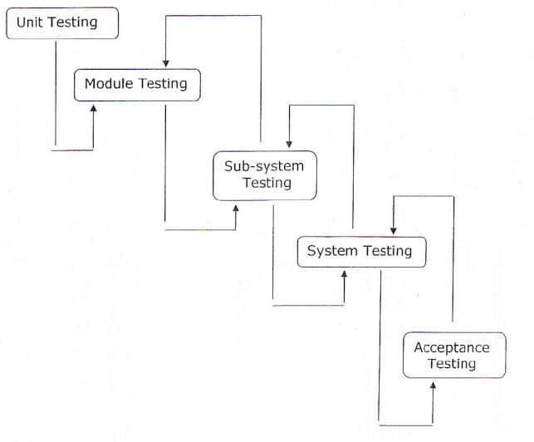

**Fig 4.1(a)**

**4.4 Types Of Testing**

**1. Unit Testing :-** It focuses on smallest unit of software design. In this we test an individual unit or group of inter related units. It is often done by programmer by using sample input and observing its corresponding outputs.

**2. Integration Testing :-** The objective is to take unit tested components and build a program structure that has been dictated by design. Integration testing is testing in which a group of components are combined to produce output. Integration testing are of two types: (i) Top down (ii) Bottom up

(a**) Black Box testing**:- It is used for validation.

In this we ignores internal working mechanism and

focuses on what is the output?.

(b) **White Box testing**:- It is used for verification.

In this we focus on internal mechanism i.e.

how the output is achieved?

#### 3. Regression Testing :- Every time new module is added leads to changes in program. This type of testing make sure that whole component works properly even after adding components to the complete program.

**4. Alpha Testing :-** This is a type of validation testing. It is a type of *acceptance testing*which is done before the product is released to customers. It is typically done by QA people.

**5. Beta Testing :-** The beta test is conducted at one or more customer sites by the end-user of the software. This version is released for the limited number of users for testing in real time environment.

#### 6. System Testing :- In this software is tested such that it works fine for different operating system. It is covered under the black box testing technique. In this we just focus on required input and output without focusing on internal working. In this we have security testing, recovery testing , stress testing and performance testing

**4.5 Used testing in project**

* **Unit testing:** During the programming stages each and every form, modules and class treated unit has been put into the test data. Every module is tested independently. The steps are follows.

1. Manually code is tested like spelling checks, logics and errors.
2. Once the manual checking is over the complication has been done. Syntactical errors if any have to be corrected.
3. After the clean completion the program, some dummy data, as specification, has been used for testing of the module to see if it works as specified.

* **Integration testing :**- After the individual’s modules were tested out we go the integrated to create a complete system. This integration process involves building the system and testing the resultant system for problems that arise from component interaction.
* **Performance testing :-** Performance testing is designed to test the runtime performance of the system within the system context of the system. These tests were performed as module level as well as system level. Individual modules were tested for required performance.
* **Condition testing:** Performance testing is the test case design method that exercises the logical conditions.
* **Interface testing:** Interface sting is integral part of integration. We examined the code to be tested and explicitly list each call to an external component. Performance testing is the test case design method that exercises the logical conditions. int the system standards tests for GUIs have been performed, which are as follows:
* The position and related for all controls were checked.
* Validations for all inputs were done.
* Pull down controls was verified for proper functionality.
* Whether the non-editable text controls disabling and it was also verified that it doesn’t exceed the maximum allowed length.

**4.6 Output Snapshot**

* **Home Page**

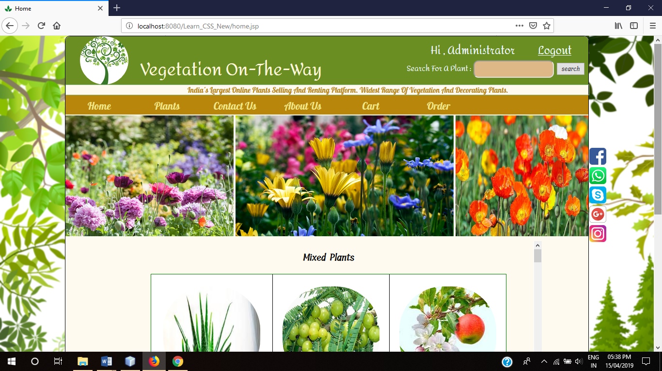

**Fig 4.6.1**

* **Registration Page**

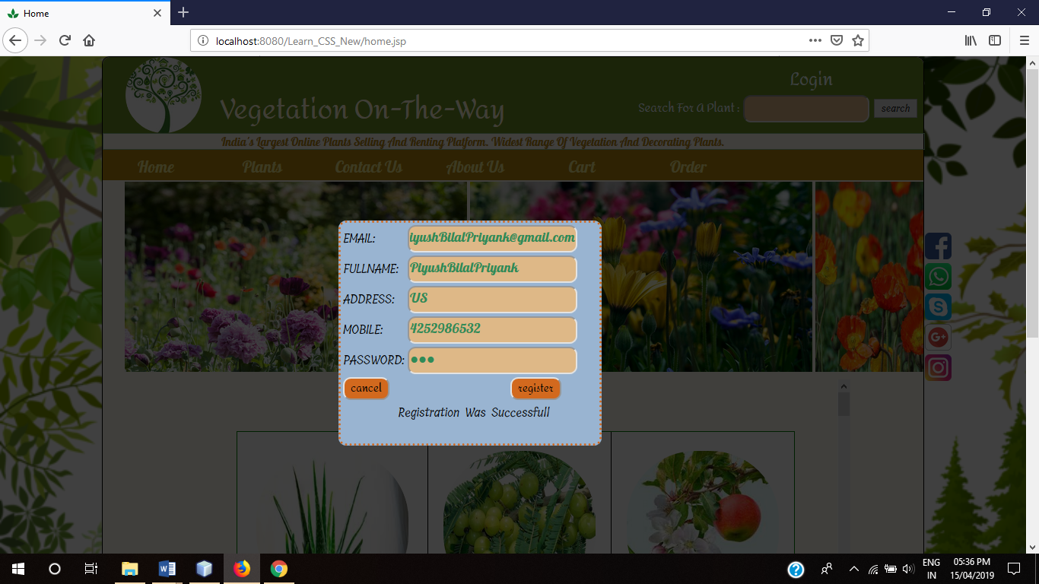

**Fig 4.6.2**

* **Contact-us page**

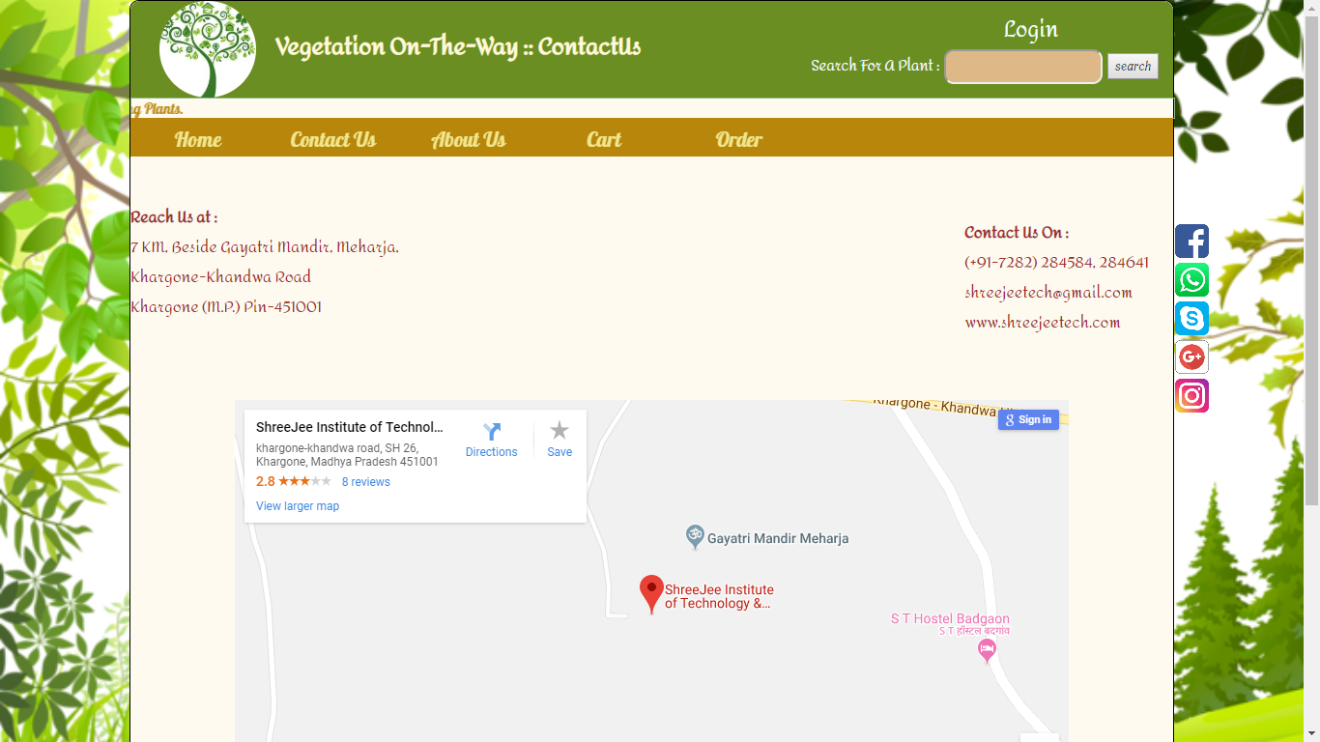

**Fig 4.6.3**

* **About-us page**

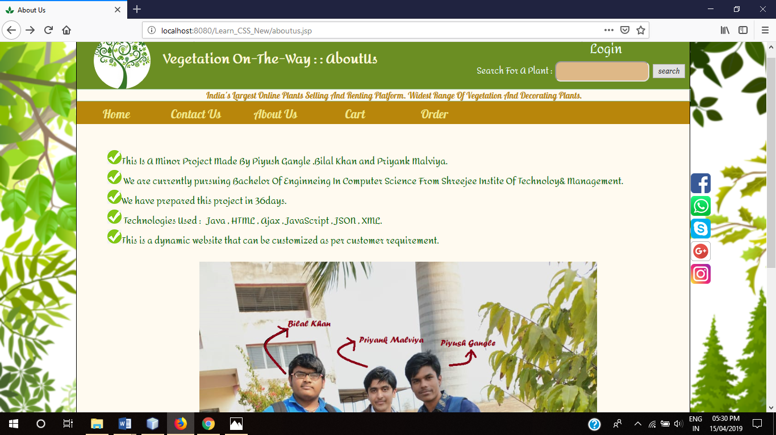

**Fig 4.6.4**

* **Cart page**

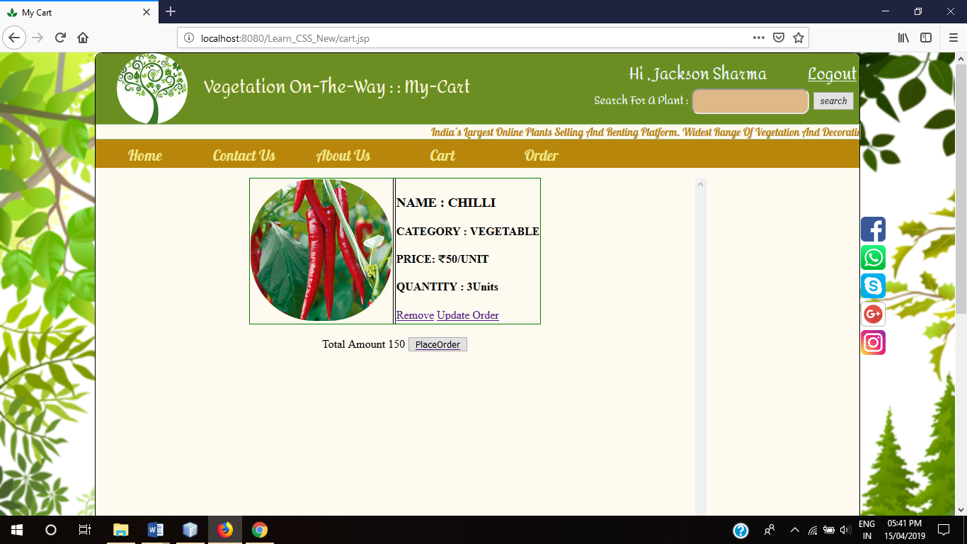

**Fig 4.6.5**

* **MyOrder page**

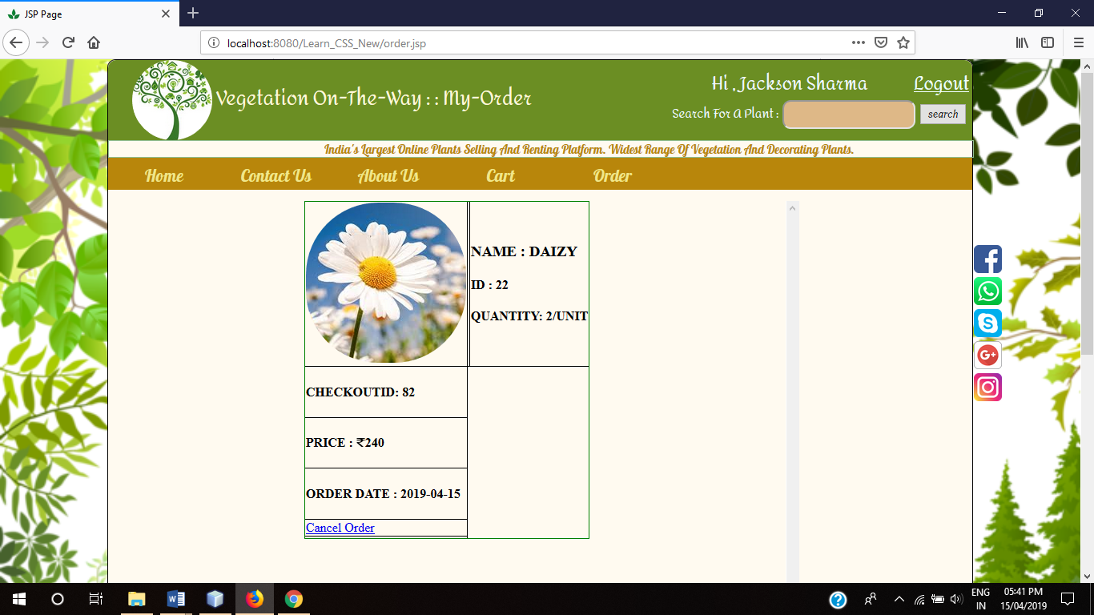

**Fig 4.6.6**

**5. LIMITATIONS AND FUTURE ENHANCEMENT**

**5.1 LIMITATIONS:**

1. In our website we have not design any gateway for online payment method, we use only cash on delivery.
2. We have not design any feedback facility for the customers.
3. The website can not generate invoice of the order.
4. The customer can purchase or rent only 10 plants at one time.
5. After registration the customer can not change its password or user name.
6. On some pages of website we have not used AJAX technology.
7. The website does not contain any complaint section.

**Some are general limitations of online stores:**

First and foremost limitation of online shopping is that it takes plenty of time. As things have to get delivered from other countries and sometimes cities, delivery process takes lots of time. Secondly, there are still people who are technology illiterate and still find very difficult to use internet to buy things.

**Technological Limitations:** Technological limitations of Online Stores have restricted a large number of people from using e-commerce. Internet has not touched the lives of every common man.

**Unsuitable for perishable items:** Online Store is not suitable for perishable goods and services. Perishable goods require proper storage and warehousing. For such items people always prefer conventional mode. For purchasing perishable goods like food items people generally prefer conventional shopping mode.

**Security:** Security continues to be an issue when it comes to Online Shopping. Online businesses are not trusted by the customers as there have been many cases of frauds and faulty payments.

**Ineffective Customer Relations:** Most of the businesses have forgotten that customer relations are difficult to maintain when it comes to e-business. They never realize that e-business also requires loyal customers.

**5.2 FUTURE ENHANCEMENTS:**

* More Functionality can be added depending upon the user requirements and specifications.
* We trying to increase website performance by using maximize use of available resources.
* Provide more controlling by administration.
* Database record shall be encrypted so that it was not read by any unauthorized user.
* Notifications of user cart, sales, discount offer etc.
* Online payment gateway and also provide a facility for third party security system during transaction.
* Developed for other devices also such as Mobile.
* In future we can create this site for world wide.
* We can also provide to sub-admin to advertisement.
* We can also provide price wise searching Plants in future.
* Provide more online tips and help for customers.
* Online invoice generation.
* Providing AJAX refreshing technology in our website.
* Bases on the future security issues can be improved using emerging technology.
* We can enhance it by making the same project to work on mobile app.
* We also plan to enhance the interface so that it looks more attractive and interactive.
* Allow customers to edit their profile details and change their password at any time.
* SMS notification after successful order placing and dispatching.
* Order tracking facility.
* Encrypted webpage to ensure customer privacy and transaction security.
* Provide an Encyclopedia of plants for customers in future.
* Another feature we wish to implement is the system may keep track of history of purchases of each customer and provide suggestions based on their history.
* Implementing personalized user experience using modern approaches like data mining and artificial intelligence.

These features could have implemented unless the time did not limited us.

**6. CONCLUSION**

The conclusion is in proposing system Online Plant Shopping it should satisfies both the customers. Admin should play the crucial role in this system Admin should maintain the information about the plant details, order details, and delivery reports. We are committed to serve best with quality as a major ingredient of our services. Our innovative ideas are always there to help our varied customers in every possible way.

The system has been developed with much care and free of errors and at the same time it is efficient and less time consuming. The purpose of this project was to develop a web application for purchasing Plants from a nursery.

This project helped us in gaining valuable information and practical knowledge on several topics like designing web pages using HTML, JavaScript & CSS and management of database using Oracle Database. The entire system is secured. Also the project helped us understanding about the development phase of a project and software development life cycle. We learned how to test different features of a project. This project has given us great satisfaction in having designed an application which can be implemented to any nearby Nursery and also for other stores for selling various kinds of plants and other products by simple modifications.

We have successfully implemented the site “Vegetation On The Way” with the help of various links and tools, we have been able to provide a site which is live and running on the web. We have been successful in our attempt to take care of the needs of the both the customers as well as the administrator. Finally we hope that this will go a long way in popularizing the organization and making it’s business more profitable.

**REFERENCES**

1. Google for problem solving.
2. StackOverflow for small error fixing
3. W3school For Html and CSS Advance Features.
4. Java Complete Reference 7th edition.
5. Software Engineering by Pressman
6. Oracle for database and java development kit.
7. Javatpoint for java tutorials
8. Netbeans for IDE.
9. Tutorialspoint for Software engineering modals.
10. Geeksforgeeks for programming hacks.